Instructions for getting to the "ANICLADE™" Minigame Demo.

Follow this link: https://aniclade.itch.io/minigame-demo-by-aniclade
The Minigame is Published Here
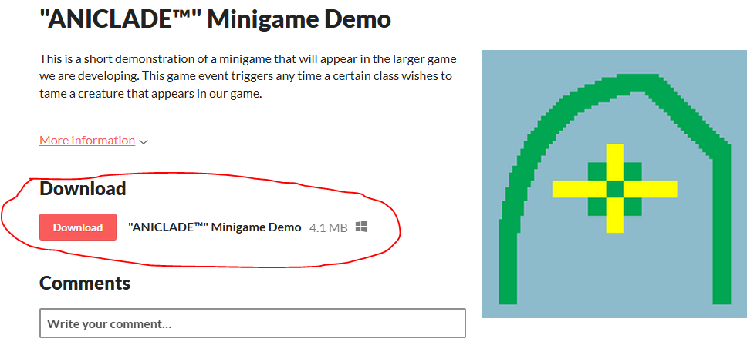
Downloading the Game:
Hitting download will place the game in a zipped file in your download folder.
Open the zipped file and choose “Breaking Minigame” type: application.
Select “Extract All”
Choose your download folder as the file destination:
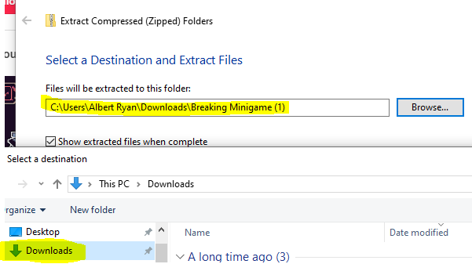
Hit “Extract”
The game will appear as one of your downloads (and be deleted routinely from there).
Opening the application file will cause your computer to get worried (but it’s fine). Select “more info” then select “run anyway.” And the game will run.

