**The Presbyterian Church**

**at Tenafly**

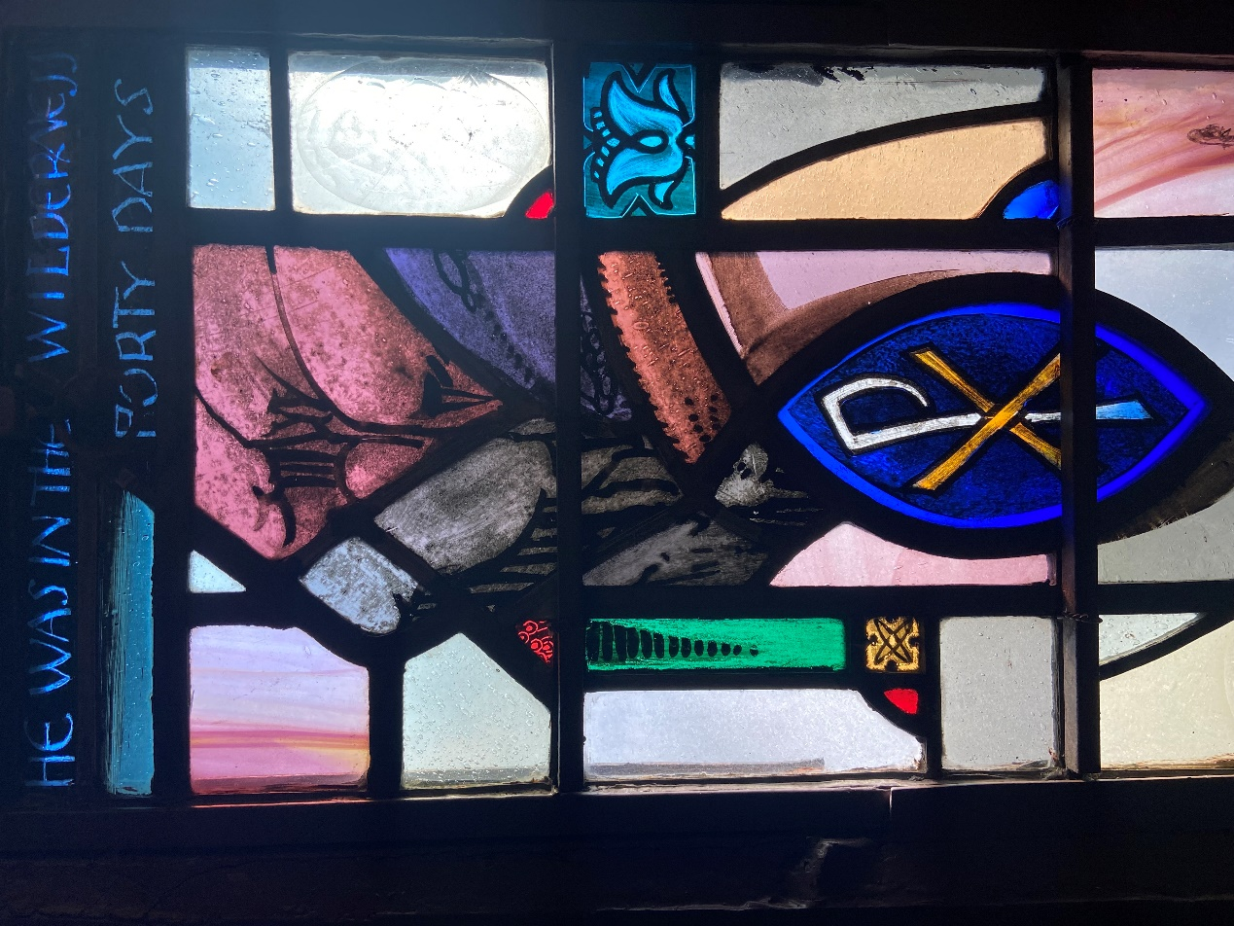

***For Every Heart a Home***

**February 26, 2023 First Sunday in Lent 10:30am**

**Liturgist: Jeanne Lambert Cantor: Gay Willis Rev Dr Martin Ritchie**

*Welcome to worship! If you are visiting or here for the first time and would like to stay in touch with us, please consider filling in one of the contact cards that you will find alongside the hymnals. These can be placed in the offering plate or handed to an usher.*

**Prelude**

**Welcome and Announcements**

**Joys and Concerns** Rev Dr Martin Ritchie

**Call to Worship**

**\*Hymn 696** *O God, You Are My God Alone*

**Prayer of Approach and Confession (unison)**

**God of all times and seasons. We are ready to walk with you in the narrow way of Lent. You invite us to set aside distractions and focus on you. We bring our whole selves to this journey. From our birth, you have walked with us in times of joy as well as in times of sorrow, even if we have not recognised your presence. In the wonder of Creation, you are there. In the kindness of friends and strangers, you are there. In the blessings of work and leisure, you are there. In the tragedies of our lives, you are present, weeping with us.**

**And so, trusting in your presence, we take a moment of quiet to think of how our lives have been this last week. We bring all of it before you now, the highs and the lows. The times that we have followed your way closely, and the times when we may have wandered from it.**

**Silence…….**

**KYRIE ELEISON**

**Martin sings:** Kyrie Eleison

**Congregation & Cantor:** Kyrie Eleison

**Martin sings:** Christe Eleison

**Congregation & Cantor:** Christe Eleison

**Martin sings:** Kyrie Eleison

**Congregation & Cantor:** Kyrie Eleison

**Declaration of Forgiveness**

**Choir Anthem** *Dominus Vobiscum,* by Jacob Narverud

*Dominus vobiscum, pacem relinquo vobis, ut et cum spirito tuo. Amen*

*The Lord be with you, peace we leave with you, and with your spirit. Amen*

**First Reading** Genesis 2:15-17, 3:1-7

The Lord God took the man and put him in the garden of Eden to till it and keep it. And the Lord God commanded the man, “You may freely eat of every tree of the garden, but of the tree of the knowledge of good and evil you shall not eat, for in the day that you eat of it you shall die.” Now the serpent was more crafty than any other wild animal that the Lord God had made. He said to the woman, “Did God say, ‘You shall not eat from any tree in the garden’?” The woman said to the serpent, “We may eat of the fruit of the trees in the garden, but God said, ‘You shall not eat of the fruit of the tree that is in the middle of the garden, nor shall you touch it, or you shall die.’ ” But the serpent said to the woman, “You will not die, for God knows that when you eat of it your eyes will be opened, and you will be like God, knowing good and evil.”

So when the woman saw that the tree was good for food and that it was a delight to the eyes and that the tree was to be desired to make one wise, she took of its fruit and ate, and she also gave some to her husband, who was with her, and he ate. Then the eyes of both were opened, and they knew that they were naked, and they sewed fig leaves together and made loincloths for themselves.

**\*Song** Setting of Psalm 32

***[All] Refrain****:*

*You are my hiding place. You always fill my heart with songs of deliverance. Whenever I am afraid I will trust in you. I will trust in you. Let the weak say, “I am strong in the strength of the Lord.”*

[Solo] Happy are they whose transgressions are forgiven, and whose sin is put away! Happy are they to whom the Lord imputes no guilt, and in whose spirit there is no guile! While I held my tongue, my bones withered away, because of my groaning all day long. For your hand was heavy upon me day and night; my moisture was dried up as in the heat of summer.

**[All] *Refrain***

[Solo] Then I acknowledged my sin to you, and did not conceal my guilt. I said, “I will confess my transgressions to the Lord.” Then you forgave me the guilt of my sin. Therefore all the faithful will make their prayers to you in time of trouble; when the great waters overflow, they shall not reach them.

**[All] *Refrain***

[Solo] You are my hiding place; you preserve me from trouble; you surround me with shouts of deliverance. “I will instruct you and teach you in the way that you should go; I will guide you with my eye. Do not be like horse or mule, which have no understanding; who must be fitted with bit and bridle, or else they will not stay near you.” Great are the tribulations of the wicked; but mercy embraces those who trust in the Lord. Be glad, you righteous, and rejoice in the Lord; shout for joy, all who are true of hear.

**[All] *Refrain***

**Second Reading** Matthew 4:1-11

Then Jesus was led up by the Spirit into the wilderness to be tested by the devil. He fasted forty days and forty nights, and afterward he was famished. The tempter came and said to him, “If you are the Son of God, command these stones to become loaves of bread.” But he answered, “It is written, ‘One does not live by bread alone,  
but by every word that comes from the mouth of God.’ ” Then the devil took him to the holy city and placed him on the pinnacle of the temple, saying to him, “If you are the Son of God, throw yourself down, for it is written, ‘He will command his angels concerning you,’ and ‘On their hands they will bear you up, so that you will not dash your foot against a stone.’ ” Jesus said to him, “Again it is written, ‘Do not put the Lord your God to the test.’ ” Again, the devil took him to a very high mountain and showed him all the kingdoms of the world and their glory, and he said to him, “All these I will give you, if you will fall down and worship me.” Then Jesus said to him, “Away with you, Satan! for it is written, ‘Worship the Lord your God, and serve only him.’ ” Then the devil left him, and suddenly angels came and waited on him.

**\*Hymn 175** *Seek Ye First the Kingdom of God*

**Sermon** Rev. Dr. Martin Ritchie

**Sharing our Gifts** *Give Me Jesus,* by Francisco Ortega

Gay Willis, solo

**Doxology**

**Prayer of Dedication**

**Prayers of Thanksgiving and Intercession**

**The Lord’s Prayer**

**\*Hymn 445**  *God How Can We Forgive*

**Charge, Benediction and Celtic Amen**

***Amen, Amen, Alleluia, Amen (x2)***

**Postlude** *Blessed Assurance*

**\* * * \***

**\*Those who are able, please stand.**

**Livestreaming of Worship.** Today’s service is broadcast live online. You can watch the service again later via our website homepage if you wish to. Huge thanks to our entire technical team.

**Presby Readers** willbe discussing *Lessons in Chemistry: A Novel*, by Bonnie Garmus

today at the Shima’s home at 4pm. All are welcome!

**Lent Space**. You are invited to leave behind the stresses of life and come to the candlelit chapel for a time of quiet reflection. Each Wednesday evening in Lent from 7-7:30pm from March 1st.

**Lent Study** begins Wednesday March 1st. This year we will share a study based on the movie *Chocolat.* Meet in the church house at 12noon (bring your lunch) or **7:45pm**. Everyone is welcome.

**Muhammad Najem, War Reporter: How one boy put the spotlight on Syria.** We’re going to be welcoming Nora Neus, who grew up in Tenafly and will be known to some of you. She’s an Emmy-nominated producer, writer, and journalist, and recently collaborated on this graphic novel. She’ll be joining us for a discussion with Debbie Abitante about this fascinating book **Sunday, March 5th at 4pm in the sanctuary.**

**Presbyterian Disaster Assistance** A 7.8 magnitude earthquake near the Turkey-Syria border struck in the early hours of February 6, 2023. This earthquake is estimated to affect more than 23 million people.

You can share your financial blessings to help disaster survivors by sending donations to the church office. Make checks payable to PCAT and note “Earthquake” in the memo line - we will forward your gifts on to PDA.

If you wish to mail directly to them, designate your check to: DR999999-ST Earthquake in the memo line and mail to:

Presbyterian Church (U.S.A.)  
P.O. Box 643700  
Pittsburgh, PA 15264-3700

**THE PRESBYTERIAN CHURCH AT TENAFLY**

55 Magnolia Avenue, Tenafly, NJ 07670

Phone (201) 567-0111 / Fax (201) 567-0529

Emails : [tenaflypresbyterianchurch@gmail.com](mailto:tenaflypresbyterianchurch@gmail.com)

pastorpcat@gmail.com

Web page: [www.tenaflypresby.org](http://www.tenaflypresby.org)

Doodle away . . .

We all have different personalities, and we engage in worship in different ways. This space is left for you to use in any way that you would like during the service. You may like to write notes or you may wish to draw in response to how you hear God speaking. You can use the pencils which are in the pews or bring your own.

We are providing this space every week.