The Presbyterian Church
at Tenafly
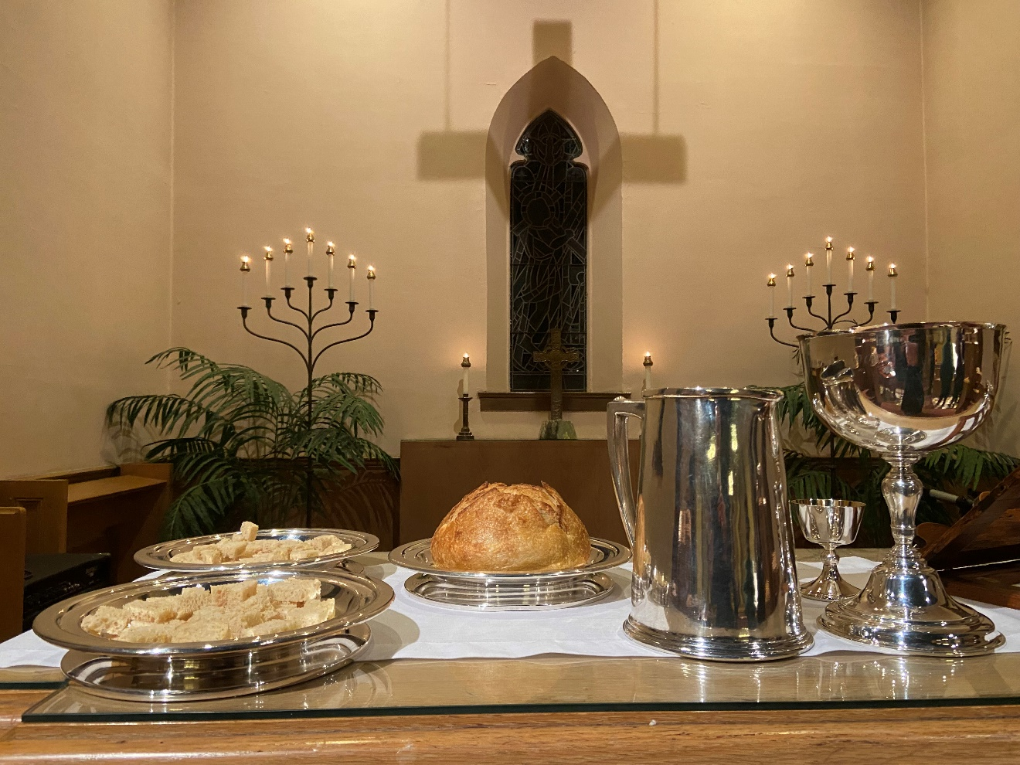

For Every Heart a Home

March 5, 2023 2nd Sunday in Lent 10:30am
Sacrament of the Lord’s Supper
Liturgist: Lily Lee Cantor: Carroll Van Cleave
Rev Dr Martin Ritchie
Welcome to worship! If you are visiting or here for the first time and would like to stay in touch with us, please consider filling in one of the contact cards that you will find alongside the hymnals. These can be placed in the offering plate or handed to an usher.

Prelude

Welcome and Announcements Lily Lee

Joys and Concerns

Call to Worship

* Hymn 37 Let All Things Now Living

Prayer of Approach and Confession (unison)

Good and gracious God. You are our encourager and our guide on the paths of our lives. Sometimes your presence seems hidden. We become frustrated and directionless. At other times we burn brightly with the sense that you are near. These are the changing scenes of life, and by faith we trust that you are in, and through, and beyond all of it.

As we continue on our Lenten journey, we take a moment to bring our thoughts of how this week has been for us, giving thanks for all that has been good, and sharing with sorrow what has been hard. In a moment of quiet, we offer our sense of where we have followed your ways, and where we have departed from them.

Silence

KYRIE ELEISON
Martin sings: Kyrie Eleison
Congregation & Cantor: Kyrie Eleison
Martin sings: Christe Eleison
Congregation & Cantor: Christe Eleison
Martin sings: Kyrie Eleison
Congregation & Cantor: Kyrie Eleison

Declaration of Forgiveness Lily Lee

Choir Anthem Ave Verum Corpus, by Mozart

Ave Verum Corpus natum de Maria Virgine: vere passum, immolatum in cruce pro homine: cuius latus perforatum fluxit aqua et sanguine:
esto nobis praegustatum, in mortis examine. O Jesu dulcis, O Jesu pie, O Jesu Fili Mariae. Miserere mei. Amen.

Hail the true body, born from the Virgin Mary: You who truly suffered and were sacrificed on the cross for the sake of man. From whose pierced flank flowed water and blood: be a foretaste for us in the trial of death. O sweet, O merciful, O Jesus, Son of Mary. Have mercy on me. Amen.

Reading Genesis 12:1-4a Lily Lee

Now the Lord said to Abram, “Go from your country and your kindred and your father’s house to the land that I will show you. I will make of you a great nation, and I will bless you and make your name great, so that you will be a blessing. I will bless those who bless you, and the one who curses you I will curse, and in you all the families of the earth shall be blessed.” So Abram went, as the Lord had told him, and Lot went with him. Abram was seventy-five years old when he departed from Haran.

* Hymn 45 (Psalm 121) I to the Hills Will Lift My Eyes

Reading John 3:1-17 Rev Dr Martin Ritchie

Now there was a Pharisee named Nicodemus, a leader of the Jews. He came to Jesus by night and said to him, “Rabbi, we know that you are a teacher who has come from God, for no one can do these signs that you do unless God is with that person.” Jesus answered him, “Very truly, I tell you, no one can see the kingdom of God without being born from above.” Nicodemus said to him, “How can anyone be born after having grown old? Can one enter a second time into the mother’s womb and be born?” Jesus answered, “Very truly, I tell you, no one can enter the kingdom of God without being born of water and Spirit. What is born of the flesh is flesh, and what is born of the Spirit is spirit. Do not be astonished that I said to you, ‘You must be born from above.’ The wind blows where it chooses, and you hear the sound of it, but you do not know where it comes from or where it goes. So it is with everyone who is born of the Spirit.” Nicodemus said to him, “How can these things be?” Jesus answered him, “Are you the teacher of Israel, and yet you do not understand these things? “Very truly, I tell you, we speak of what we know and testify to what we have seen, yet you do not receive our testimony. If I have told you about earthly things and you do not believe, how can you believe if I tell you about heavenly things? No one has ascended into heaven except the one who descended from heaven, the Son of Man. And just as Moses lifted up the serpent in the wilderness, so must the Son of Man be lifted up, that whoever believes in him may have eternal life.
“For God so loved the world that he gave his only Son, so that everyone who believes in him may not perish but may have eternal life.
“Indeed, God did not send the Son into the world to condemn the world but in order that the world might be saved through him.

* Hymn Living Waters, by Keith and Kristyn Getty and Ed Cash
Are you thirsty Are you empty
Come and drink these living waters
Tired and broken Peace unspoken
Rest beside these living waters
Christ is calling Find refreshing
At the cross of living waters
Lay your life down All the old gone
Rise up in these living waters
Chorus:
There’s a river that flows With mercy and love
Bringing joy to the city of our God There our hope is secure
Do not fear anymore Praise the Lord of living waters
Spirit moving Mercy washing
Healing in these living waters
Lead your children To the shore line
Life is in these living waters
CHORUS
Are you thirsty Are you empty
Come and drink these living waters
Love, forgiveness Vast and boundless
Christ, He is our living waters
CHORUS
Sermon Rev Dr Martin Ritchie

Offering
Doxology
Prayer of Dedication

Sharing the Peace

Invitation to Communion

The table of bread and wine has been made ready. It is the table of company with Jesus, and all who love him. So come to this table, you who have much faith and you who would like to have more; you who have been here often and you who have not been for a while. You who have tried to follow Jesus, and you who have failed. Come. It is Christ who invites us to meet him here.

*Song We Are Coming, Lord, to the Table

We are coming, Lord, to the table. We are coming, Lord, to the table.
With the gift of bread, we are coming, Lord.
With the gift of wine, we are coming, Lord.

Oh, we are coming, Lord. Oh, we are coming, Lord.
Oh, we are coming, Lord. Oh, we are coming Lord.

We are coming, Lord, to the table. We are coming, Lord, to the table.
To receive the bread, we are coming, Lord.
To receive the wine, we are coming, Lord.

Oh, we are coming, Lord. Oh, we are coming, Lord.
Oh, we are coming, Lord. Oh, we are coming Lord.
(Remain Standing)

The Great Thanksgiving

The Lord be with you
And also with you
Lift up your hearts
We lift them to the Lord.
Let us give thanks to the Lord our God
It is right to give our thanks and praise.
Worship and praise belong to you, maker of light and darkness.
Your wisdom draws beauty from chaos, brings a harvest out of sorrow
and leads the exiles home.

In Christ your Son enemies are reconciled, debts forgiven and strangers made welcome. Your Spirit frees us to live as sons and daughters in our Father's house.

We who by Christ's power follow the way of the Cross, sharing the joy of his obedience, now offer you our praise, with angels and archangels
and the whole company of heaven saying the hymn of your unending glory:

Sanctus and Benedictus (unison)
Holy, Holy, Holy Lord, God of power and might. Heaven and earth are full of your glory, hosanna in the highest. Blessed is he who comes in the name of the Lord. Hosanna, in the highest.
(the congregation sits)

Telling the Story
Glory and thanksgiving be to you, most loving Father,
for Christ in whom the world is reconciled.
Lifted on the Cross, his suffering and forgiveness
spanned the gulf our sins had made.
Through that dark struggle death was swallowed up in victory,
that life and light might reign.

Before he was given up to suffering and death, recalling the night
of Israel's release, the night in which the sons of Egypt died,
your Chosen One, himself the First-Born, freely offered his life.
At supper with his disciples he took bread and offered you thanks.
He broke the bread, and gave it to them, saying:
"Take, eat. This is my Body: it is broken for you."
After supper, he took the cup,
he offered you thanks, and gave it to them saying:
"Drink this, all of you. This is my Blood of the new covenant;
it is poured out for you, and for all, that sins may be forgiven.
Do this in remembrance of me."

We now obey your Son's command.
We recall his blessed passion and death,
his glorious resurrection and ascension;
and we look for the coming of his Kingdom.
Made one with him, we offer you these gifts
and with them ourselves, a single, holy, living sacrifice.

Hear us, most merciful Father, and send your Holy Spirit upon us
and upon this bread and this wine,
that, overshadowed by your life-giving power,
they may be for us spiritual food and drink,
and we may be kindled with the fire of your love
and renewed for the service of your Kingdom.
Help us, who are baptized into the fellowship of Christ's Body
to live and work to your praise and glory;
may we grow together in unity and love
until at last, in your new creation,
we enter into our heritage in the company of the apostles,
and prophets, and of all our brothers and sisters living and departed.

Through Jesus Christ our Lord, with whom, and in whom,
in the unity of the Holy Spirit, all honour and glory be to you,
Lord of all ages, world without end.
Amen.

Agnus Dei
Jesus, Lamb of God
Have mercy on us
Jesus bearer of our sins
Have mercy upon us
Jesus redeemer of the world
Grant us your peace.

Sharing the Bread and Wine
(The Elders will serve the bread to you in your seats. The wine glasses are pre-set in the pews. Please wait to eat and drink all together.)

Post-Communion Prayer (Unison)

Father of all, we give you thanks and praise that when we were still far off you met us in your Son and brought us home. Dying and living, he declared your love, gave us grace, and opened the gate of glory. May we who share Christ's body live his risen life; we who drink his cup bring life to others; we whom the Spirit lights, give light to the world. Keep us firm in the hope you have set before us, so we and all your children shall be free, and the whole earth live to praise your name; through Christ our Lord. Amen.

* Hymn 547 Go, My Children, with My Blessing

Charge, Benediction and Celtic Amen
Amen, Amen, Alleluia, Amen (x2)

Postlude
*****

*Those who are able, please stand.

THE PRESBYTERIAN CHURCH AT TENAFLY
55 Magnolia Avenue, Tenafly, NJ 07670
Phone (201) 567-0111 / Fax (201) 567-0529
Emails : tenaflypresbyterianchurch@gmail.com
pastorpcat@gmail.com
Web page: www.tenaflypresby.org
Doodle away . . .
We all have different personalities, and we engage in worship in different ways. This space is left for you to use in any way that you would like during the service. You may like to write notes or you may wish to draw in response to how you hear God speaking. You can use the pencils which are in the pews or bring your own.
We are providing this space every week.

Coming Up . .

