**The Presbyterian Church**

**at Tenafly**

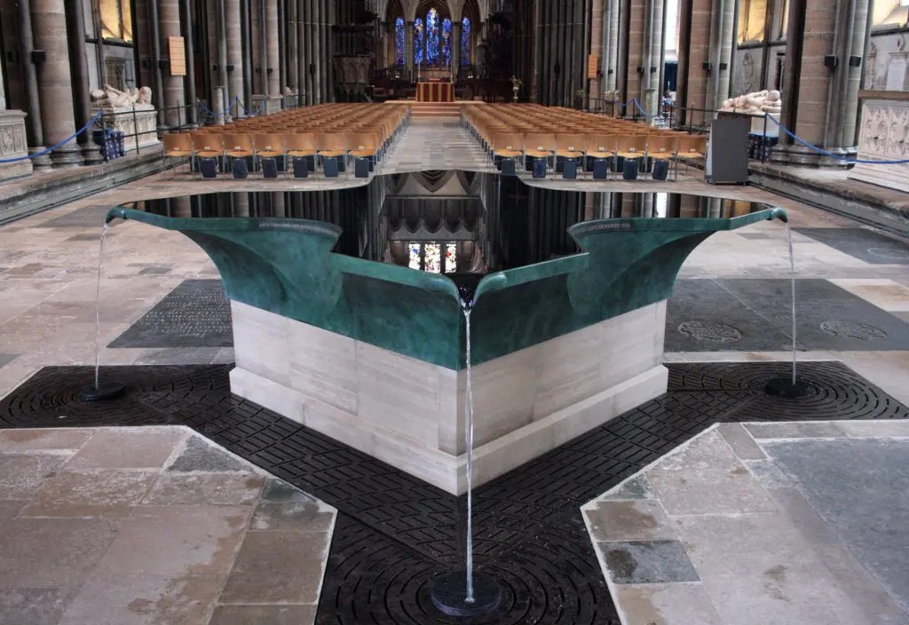

***For Every Heart a Home***

**March 12, 2023 Third Sunday in Lent 10:30am**

**Intergenerational Worship**

**Cantor: Ann Van Cleave Rev Dr Martin Ritchie**

**Sherrie Reilley**

*Welcome to worship! If you are visiting or here for the first time and would like to stay in touch with us, please consider filling in one of the contact cards that you will find alongside the hymnals. These can be placed in the offering plate or handed to an usher.*

**Prelude**

**Welcome and Announcements** Carolyn Rocco

**Minute for Mission** Mickey Sechrist

**Skit** *What Will Quench Our Thirst?*

**\*Song** *Living Waters,* by Keith and Kristyn Getty and Ed Cash

Are you thirsty Are you empty  
Come and drink these living waters  
Tired and broken Peace unspoken  
Rest beside these living waters

Christ is calling Find refreshing  
At the cross of living waters  
Lay your life down All the old gone  
Rise up in these living waters

Chorus:  
There’s a river that flows With mercy and love  
Bringing joy to the city of our God There our hope is secure  
Do not fear anymore Praise the Lord of living waters

Spirit moving Mercy washing  
Healing in these living waters  
Lead your children To the shore line  
Life is in these living waters

CHORUS

Are you thirsty Are you empty  
Come and drink these living waters  
Love, forgiveness Vast and boundless  
Christ, He is our living waters

CHORUS

**Prayer of Approach and Confession (unison)** Anthony Moran

**God of all times and seasons. We sit before you in wonder at the way in which you have made us and keep us in being. We trust that you were at our beginning and will be at our ending, and through all the seasons of life in between. For a short time we are part of life on your amazing planet, and for that we are grateful. Our lives are so often filled with good things and with your light. But at times that light is overcome by darkness. In a moment of quiet we hand to you now any darkness that has been our experience in recent days, for ourselves, for our community, for the wider world.**

**Silence…….**

**KYRIE ELEISON**

**Martin sings:** Kyrie Eleison

**Congregation & Cantor:** Kyrie Eleison

**Martin sings:** Christe Eleison

**Congregation & Cantor:** Christe Eleison

**Martin sings:** Kyrie Eleison

**Congregation & Cantor:** Kyrie Eleison

**Declaration of Forgiveness** Anthony Moran

As the deer longs for water in a dry place, so we long for you, O God. May we all know your forgiveness as we continue on our journeys of life, wandering through wilderness as well as green pastures. We pray that we will find your living water in even the hardest and stoniest of places. In Jesus’ name we pray. **AMEN**

**Video based on Exodus 17:1-7** Sherrie Reilley

**Choir** *Wade in the Water*

Wade in the water. Wade in the water, children.

Wade in the water children, God’s gonna trouble the water.

Down in the valley, down on my knees. Wade in the water.

Askin’ my Lord to save me please. Wade in the water.

Up on the mountain, Jehovah, he spoke. Wade in the water.

Out of his mouth came fire and smoke. Wade in the water.

I heard a rumblin’ up in the sky. Wade in the water.

Musta been Jesus passin’ by. Wade in the water.

You gotta wade in the water. You gotta wade in the water, children.

You gotta wade in the water. God’s gonna trouble the water.

**Story based on John 4:5-42** *The Woman at the Well* Rev Dr Martin Ritchie

**\*Hymn 626** *As the Deer*(Psalm 42)

As the deer pants for the water, so my soul longs after you.

You alone are my heart’s desire, and I long to worship you.

*Refrain*:

You alone are my strength, my shield,

To you alone may my spirit yield.

You alone are my heart’s desire,

And I long to worship you.

I want you more than gold or silver; only you can satisfy.

You alone are the real joy-giver, and the apple of my eye. *Refrain*

You’re my friend and you are my brother, even though you are a King.

I love you more than any other, so much more than anything. *Refrain*

**A Time to Wonder**Rev Dr Martin Ritchie

**Invitation to The Well,** during which we hear the solo *The Well*, by Casting Crowns**.**

*(During the song you are invited to come forward to the font and take a bottle with an encouraging scripture verse.)*

**Joys and Concerns and The Lord’s Prayer**

**\*Song**  *I’ve Got Peace Like a River*

1 I’ve got peace like a river, I’ve got peace like a river,  
I’ve got peace like a river in my soul.  
  
I’ve got peace like a river, I’ve got peace like a river,  
I’ve got peace like a river in my soul.

2 I’ve got love like an ocean, I’ve got love like an ocean,  
I’ve got love like an ocean in my soul.  
  
I’ve got love like an ocean, I’ve got love like an ocean,  
I’ve got love like an ocean in my soul.

3 I’ve got joy like a fountain, I’ve got joy like a fountain,  
I’ve got joy like a fountain in my soul.  
  
I’ve got joy like a fountain, I’ve got joy like a fountain,  
I’ve got joy like a fountain in my soul.

**\*Blessing with sung Celtic Amen**

**\*Postlude**

**\*Those who are able, please stand.**

**Livestreaming of Worship.** Today’s service is broadcast live online. You can watch the service again later via our website homepage if you wish to. Huge thanks to our entire technical team.

**Our Lenten Study** continues this week on Wednesday at 12noon (bring your lunch) or 7.45pm in the church house. Based on the movie, *Chocolat* which is a great movie that opens up all sorts of big themes. Everyone is welcome, no preparation necessary as we watch sections of the movie each week then discuss.

**The chapel will be open each Wednesday evening in Lent from 7-7.30pm for our *Lent Space***, a reflective time offered freely as a place to sit in the quiet beauty of candlelight and have some peace. Anyone is welcome to come in for that – you don’t have to be going to the Lent study although you’re welcome to do both!

**Care Packages:** Children and Youth Ministries would like your help collecting snacks put into care packages for our college students. We'll collect snacks March 5 - March 26. Let's send our young adults some love!

**Chinese Lunch Sunday March 19th:** Join us after worship for lunch in the Church House for Chinese food from Good Taste. Your fortune for March 19th…*Your afternoon will be filled with friends, laughter and great food!* Suggested donations: $5.00 each for adults $15.00 for families

**Wellbeing Event:** Danielle Lambert, daughter of Jeanne and George and a member of the team from the *Gregory P Shadek Behavioral Care Center at Englewood Health* will be talking on the theme of ***When Stress Becomes Distress:******Taking Care of Our Emotional Well-Being* on Sunday March 26th** after worship in the church house at 12noon. This is open to anyone, and there will be a sandwich lunch provided.

**One Great Hour of Sharing** – Fish banks are available in the Narthex! Pick one up and start filling with your loose change. We’ll collect them back on Palm Sunday.

**Presby Readers** will next meet on **Sunday April 2nd at 4pm** at the home of Carolyn and Al Rocco. We will be discussing *Against All Odds: A True Story of Ultimate Courage and Survival in World War II* by Alex Kershaw. Everyone is welcome!

**Maundy Thursday Middle Eastern Supper** in Jim Henry Hall at 6pm. Followed by the service of Tenebrae by candlelight in the chapel at 7:30pm. Thursday April 6th

**Pancake Breakfast is back!** Come earlybefore worship on Sunday April 16th.

**THE PRESBYTERIAN CHURCH AT TENAFLY**

55 Magnolia Avenue, Tenafly, NJ 07670

Phone (201) 567-0111 / Fax (201) 567-0529

Emails : [tenaflypresbyterianchurch@gmail.com](mailto:tenaflypresbyterianchurch@gmail.com)

pastorpcat@gmail.com

Web page: [www.tenaflypresby.org](http://www.tenaflypresby.org)

Doodle away . . .

We all have different personalities, and we engage in worship in different ways. This space is left for you to use in any way that you would like during the service. You may like to write notes or you may wish to draw in response to how you hear God speaking. You can use the pencils which are in the pews or bring your own.

We are providing this space every week.