The Presbyterian Church
at Tenafly
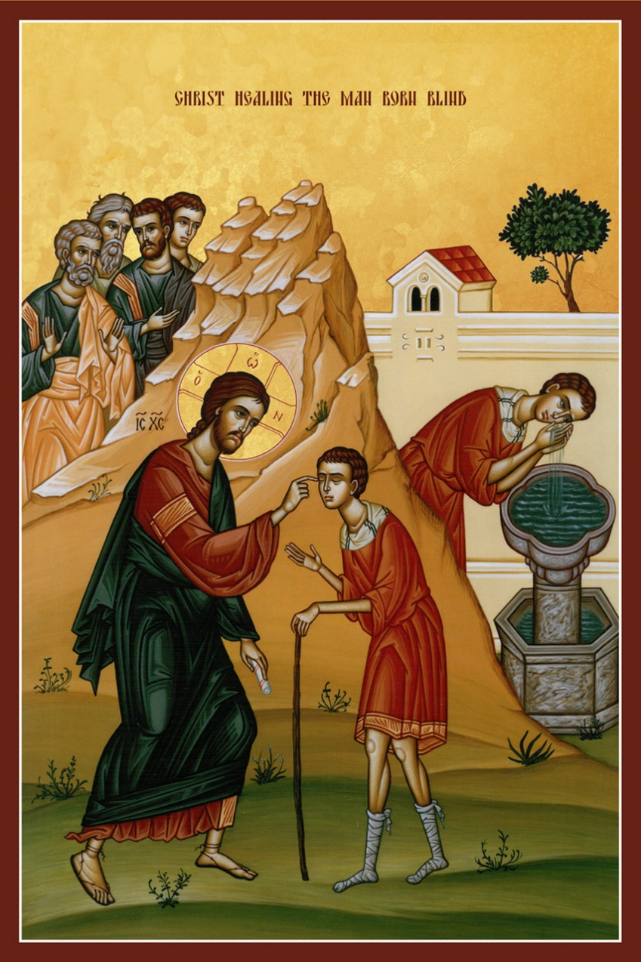

For Every Heart a Home
March 19, 2023 Fourth Sunday in Lent 10:30am

Liturgist: Marilyn Coats-Thomas Cantor: Gay Willis
Rev Dr Martin Ritchie
Welcome to worship! If you are visiting or here for the first time and would like to stay in touch with us, please consider filling in one of the contact cards that you will find alongside the hymnals. These can be placed in the offering plate or handed to an usher.

Prelude

Welcome and Announcements Marilyn Coats-Thomas
Joys and Concerns Rev Dr Martin Ritchie

Call to Worship
Liturgist: God calls us from the storms and the wild places
All: To gather beside still waters
Liturgist: He will make the rough places plain
All: And bring water from his well of compassion

*Hymn 401 Here in This Place v. 1,2, & 4

Prayer of Approach and Confession (unison)

God of the journey, as we travel through Lent, we give thanks that you are with us on our different paths. We trust in your guiding light which leads us on through every darkness and towards futures brighter than our past.

We praise you for the way in which you have been revealed to your people through the ages. Your presence is beyond our understanding, and yet at times when we have barriers down, and distractions are removed, we can know you. You are the still small voice in the raging storm, the gentle touch of kindness, the sense of connection with the heart of things.

We bring now our thoughts of how we have missed your voice in the noise of our lives and have been drawn to words and actions that have taken us far from your heart of love. We take a moment now as we reflect and open up to you in the quiet:

Silence…….

KYRIE ELEISON
Martin sings: Kyrie Eleison
Congregation & Cantor: Kyrie Eleison
Martin sings: Christe Eleison
Congregation & Cantor: Christe Eleison
Martin sings: Kyrie Eleison
Congregation & Cantor: Kyrie Eleison

Declaration of Forgiveness Marilyn Coats-Thomas
Choir Anthem (Psalm 23) My Shepherd Will Supply My Need, by Virgil Thomson

First Reading 1 Samuel 16:1-13 Marilyn Coats-Thomas

The Lord said to Samuel, “How long will you grieve over Saul? I have rejected him from being king over Israel. Fill your horn with oil and set out; I will send you to Jesse the Bethlehemite, for I have provided for myself a king among his sons.” Samuel said, “How can I go? If Saul hears of it, he will kill me.” And the Lord said, “Take a heifer with you and say, ‘I have come to sacrifice to the Lord.’ Invite Jesse to the sacrifice, and I will show you what you shall do, and you shall anoint for me the one whom I name to you.” Samuel did what the Lord commanded and came to Bethlehem. The elders of the city came to meet him trembling and said, “Do you come peaceably?” He said, “Peaceably. I have come to sacrifice to the Lord; sanctify yourselves and come with me to the sacrifice.” And he sanctified Jesse and his sons and invited them to the sacrifice. When they came, he looked on Eliab and thought, “Surely his anointed is now before the Lord.” But the Lord said to Samuel, “Do not look on his appearance or on the height of his stature, because I have rejected him, for the Lord does not see as mortals see; they look on the outward appearance, but the Lord looks on the heart.” Then Jesse called Abinadab and made him pass before Samuel. He said, “Neither has the Lord chosen this one.” Then Jesse made Shammah pass by. And he said, “Neither has the Lord chosen this one.” Jesse made seven of his sons pass before Samuel, and Samuel said to Jesse, “The Lord has not chosen any of these.” Samuel said to Jesse, “Are all your sons here?” And he said, “There remains yet the youngest, but he is keeping the sheep.” And Samuel said to Jesse, “Send and bring him, for we will not sit down until he comes here.” He sent and brought him in. Now he was ruddy and had beautiful eyes and was handsome. The Lord said, “Rise and anoint him, for this is the one.” Then Samuel took the horn of oil and anointed him in the presence of his brothers, and the spirit of the Lord came mightily upon David from that day forward. Samuel then set out and went to Ramah.

*Song Psalm 23, by Stuart Townend

The Lord’s my shepherd, I’ll not want.
He makes me lie in pastures green.
He leads me by the still, still waters,
His goodness restores my soul.

Refrain: And I will trust in You alone, and I will trust in You alone,
for Your endless mercy follows me, Your goodness will lead me home.

He guides my ways in righteousness,
and He anoints my head with oil,
And my cup, it overflows with joy,
I feast on His pure delights. Refrain

And though I walk in the darkest path,
I will not fear the evil one,
For You are with me, and Your rod and staff
are the comfort I need to know. Refrain

Second Reading John 9:1-41

As he walked along, he saw a man blind from birth. His disciples asked him, “Rabbi, who sinned, this man or his parents, that he was born blind?” Jesus answered, “Neither this man nor his parents sinned; he was born blind so that God’s works might be revealed in him. We must work the works of him who sent me while it is day; night is coming, when no one can work. As long as I am in the world, I am the light of the world.” When he had said this, he spat on the ground and made mud with the saliva and spread the mud on the man’s eyes, saying to him, “Go, wash in the pool of Siloam” (which means Sent). Then he went and washed and came back able to see. The neighbors and those who had seen him before as a beggar began to ask, “Is this not the man who used to sit and beg?” Some were saying, “It is he.” Others were saying, “No, but it is someone like him.” He kept saying, “I am he.” But they kept asking him, “Then how were your eyes opened?” He answered, “The man called Jesus made mud, spread it on my eyes, and said to me, ‘Go to Siloam and wash.’ Then I went and washed and received my sight.” They said to him, “Where is he?” He said, “I do not know.”
They brought to the Pharisees the man who had formerly been blind. Now it was a Sabbath day when Jesus made the mud and opened his eyes. Then the Pharisees also began to ask him how he had received his sight. He said to them, “He put mud on my eyes. Then I washed, and now I see.” Some of the Pharisees said, “This man is not from God, for he does not observe the Sabbath.” Others said, “How can a man who is a sinner perform such signs?” And they were divided. So they said again to the blind man, “What do you say about him? It was your eyes he opened.” He said, “He is a prophet.” The Jews did not believe that he had been blind and had received his sight until they called the parents of the man who had received his sight and asked them, “Is this your son, who you say was born blind? How then does he now see?” His parents answered, “We know that this is our son and that he was born blind, but we do not know how it is that now he sees, nor do we know who opened his eyes. Ask him; he is of age. He will speak for himself.” His parents said this because they were afraid of the Jews, for the Jews had already agreed that anyone who confessed Jesus to be the Messiah would be put out of the synagogue. Therefore his parents said, “He is of age; ask him.” So for the second time they called the man who had been blind, and they said to him, “Give glory to God! We know that this man is a sinner.” He answered, “I do not know whether he is a sinner. One thing I do know, that though I was blind, now I see.” They said to him, “What did he do to you? How did he open your eyes?” He answered them, “I have told you already, and you would not listen. Why do you want to hear it again? Do you also want to become his disciples?” Then they reviled him, saying, “You are his disciple, but we are disciples of Moses. We know that God has spoken to Moses, but as for this man, we do not know where he comes from.” The man answered, “Here is an astonishing thing! You do not know where he comes from, yet he opened my eyes. We know that God does not listen to sinners, but he does listen to one who worships him and obeys his will. Never since the world began has it been heard that anyone opened the eyes of a person born blind. If this man were not from God, he could do nothing.” They answered him, “You were born entirely in sins, and are you trying to teach us?” And they drove him out. Jesus heard that they had driven him out, and when he found him he said, “Do you believe in the Son of Man?” He answered, “And who is he, sir? Tell me, so that I may believe in him.” Jesus said to him, “You have seen him, and the one speaking with you is he.” He said, “Lord, I believe.” And he worshiped him. Jesus said, “I came into this world for judgment, so that those who do not see may see and those who do see may become blind.” Some of the Pharisees who were with him heard this and said to him, “Surely we are not blind, are we?” Jesus said to them, “If you were blind, you would not have sin. But now that you say, ‘We see,’ your sin remains.

*Hymn Amazing Grace

Amazing Grace, how sweet the sound that saved a wretch like me.
I once was lost, but now am found, was blind but now I see.

Twas Grace that taught my heart to fear, and Grace my fears relieved.
How precious did that Grace appear, the hour I first believed.

My chains are gone, I’ve been set free. My God, my Savior has ransomed me.
And like a flood, His mercy reigns. Unending love, Amazing Grace.

The Lord has promised good to me. His Word my hope secures.
He will my shield and portion be, as long as life endures.

My chains are gone, I’ve been set free. My God, my Savior has ransomed me.
And like a flood, His mercy reigns. Unending love, Amazing Grace.

The earth shall soon dissolve like snow. The sun forbear to shine.
But God, who called me here below, will be forever mine.
Will be forever mine. You are forever mine.
Sermon Rev. Dr. Martin Ritchie
Sharing our Gifts When Hands Reach Out
Gay Willis, solo
Doxology
Prayer of Dedication
Prayers of Thanksgiving and Intercession

The Lord’s Prayer

*Hymn 450 Be Thou My Vision

*Charge, Benediction and Celtic Amen
Amen, Amen, Alleluia, Amen (x2)

Postlude

* * * *

*Those who are able, please stand.

Livestreaming of Worship. Today’s service is broadcast live online. You can watch the service again later via our website homepage if you wish to. Huge thanks to our entire technical team.
Chinese Lunch today following worship. Join us in the Church House for Chinese food from Good Taste. Suggested donations: $5.00 each for adults $15.00 for families
Our Lenten Study continues this week on Wednesday at 12noon (bring your lunch) or 7.45pm in the church house. Everyone is welcome, no preparation necessary as we watch sections of the movie Chocolat each week then discuss.
The chapel will be open each Wednesday evening in Lent from 7-7.30pm for our Lent Space, a reflective time offered freely as a place to sit in the quiet beauty of candlelight and have some peace. Anyone is welcome to come in for that – you don’t have to be going to the Lent study although you’re welcome to do both!
Care Packages: Children and Youth Ministries would like your help collecting snacks to put into care packages for our college students. We'll collect snacks March 5 - March 26. Let's send our young adults some love!
NEXT SUNDAY - When Stress Become Distress: Danielle Lambert, daughter of Jeanne and George and a member of the team from the Gregory P Shadek Behavioral Care Center at Englewood Health will be talking on the theme of “Taking Care of Our Emotional Well-Being” on Sunday March 26th after worship in the church house at 12noon. This is open to anyone, and there will be a sandwich lunch provided.

One Great Hour of Sharing – Fish banks are available in the Narthex! Pick one up and start filling with your loose change. We’ll collect them back on Palm Sunday.

Presby Readers will next meet on Sunday April 2nd at 4pm at the home of Carolyn and Al Rocco. We will be discussing Against All Odds: A True Story of Ultimate Courage and Survival in World War II by Alex Kershaw. Everyone is welcome!

Invitation to Interfaith Dinner. Imam Charif from the Midland Park Mosque attended our Nora Neus event and invited anyone interested to their interfaith dinner at the mosque on Wednesday March 29th 6pm – 8:30pm. There will be a program about Ramadan and the breaking of the fast, followed by a shared dinner. Contact our office if you would like to take part and could offer a ride or would like one yourself.

Easter Flowers. Last call today for donations of easter flowers to decorate the sanctuary. There should be a form to complete inside this bulletin. If you would like to assist in decorating the sanctuary on Saturday 8th of April at 9:30am we would love to have your help. Please contact the office to let us know.

THE PRESBYTERIAN CHURCH AT TENAFLY
55 Magnolia Avenue, Tenafly, NJ 07670
Phone (201) 567-0111 / Fax (201) 567-0529
Emails : tenaflypresbyterianchurch@gmail.com
pastorpcat@gmail.com
Web page: www.tenaflypresby.org
Doodle away . . .
We all have different personalities, and we engage in worship in different ways. This space is left for you to use in any way that you would like during the service. You may like to write notes or you may wish to draw in response to how you hear God speaking. You can use the pencils which are in the pews or bring your own.
We are providing this space every week.

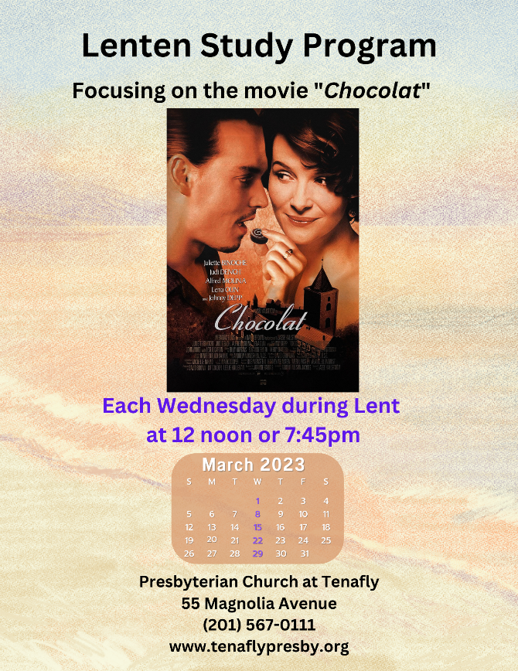
All Are Welcome . .

