The Presbyterian Church
at Tenafly

For Every Heart a Home
April 30, 2023 4th Sunday of Easter 10:30am

Liturgist: Carolyn Rocco Cantor: Gay Willis
Rev Dr Martin Ritchie

Welcome to worship! If you are visiting or here for the first time and would like to stay in touch with us, please consider filling in one of the contact cards that you will find alongside the hymnals. These can be placed in the offering plate or handed to an usher. Church School for children happens in the Church House during our worship service. Ask one of the ushers if you would like to take your child through to join in.

Prelude

Welcome and Announcements Liturgist

Minute for Mission Gillian Iappelli

Joys and Concerns Rev Dr Martin Ritchie

Call to Worship Liturgist
*Hymn 246 Christ is Alive!

Prayer of Approach and Confession (unison) Liturgist

Risen Lord, we sit before you now turning over the stories and images of Easter in our hearts. Through them, you continue to come amongst us in beautiful and incredible ways. You slip into our hearts unnoticed, you break into our minds all of a sudden. And sometimes you remain frustratingly absent. All of this is our Easter faith, a faith that is both presence and absence.

And in all of this, our lives go on. We live our own stories and bring them before you now. We trust that you already know them, but in a moment of quiet we intentionally name in our hearts the things that have been good and the things that have been difficult in recent days.

Silence…….

KYRIE ELEISON
Martin sings: Kyrie Eleison
Congregation & Cantor: Kyrie Eleison
Martin sings: Christe Eleison
Congregation & Cantor: Christe Eleison
Martin sings: Kyrie Eleison
Congregation & Cantor: Kyrie Eleison
Declaration of Forgiveness

The Lord’s Prayer

Choir Anthem On That Great, Great, Mornin’ by Mary McDonald

On that great, great mornin' when the stone was rolled away, on that resurrection mornin' Jesus rose to life that day. There the tomb was empty; they said, "Jesus is not here! He's alive!" Great mornin', hallelu, hallelu! On that great, great mornin', at the risin' of the sun, those who saw the tomb was empty knew the vict'ry had been won. "He's alive" Go, tell it" Jesus lives for evermore! Great mornin', hallelu, hallelu! Jesus is alive, yes, Jesus is alive! Hallelu, he's alive! Hallelu, he's alive. What a great day! Jesus is alive! What a great, great day! Jesus is alive! Yes, my Jesus is alive. Hallelujah, he's alive! On that great, mornin', he came to set us free; on that resurrection mornin', Jesus won the victory! Heaven's gates are opened, hallelujah, let us sing! He's alive, great mornin'; hallelujah, great mornin', on that great, great mornin', Jesus is alive!

First Reading Ezekiel 34:7-14 Liturgist
Therefore, you shepherds, hear the word of the Lord: As I live, says the Lord God, because my sheep have become a prey and my sheep have become food for all the wild animals, since there was no shepherd, and because my shepherds have not searched for my sheep, but the shepherds have fed themselves and have not fed my sheep, therefore, you shepherds, hear the word of the Lord: Thus says the Lord God: I am against the shepherds, and I will hold them accountable for my sheep and put a stop to their feeding the sheep; no longer shall the shepherds feed themselves. I will rescue my sheep from their mouths, so that they may not be food for them. For thus says the Lord God: I myself will search for my sheep and will sort them out. As shepherds sort out their flocks when they are among scattered sheep, so I will sort out my sheep. I will rescue them from all the places to which they have been scattered on a day of clouds and thick darkness. I will bring them out from the peoples and gather them from the countries and bring them into their own land, and I will feed them on the mountains of Israel, by the watercourses, and in all the inhabited parts of the land. I will feed them with good pasture, and the mountain heights of Israel shall be their pasture; there they shall lie down in good grazing land, and they shall feed on rich pasture on the mountains of Israel.

*Hymn (Psalm 23) The Lord’s My Shepherd

- The Lord’s my shepherd, I’ll not want. He makes me lie in pastures green.
He leads me by the still, still waters, His goodness restores my soul.
Refrain: And I will trust in You alone, and I will trust in You alone,
for Your endless mercy follows me, Your goodness will lead me home.

- He guides my ways in righteousness, and He anoints my head with oil, and my cup, it overflows with joy, I feast on His pure delights.
Refrain: And I will trust in You alone, and I will trust in You alone,
for Your endless mercy follows me, Your goodness will lead me home.

- And though I walk in the darkest path, I will not fear the evil one, for You are with me, and Your rod and staff are the comfort I need to know.
Refrain: And I will trust in You alone, and I will trust in You alone,
for Your endless mercy follows me, Your goodness will lead me home.

Second Reading John 10:1-10 Rev Dr Martin Ritchie
“Very truly, I tell you, anyone who does not enter the sheepfold by the gate but climbs in by another way is a thief and a bandit. The one who enters by the gate is the shepherd of the sheep. The gatekeeper opens the gate for him, and the sheep hear his voice. He calls his own sheep by name and leads them out. When he has brought out all his own, he goes ahead of them, and the sheep follow him because they know his voice. They will not follow a stranger, but they will run from him because they do not know the voice of strangers.” Jesus used this figure of speech with them, but they did not understand what he was saying to them. So again Jesus said to them, “Very truly, I tell you, I am the gate for the sheep. All who came before me are thieves and bandits, but the sheep did not listen to them. I am the gate. Whoever enters by me will be saved and will come in and go out and find pasture. The thief comes only to steal and kill and destroy. I came that they may have life and have it abundantly.

*Hymn 840 When Peace Like a River

Sermon Rev Dr Martin Ritchie

Sharing our Gifts The Lord is My Shepherd by Howard Goodall
Gay Willis, solo
Doxology
Prayer of Dedication

Prayers of Thanksgiving and Intercession during which we sing Goodness is Stronger than Evil [sung once at the beginning of the prayers, once during, and once at the end]

Goodness is stronger than evil;
Love is stronger than hate;
Light is stronger than darkness;
Life is stronger than death.
Victory is ours, victory is ours
Through him who loved us.

*Hymn 251 Christ Has Arisen, Alleluia!

*Charge, Benediction and Celtic Amen
Amen, Amen, Alleluia, Amen (x2)

Postlude

*Those who are able, please stand.

*****
Livestreaming of Worship. Today’s service is broadcast live online. You can watch the service again later via our website homepage if you wish to. Huge thanks to our entire technical team.

The flowers this morning are given to the glory of God in loving memory of Bill Kuhns
by his wife Joan and their family.

Please note that the church office will be closed on Monday, May 1st

Soup Squad is Back! Thank you to our volunteer soup makers so far! Could you help? We aim to have a stock of delicious and nourishing, home-made soup in our church freezer available to take to those in pastoral need. Contact the office if you could help now and again.

The book Genesis for Normal People is the focus for our next Bible Study series. We'll be looking at this accessible and stimulating book by local guy turned top Biblical Scholar, Pete Enns. You can readily order a copy online, but let the office know if you need help and we'll help! The series will also look at how the book Genesis and the Gospel of John have deep and rich connections between them. We meet on Wednesdays May 3rd, 10th and 17th at 12noon in the Church House. Bring along your lunch. It's also hoped to offer one condensed evening session for folks who can't make it during the day. Please let the office know if you are interested in a “Cliff-notes” evening session on Wednesday 31st of May so we can gauge viability.

Interfaith Study Event: Was the Forbidden Fruit an Apple? Temple Sinai invites members of local churches to come along to hear their visiting scholar, Dr Azzan Yadin-Israel of the Jewish Studies and Classics Departments at Rutgers University. Saturday May 6th at 12.00 noon to 2pm, including lunch. More details of the program will be available soon. Free to take part thanks to a donor from Temple Sinai. Please let the office know if you'd like to take part so that we can let the Synagogue know for catering purposes.

Benefit concert in support of Presbyterian Disaster Assistance’s work for the Turkey/Syria earthquake relief. Enjoy a beautiful concert of music for wind and piano quintet including works by Mozart and von Herzogenberg. Our Interim Director of Music Jim Millar performs with The Highwood Ensemble at 4pm on Sunday, May 7th in the sanctuary. Retiring collection.

Drive in movie! Saturday, May 20th from 4-6pm in the church house. A fun family outreach event for ages 3 years to 3rd grade along with parents and care takers. Build your own car (materials provided) then chill out with snacks and watch feature movie Thomas and Friends: Journey Beyond Sodor. Open to any families – feel free to invite friends.

International Dinner Saturday June 3rd from 6pm in the Church House. Save the date! Our Outreach Team are hosting this fun and tasty social event. We invite contributions of appetizers, entrees, or desserts connected to your cultural heritage – or just something that you like to cook. BYOB – this is an adult only event. Sign up in the Narthex to come along (guests are welcome).

Four Grammys and a Granpa! A beautiful concert with Jim Millar and stars young students from Tenafly who play in the grammy award-winning New York Youth Symphony Orchestra. Enjoy the ambience of the chapel for a program of string and piano quintet music. New date: Monday, June 19th at 7pm in the chapel.

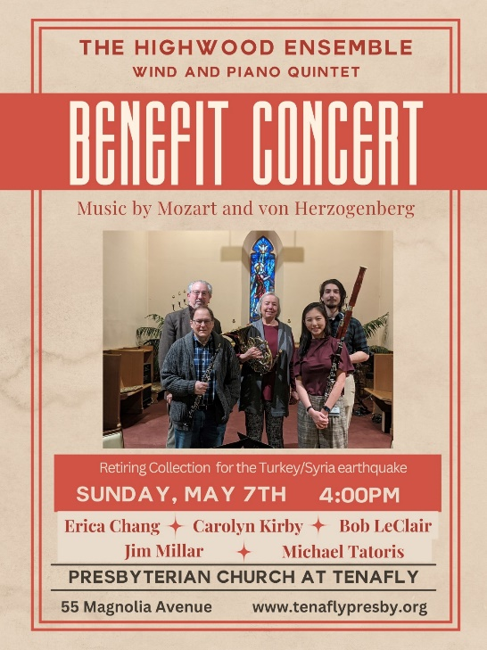

THE PRESBYTERIAN CHURCH AT TENAFLY
55 Magnolia Avenue, Tenafly, NJ 07670
Phone (201) 567-0111 / Fax (201) 567-0529
Emails : tenaflypresbyterianchurch@gmail.com
pastorpcat@gmail.com
Web page: www.tenaflypresby.org
Doodle away . . .
We all have different personalities, and we engage in worship in different ways.
This space is left for you to use in any way that you would like during the service.
You may like to write notes or you may wish to draw in response to how you hear God speaking. You can use the pencils which are in the pews or bring your own.
We are providing this space every week.

he Forb

