The Presbyterian Church
at Tenafly

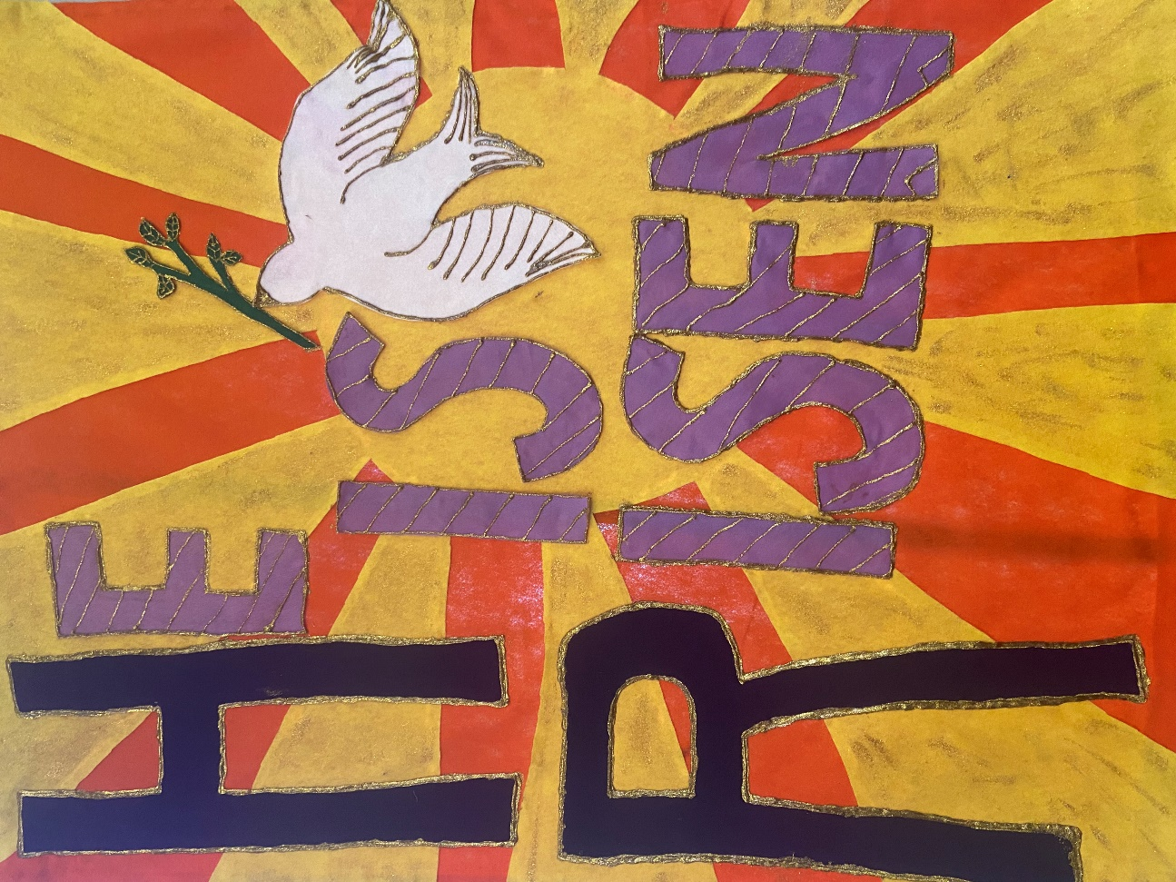

For Every Heart a Home

May 7, 2023 5th Sunday of Easter 10:30am
Sacrament of the Lord’s Supper

Liturgist: Gillian Iappelli Cantor: Nancy Smith
Rev Dr Martin Ritchie

Coffee Hour Host: Diane Allen

Welcome to worship! If you are visiting or here for the first time and would like to stay in touch with us, please consider filling in one of the contact cards that you will find alongside the hymnals. These can be placed in the offering plate or handed to an usher. Church School for children happens in the Church House during our worship service. Ask one of the ushers if you would like to take your child through to join in.

All are welcome at the Lord’s table. Today the bread and grape juice will be served together during the distribution. We use gluten free bread. Please wait to eat and drink together on the Pastor’s cue.

Prelude

Welcome and Announcements Liturgist

Joys and Concerns Rev Dr Martin Ritchie

Call to Worship

* Hymn Come People of the Risen King

Come, people of the Risen King, who delight to bring Him praise;
Come all, and tune your hearts to sing to the Morning Star of grace.
From the shifting shadows of the earth, we will lift our eyes to Him,
Where steady arms of mercy reach, to gather children in.

Rejoice, Rejoice!
Let every tongue rejoice!
One heart, one voice;
O Church of Christ, rejoice!
Come those whose joy is morning sun, and those weeping through the night;
Come, those who tell of battles won, and those struggling in the fight.
For His perfect love will never change, and His mercies never cease,
But follow us through all our days, with the certain hope of peace.

Rejoice, Rejoice!
Let every tongue rejoice!
One heart, one voice;
O Church of Christ, rejoice!

Come young and old from every land, men and women of the faith;
Come those with full or empty hands - find the riches of His grace.
Over all the world, His people sing - shore to shore we hear them call
The Truth that cries in every age, "Our God is all in all".

Rejoice, Rejoice!
Let every tongue rejoice!
One heart, one voice;
O Church of Christ, rejoice!

Prayer of Approach and Confession (unison) Liturgist

Risen Lord, we sit before you now turning over the stories and images of Easter in our hearts. Through them, you continue to come amongst us in beautiful and incredible ways. You slip into our hearts unnoticed, you break into our minds all of a sudden. And sometimes you remain frustratingly absent. All of this is our Easter faith, a faith that is both presence and absence.

And in all of this, our lives go on. We live our own stories and bring them before you now. We trust that you already know them, but in a moment of quiet we intentionally name in our hearts the things that have been good and the things that have been difficult in recent days.

Silence…….

KYRIE ELEISON
Martin sings: Kyrie Eleison
Congregation & Cantor: Kyrie Eleison
Martin sings: Christe Eleison
Congregation & Cantor: Christe Eleison
Martin sings: Kyrie Eleison
Congregation & Cantor: Kyrie Eleison

Declaration of Forgiveness

The Lord’s Prayer

Choir Anthem Laudamus Te, from Vivaldi Gloria
Laudamus te We praise You
Benedicimus te We bless You
Adoramus te We adore You
Glorificamus te We glorify You

First Reading Proverbs 4:10-18 Liturgist
Hear, my child, and accept my words, that the years of your life may be many.
I have taught you the way of wisdom; I have led you in the paths of uprightness.
When you walk, your step will not be hampered, and if you run, you will not stumble. Keep hold of instruction; do not let go; guard her, for she is your life.
Do not enter the path of the wicked, and do not walk in the way of evildoers.
Avoid it; do not go on it; turn away from it and pass on. For they cannot sleep unless they have done wrong; they are robbed of sleep unless they have made someone stumble. For they eat the bread of wickedness and drink the wine of violence.
But the path of the righteous is like the light of dawn, which shines brighter and brighter until full day.

* Hymn 274 You, Lord, Are Both Lamb and Shepherd

Second Reading John 14:1-14 Rev Dr Martin Ritchie
“Do not let your hearts be troubled. Believe in God; believe also in me. In my Father’s house there are many dwelling places. If it were not so, would I have told you that I go to prepare a place for you? And if I go and prepare a place for you, I will come again and will take you to myself, so that where I am, there you may be also. And you know the way to the place where I am going.” Thomas said to him, “Lord, we do not know where you are going. How can we know the way?” Jesus said to him, “I am the way and the truth and the life. No one comes to the Father except through me. If you know me, you will know my Father also. From now on you do know him and have seen him.”
Philip said to him, “Lord, show us the Father, and we will be satisfied.” Jesus said to him, “Have I been with you all this time, Philip, and you still do not know me? Whoever has seen me has seen the Father. How can you say, ‘Show us the Father’? Do you not believe that I am in the Father and the Father is in me? The words that I say to you I do not speak on my own, but the Father who dwells in me does his works. Believe me that I am in the Father and the Father is in me, but if you do not, then believe because of the works themselves. Very truly, I tell you, the one who believes in me will also do the works that I do and, in fact, will do greater works than these, because I am going to the Father. I will do whatever you ask in my name, so that the Father may be glorified in the Son. If in my name you ask me for anything, I will do it.

*Hymn 444 Forgive Our Sins as We Forgive

Sermon Rev Dr Martin Ritchie

Offering What Wondrous Love is This?
Nancy Smith, solo
Doxology
Prayer of Dedication

Sharing the Peace

Invitation to Communion

*Song We Are Coming, Lord, to the Table

We are coming, Lord, to the table. We are coming, Lord, to the table.
With the gift of bread, we are coming, Lord.
With the gift of wine, we are coming, Lord.

Oh, we are coming, Lord. Oh, we are coming, Lord.
Oh, we are coming, Lord. Oh, we are coming Lord.

We are coming, Lord, to the table. We are coming, Lord, to the table.
To receive the bread, we are coming, Lord.
To receive the wine, we are coming, Lord.

Oh, we are coming, Lord. Oh, we are coming, Lord.
Oh, we are coming, Lord. Oh, we are coming Lord.
(Remain Standing)

The Great Thanksgiving

The Lord be with you
And also with you
Lift up your hearts
We lift them to the Lord.
Let us give thanks to the Lord our God
It is right to give our thanks and praise.
Worship and praise belong to you, maker of light and darkness.
Your wisdom draws beauty from chaos, brings a harvest out of sorrow
and leads the exiles home.

In Christ your Son enemies are reconciled, debts forgiven and strangers made welcome. Your Spirit frees us to live as sons and daughters in our Father's house.

We who by Christ's power follow the way of the Cross, sharing the joy of his obedience, now offer you our praise, with angels and archangels
and the whole company of heaven saying the hymn of your unending glory:

Sanctus and Benedictus (unison)

Holy, Holy, Holy Lord, God of power and might. Heaven and earth are full of your glory, hosanna in the highest. Blessed is he who comes in the name of the Lord. Hosanna, in the highest.
(the congregation sits)

Telling the Story
Glory and thanksgiving be to you, most loving Father,
for Christ in whom the world is reconciled.
Lifted on the Cross, his suffering and forgiveness
spanned the gulf our sins had made.
Through that dark struggle death was swallowed up in victory,
that life and light might reign.

Before he was given up to suffering and death, recalling the night
of Israel's release, the night in which the sons of Egypt died,
your Chosen One, himself the First-Born, freely offered his life.
At supper with his disciples he took bread and offered you thanks.
He broke the bread, and gave it to them, saying:
"Take, eat. This is my Body: it is broken for you."
After supper, he took the cup, he offered you thanks, and gave it to them saying: "Drink this, all of you. This is my Blood of the new covenant;
it is poured out for you, and for all, that sins may be forgiven.
Do this in remembrance of me."
We now obey your Son's command.
We recall his blessed passion and death,
his glorious resurrection and ascension;
and we look for the coming of his Kingdom.
Made one with him, we offer you these gifts
and with them ourselves, a single, holy, living sacrifice.

Hear us, most merciful Father, and send your Holy Spirit upon us
and upon this bread and this wine,
that, overshadowed by your life-giving power,
they may be for us spiritual food and drink,
and we may be kindled with the fire of your love
and renewed for the service of your Kingdom.
Help us, who are baptized into the fellowship of Christ's Body
to live and work to your praise and glory;
may we grow together in unity and love
until at last, in your new creation,
we enter into our heritage in the company of the apostles,
and prophets, and of all our brothers and sisters living and departed.

Through Jesus Christ our Lord, with whom, and in whom,
in the unity of the Holy Spirit, all honour and glory be to you,
Lord of all ages, world without end.
Amen.

Agnus Dei
Jesus, Lamb of God
Have mercy on us
Jesus bearer of our sins
Have mercy upon us
Jesus redeemer of the world
Grant us your peace.

Sharing the Bread and Wine, during which we hear organ music for reflection
(The Elders will serve the bread (gluten free) and wine to you in your seats. Please wait to eat and drink all together.)

Post-Communion Prayer (Unison)

Father of all, we give you thanks and praise that when we were still far off you met us in your Son and brought us home. Dying and living, he declared your love, gave us grace, and opened the gate of glory. May we who share Christ's body live his risen life; we who drink his cup bring life to others; we whom the Spirit lights, give light to the world. Keep us firm in the hope you have set before us, so we and all your children shall be free, and the whole earth live to praise your name; through Christ our Lord. Amen.

*Hymn Bless the Lord

ALL: Bless the Lord,
Bless the Lord:
Bless the Lord, there is no other God.

Charge, Benediction and Celtic Amen
Amen, Amen, Alleluia, Amen (x2)

Postlude
*****
*Those who are able, please stand.

Livestreaming of Worship. Today’s service is broadcast live online. You can watch the service again later via our website homepage if you wish to. Huge thanks to our entire technical team.

The flowers this morning are given to the glory of God in celebration of Dr. Harry
Roselle’s birthday by his wife Joan and their family. Happy Birthday!

TONIGHT! Benefit concert in support of Presbyterian Disaster Assistance’s
work for the Turkey/Syria earthquake relief. Enjoy a beautiful concert of music
for wind and piano quintet including works by Mozart and von Herzogenberg. Our
Interim Director of Music Jim Millar performs with The Highwood Ensemble at 4pm
in the sanctuary. Retiring collection will be taken.
The book Genesis for Normal People is the focus for our next Bible Study series. We'll be looking at this accessible and stimulating book by local guy turned top Biblical Scholar, Pete Enns. You can readily order a copy online, but let the office know if you need help and we'll help! The series will also look at how the book Genesis and the Gospel of John have deep and rich connections between them. We meet on Wednesdays: May 10th and 17th at 12noon in the Church House. Bring along your lunch. It's also hoped to offer one condensed evening session for folks who can't make it during the day. Please let the office know if you are interested in a “Cliff-notes” evening session on Wednesday 31st of May so we can gauge viability.

Next Sunday for Mother’s Day we’ll take a collection in support of Church World Services “Blanket Sunday”. You’ll find enclosed an offering envelope if you so wish to make a donation. Please return them next Sunday.

Drive in movie! Saturday, May 20th from 4-6pm in the church house. A fun family outreach event for ages 3 years to 3rd grade along with parents and care takers. Build your own car (materials provided) then chill out with snacks and watch feature movie Thomas and Friends: Journey Beyond Sodor. Open to any families – feel free to invite friends. Please RSVP to the church office.

International Dinner Saturday June 3rd from 6pm in the Church House. Our Outreach Team are hosting this fun and tasty social event. We invite contributions of appetizers, entrees, or desserts connected to your cultural heritage – or just something that you like to cook. BYOB – this is an adult only event. Sign up in the Narthex to come along (guests are welcome).

Four Grammys and a Grampa! A beautiful concert of music for piano and strings by Brahms and Dvorak featuring Jim Millar and star young players from Tenafly who play in the grammy award-winning New York Youth Symphony Orchestra. Monday, June 19th at 7pm in the chapel.

PresbyReaders will meet again on July 9th at 4pm at the Shima’s home. We will be discussing North: A Novel by Brad Kessler. “In Brad Kessler's fine new novel, North...the seemingly disparate lives that converge on a snowy Vermont night—Sahro, a Somali refugee seeking asylum, and Father Christopher, the abbot of a mountain monastery—are woven together with intricate threads of home, flight, sanctuary, danger, hope, faith, storytelling and much more.”―Shelf Awareness

Doodle away . . .
We all have different personalities, and we engage in worship in different ways.
This space is left for you to use in any way that you would like during the service.
You may like to write notes or you may wish to draw in response to how you hear God speaking. You can use the pencils which are in the pews or bring your own.
We are providing this space every week.

THE PRESBYTERIAN CHURCH AT TENAFLY
55 Magnolia Avenue, Tenafly, NJ 07670
Phone (201) 567-0111 / Fax (201) 567-0529
Emails : tenaflypresbyterianchurch@gmail.com
pastorpcat@gmail.com
Web page: www.tenaflypresby.org

