The Presbyterian Church
at Tenafly
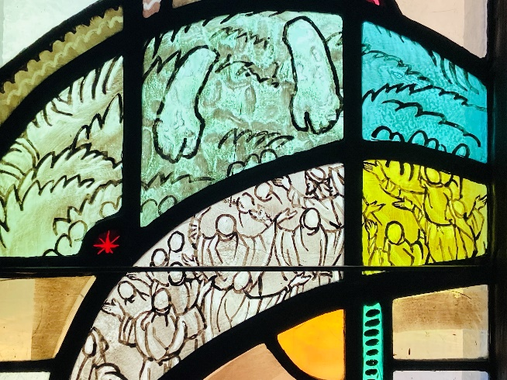
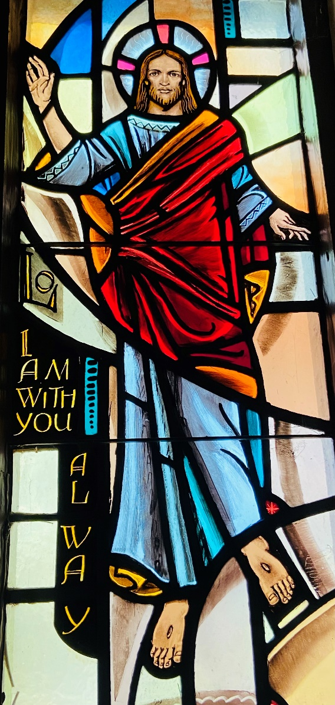

For Every Heart a Home
May 21, 2023 7th Sunday of Easter 10:30am

Liturgist: Mary Jane Eimer Rev Dr Martin Ritchie

Coffee Hour Host: Api Lee

Welcome to worship! If you are visiting or here for the first time and would like to stay in touch with us, please consider filling in one of the contact cards that you will find alongside the hymnals. These can be placed in the offering plate or handed to an usher. Church School for children happens during our worship service. Ask one of the ushers for directions if you would like to take your child through to join in.

Preludes Impromptu in G Flat by Schubert and Barcarolle by Ned Rorem

Welcome and Announcements Liturgist

Minute for Mission Tim Patryk

Joys and Concerns Rev Dr Martin Ritchie

Call to Worship
Liturgist: Jesus prayed for his disciples, giving them into God’s eternal care.
ALL: Jesus prays for us, giving us into God’s care.
Liturgist: Know that you have been blessed with the love of the Savior.
ALL: We live in that love and seek to serve God.
Liturgist: Open your hearts and spirits now to hear God’s word.
ALL: May our lives be open to God’s Spirit and reflect God’s love. AMEN.

* Song Come People of the Risen King

Come, people of the Risen King, who delight to bring Him praise;
Come all, and tune your hearts to sing to the Morning Star of grace.
From the shifting shadows of the earth, we will lift our eyes to Him,
Where steady arms of mercy reach, to gather children in.

Rejoice, Rejoice!
Let every tongue rejoice!
One heart, one voice;
O Church of Christ, rejoice!

Come those whose joy is morning sun, and those weeping through the night;
Come, those who tell of battles won, and those struggling in the fight.
For His perfect love will never change, and His mercies never cease,
But follow us through all our days, with the certain hope of peace.

Rejoice, Rejoice!
Let every tongue rejoice!
One heart, one voice;
O Church of Christ, rejoice!

Come young and old from every land, men and women of the faith;
Come those with full or empty hands - find the riches of His grace.
Over all the world, His people sing - shore to shore we hear them call
The Truth that cries in every age, "Our God is all in all".

Rejoice, Rejoice!
Let every tongue rejoice!
One heart, one voice;
O Church of Christ, rejoice!

Prayer of Approach and Confession (unison) Liturgist

God of all times and places. Draw us gently into a sense of your caring presence in this time of worship. You are our host, and we are the guests on this earth. Bring us to a sense of wonder that you are to be found in the smallest detail of the world, as well as the staggering vastness of the universe. When we try to discover you and explain you, we find that we cannot. You are all in all, the beginning and the end, our Alpha and Omega, the first and the last. You are beyond what we can imagine.

In humility we lay before you the details of our lives: the things that matter to us and which have been significant for us this week. We trust that you cherish it all. Our lives are a mixture of things that we are proud to share, and things of which we are not proud. In a moment of quiet, we bring it all to you.

Silence…….

KYRIE ELEISON
Martin sings: Kyrie Eleison
Congregation & Cantor: Kyrie Eleison
Martin sings: Christe Eleison
Congregation & Cantor: Christe Eleison
Martin sings: Kyrie Eleison
Congregation & Cantor: Kyrie Eleison

Declaration of Forgiveness

The Lord’s Prayer

Choir Anthem Jonah, by Rollo Dilworth
This is the story about Jonah, whose circumstances made for quite a tale. He was a man who had a great adventure, while caught up in the belly of a whale! Jonah, Jonah, in the belly of a whale! Jonah was a runnin, from the call of the Lord. So he finds a ship that’s sailin and he makes his way on board. But soon and very soon, the tempests come. The call of the Lord, he was hidin from, and a mighty whale was awaitin by. Jonah! Jonah! The Crew said “we must all do something fast before this boat sinks.” So they all drew lots and found that old Jonah was the jinks. Poor Jonah then confessed: “I know it’s me.” The crew of the ship threw him in the sea, and a mighty whale was awaitin by. Jonah! Jonah! And He was swallowed up by the whale, and given some time to think things over. Swallowed up by the whale and given some time to pray. He spent three days, three nights. Three days, three nights. Three days, three nights, then the whale set Jonah free! Jonah in the belly of a whale! Jonah!

First Reading Acts 1:6-14 Liturgist
So when they had come together, they asked him, “Lord, is this the time when you will restore the kingdom to Israel?” He replied, “It is not for you to know the times or periods that the Father has set by his own authority. But you will receive power when the Holy Spirit has come upon you, and you will be my witnesses in Jerusalem, in all Judea and Samaria, and to the ends of the earth.” When he had said this, as they were watching, he was lifted up, and a cloud took him out of their sight. While he was going and they were gazing up toward heaven, suddenly two men in white robes stood by them. They said, “Men of Galilee, why do you stand looking up toward heaven? This Jesus, who has been taken up from you into heaven, will come in the same way as you saw him go into heaven.” Then they returned to Jerusalem from the mount called Olivet, which is near Jerusalem, a Sabbath day’s journey away. When they had entered the city, they went to the room upstairs where they were staying: Peter, and John, and James, and Andrew, Philip and Thomas, Bartholomew and Matthew, James son of Alphaeus, and Simon the Zealot, and Judas son of James. All these were constantly devoting themselves to prayer, together with certain women, including Mary the mother of Jesus, as well as his brothers.

*Song (Psalm 68) Approach Our God with Songs of Praise

Approach our God with songs of praise,
the Lord, and light of all our days,
the hope of every nation;
from all who would our lives oppress,
God will redeem by righteousness,
and bless us with salvation.
Rejoice! God calms the raging sea;
from bondage brings us victory;
good news in ancient story!
By faith we know when ways confound,
God’s loving grace is all around;
come, now, proclaim God’s blessing!

We lift our voices, shout and sing.
Hail! The procession of our King;
the risen Lord still guides us.
The God of all in ages past,
who reigned before the world was cast,
still comes to dwell among us.
At God’s right hand the hosts rejoice;
earth joins the song in humbler voice,
God’s majesty professing;
strength and compassion, love and peace,
from God’s abundance never cease;
arise, and claim God’s blessing!

Second Reading John 17:1-11 Rev Dr Martin Ritchie
After Jesus had spoken these words, he looked up to heaven and said, “Father, the hour has come; glorify your Son so that the Son may glorify you, since you have given him authority over all people, to give eternal life to all whom you have given him. And this is eternal life, that they may know you, the only true God, and Jesus Christ, whom you have sent. I glorified you on earth by finishing the work that you gave me to do. So now, Father, glorify me in your own presence with the glory that I had in your presence before the world existed. “I have made your name known to those whom you gave me from the world. They were yours, and you gave them to me, and they have kept your word. Now they know that everything you have given me is from you, for the words that you gave to me I have given to them, and they have received them and know in truth that I came from you, and they have believed that you sent me. I am asking on their behalf; I am not asking on behalf of the world but on behalf of those whom you gave me, because they are yours. All mine are yours, and yours are mine, and I have been glorified in them. And now I am no longer in the world, but they are in the world, and I am coming to you. Holy Father, protect them in your name that you have given me, so that they may be one, as we are one.

*Song (Psalm 150) Sing Praise to the Lord, You People of Grace

Sing praise to the Lord, you people of grace; fill heaven with the songs that sound from this place; since you are God’s servants and meet in his name, his wonders declare and his glory proclaim.
Halle! Hallelujah! Halle! Halle! Hallelujah!
Halle! Hallelujah! Halle! Halle! Hallelujah!

His greatness exceeds what words can explain, and his is the power no force can restrain; with fanfares of horns and crescendos of strings raise anthems to honor the King of all kings.
Halle! Hallelujah! Halle! Halle! Hallelujah!
Halle! Hallelujah! Halle! Halle! Hallelujah!

Where music is made, let rhythms abound; let cymbals and drums add weight to the sound; with dance that is graceful and words that are clear, bring joy to the God you adore and revere.
Halle! Hallelujah! Halle! Halle! Hallelujah!
Halle! Hallelujah! Halle! Halle! Hallelujah!

Yield all that you are to worship the Lord - see life as a psalm, each moment a chord; let harmonies flourish and melodies soar - let all that has breath praise the Lord evermore.
Halle! Hallelujah! Halle! Halle! Hallelujah!
Halle! Hallelujah! Halle! Halle! Hallelujah!

Sermon Rev Dr Martin Ritchie

Sharing our Gifts during which we hear on piano, the second movement of
Ravel’s Sonatine, played by Jim Millar.
Doxology
Prayer of Dedication

Prayers of Thanksgiving and Intercession during which we sing Goodness is Stronger than Evil [sung once at the beginning of the prayers, once during, and once at the end]

Goodness is stronger than evil;
Love is stronger than hate;
Light is stronger than darkness;
Life is stronger than death.
Victory is ours, victory is ours
Through him who loved us.

*Hymn 733 We All Are One in Mission

*Charge, Benediction and Celtic Amen
Amen, Amen, Alleluia, Amen (x2)

Postlude Gigue Fugue by Dietrich Buxtehude

*Those who are able, please stand.

Livestreaming of Worship. Today’s service is broadcast live online. You can watch the service again later via our website homepage if you wish to. Huge thanks to our entire technical team.

On Wednesdays May 24th and 31st at 12 noon we’ll have two lunchtime study sessions looking at the Alvin Ailey American Dance Theater’s production called “Revelations”. It’s an iconic dance piece set to incredible African American spirituals such as “Wade in the Water” and “Didn’t my Lord Deliver Daniel”. We’ll hear and think about the songs themselves, take a look at some video of live performance, and then there’s the chance to attend a show at Brooklyn Academy of Music on Saturday June 10th at 2pm. We have a group booking of 15 tickets. You are welcome to join the group visit even if you have not been able to attend the lunch time sessions. Please let Pastor Martin know as soon as possible, if you’d like to go. Friends are welcome! Tickets are around $50 each.

Genesis for Normal People. We are offering a condensed session based upon our recent lunch time study series, for those who are unavailable during the day. It will take place on the evening of Wednesday May 31st at 7:30pm in the church house. Everyone is welcome!

International Dinner Saturday June 3rd from 6pm in the Church House. Our Outreach Team are hosting this fun and tasty social event. We invite contributions of appetizers, entrees, or desserts connected to your cultural heritage – or just something that you like to cook. BYOB – this is an adult only event. Sign up in the Narthex to come along (guests are welcome).

Tenafly 5K Outreach. On Sunday June 4th from 8:30am – 9:30am the mission team will be handing out water to the participants in the 5k run as they pass by. Could you help? Contact Mickey Sechrist.

Sunday June 4th. Please note that due to the 5k activity there will be no church school. However, we will provide child-care as usual. Children age 1st grade and upwards will be most welcome in the service that day – as always! Activity books will be available.

Four Grammys and a Grampa! A beautiful concert of music for piano and strings by Brahms and Dvorak featuring Jim Millar and star young players from Tenafly who play in the grammy award-winning New York Youth Symphony Orchestra. Monday, June 19th at 7pm in the chapel.

PresbyReaders will meet again on July 9th at 4pm at the Shima’s home. We will be discussing North: A Novel by Brad Kessler. “In Brad Kessler's fine new novel, North...the seemingly disparate lives that converge on a snowy Vermont night—Sahro, a Somali refugee seeking asylum, and Father Christopher, the abbot of a mountain monastery—are woven together with intricate threads of home, flight, sanctuary, danger, hope, faith, storytelling and much more.”―Shelf Awareness

THE PRESBYTERIAN CHURCH AT TENAFLY
55 Magnolia Avenue, Tenafly, NJ 07670
Phone (201) 567-0111 / Fax (201) 567-0529
Office Email : tenaflypresbyterianchurch@gmail.com
Pastor Martin’s email : pastorpcat@gmail.com
Cell # (551) 755-0950
Sherrie Reilley, Director of Children, Youth and Family Ministry
Email: Reilleysherrie@gmail.com

Web page: www.tenaflypresby.org

Looks for us on Facebook, Instagram, and Twitter
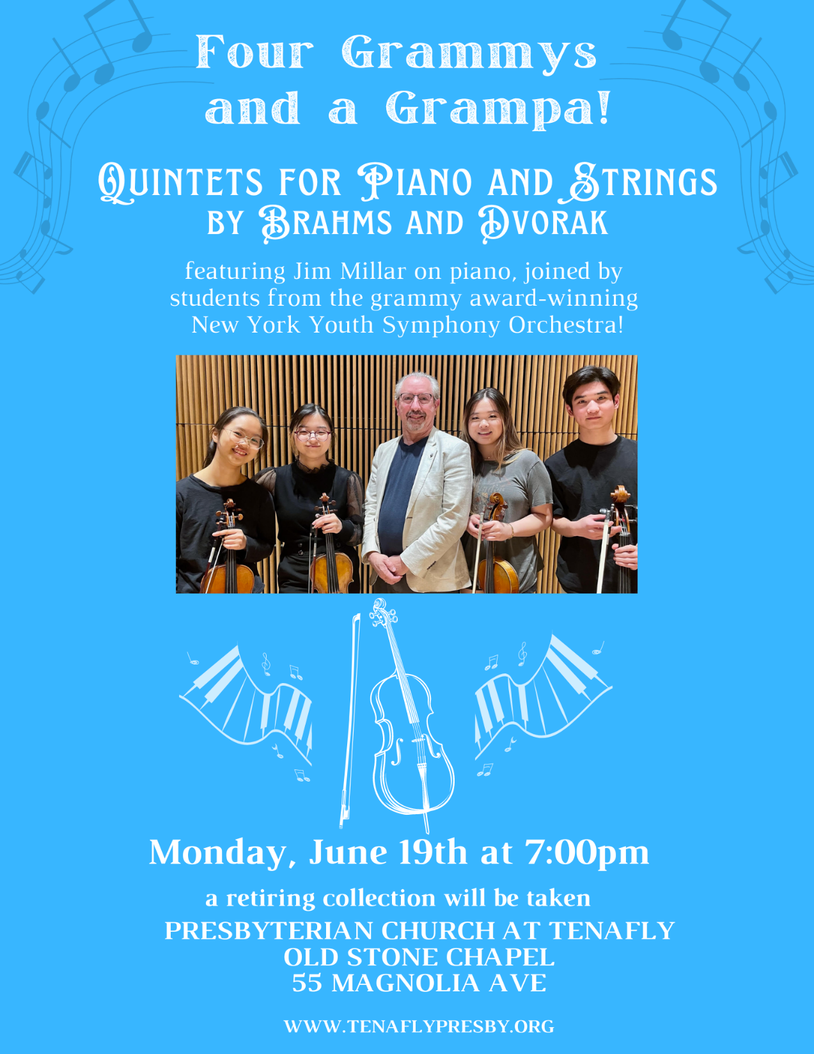
Doodle away . . .
We all have different personalities, and we engage in worship in different ways.
This space is left for you to use in any way that you would like during the service.
You may like to write notes or you may wish to draw in response to how you hear God speaking. You can use the pencils which are in the pews or bring your own.
We are providing this space every week.

Thanks for the care packages sent with love!

