The Presbyterian Church
at Tenafly

For Every Heart a Home
May 28, 2023 The Day of Pentecost 10:30am

Liturgist: Indiana Diaz Cantor: Ann Van Cleave
Rev Dr Martin Ritchie

Coffee Hour Host: Diane Allen

Welcome to worship! If you are visiting or here for the first time and would like to stay in touch with us, please consider filling in one of the contact cards that you will find alongside the hymnals or you can use this QR code. These can be placed in the offering plate or handed to an usher. Church School for children happens during our worship service. Ask one of the ushers for directions if you would like to take your child through to join in.

Preludes

Welcome and Announcements Liturgist

Chorale Prelude Komm, Gott Schӧpfer, Heiliger Geist,
(Come, Creator Spirit) by J.S. Bach, BWV631

Introit Anthem Come Holy Ghost, Our Souls Inspire

Call to Worship Rev Dr Martin Ritchie

* Processional Hymn Come, Holy Spirit, Come

Come, Holy Spirit, come!
Inflame our souls with love,
transforming every heart and home
with wisdom from above.
Let none of us despise
the humble path Christ trod,
but choose, to shame the worldly wise,
the foolishness of God.

Spirit of truth, arise;
inspire the prophet’s voice:
expose to scorn the tyrant’s lies,
and bid the poor rejoice.
O Spirit, clear our sight,
all prejudice remove,
and help us to discern the right,
and covet only love.

Come, Holy Spirit, dance
within our hearts today,
our earthbound spirits to entrance,
our mortal fears allay.
And teach us to desire,
all other things above,
that self-consuming holy fire,
the perfect gift of love.

Prayer of Approach and Confession Liturgist

KYRIE ELEISON
Martin sings: Kyrie Eleison
Congregation & Cantor: Kyrie Eleison
Martin sings: Christe Eleison
Congregation & Cantor: Christe Eleison
Martin sings: Kyrie Eleison
Congregation & Cantor: Kyrie Eleison

Declaration of Forgiveness

Choir Anthem Every Time I Feel the Spirit, traditional African American.

Every time I feel the Spirit moving in my heart I will pray.
Yes, ev’ry time I feel the Spirit moving in my heart I will pray.
Up on the mountain, my Lord spoke, out of His mouth came fire and smoke.
Yes, on that mountain, my Lord spoke, out of His mouth came fire and smoke.
All around me looked so fine, and I asked my Lord if all was mine. Yes, all
around me looked so fine, and I asked my Lord if all was mine.
Jordan river, chilly and cold, it chills the body but not the soul. Yes, Jordan
river, chilly and cold, it chills the body but not the soul.

First Reading Acts 2:1-21 Liturgist

When the day of Pentecost had come, they were all together in one place. And suddenly from heaven there came a sound like the rush of a violent wind, and it filled the entire house where they were sitting. Divided tongues, as of fire, appeared among them, and a tongue rested on each of them. All of them were filled with the Holy Spirit and began to speak in other languages, as the Spirit gave them ability. Now there were devout Jews from every people under heaven living in Jerusalem. And at this sound the crowd gathered and was bewildered, because each one heard them speaking in the native language of each. Amazed and astonished, they asked, “Are not all these who are speaking Galileans? And how is it that we hear, each of us, in our own native language? Parthians, Medes, Elamites, and residents of Mesopotamia, Judea and Cappadocia, Pontus and Asia, Phrygia and Pamphylia, Egypt and the parts of Libya belonging to Cyrene, and visitors from Rome, both Jews and proselytes, Cretans and Arabs—in our own languages we hear them speaking about God’s deeds of power.” All were amazed and perplexed, saying to one another, “What does this mean?” But others sneered and said, “They are filled with new wine.” But Peter, standing with the eleven, raised his voice and addressed them, “Fellow Jews and all who live in Jerusalem, let this be known to you, and listen to what I say. Indeed, these are not drunk, as you suppose, for it is only nine o’clock in the morning. No, this is what was spoken through the prophet Joel: ‘In the last days it will be, God declares, that I will pour out my Spirit upon all flesh, and your sons and your daughters shall prophesy, and your young men shall see visions, and your old men shall dream dreams. Even upon my slaves, both men and women, in those days I will pour out my Spirit, and they shall prophesy. And I will show portents in the heaven above and signs on the earth below, blood, and fire, and smoky mist. The sun shall be turned to darkness and the moon to blood, before the coming of the Lord’s great and glorious day. Then everyone who calls on the name of the Lord shall be saved.’

*Hymn 41 (Psalm 104) O Worship the King, All Glorious Above!

Second Reading John 7: 37-39 Rev Dr Martin Ritchie

On the last day of the festival, the great day, while Jesus was standing there, he cried out, “Let anyone who is thirsty come to me, and let the one who believes in me drink. As the scripture has said, ‘Out of the believer’s heart shall flow rivers of living water.’ ” Now he said this about the Spirit, which believers in him were to receive, for as yet there was no Spirit because Jesus was not yet glorified.

*Song Living Waters

Are you thirsty? Are you empty? Come and drink these living waters.
Tired and broken, peace unspoken, Come and drink these living waters.
Christ is calling, find refreshing at the cross of living waters.
Lay your life down, all the old gone, rise up in these living waters.

There’s a river that flows with mercy and love,
Bringing joy to the city of our God,
There our hope is secure, do not fear anymore,
Praise the Lord of living waters.

Spirit moving, mercy washing, healing in these living waters.
Lead your children to the shoreline, life is in these living waters.
Are you thirsty? Are you empty? Come and drink these living waters.
Love, forgiveness, vast and boundless, Christ, he is our living waters.

There’s a river that flows with mercy and love,
Bringing joy to the city of our God,
There our hope is secure, do not fear anymore,
Praise the Lord of living waters.

Sermon Rev Dr Martin Ritchie

Sharing our Gifts during which we hear the song, Holy Spirit, Living Breath of God
sung by Ann Van Cleave with Jim Millar, Piano and Bob Leclair, Oboe
Doxology
Prayer of Dedication

Prayers of Thanksgiving and Intercession

The Lord’s Prayer

*Hymn We Sing a Love That Sets All People Free

We sing a love that sets all people free,
That blows like wind, that burns like scorching flame,
Enfolds like earth, springs up like water clear:
Come, living love, live in our hearts today.

We sing a love that seeks another’s good,
That longs to serve and not to count the cost,
A love that, yielding, finds itself made new:
Come, caring love, live in our hearts today.

We sing a love, unflinching, unafraid
To be itself, despite another’s wrath,
A love that stands alone and undismayed:
Come, strengthening love, live in our hearts today.

We sing a love, that, wandering, will not rest
Until it finds its way, its home, its source,
Through joy and sadness pressing on refreshed:
Come, pilgrim love, live in our hearts today.

We sing a burning, fiery, Holy Ghost
That seeks out shades of ancient bitterness,
Transfiguring these, as Christ in every heart:
Come joyful love, live in our hearts today.

*Charge, Benediction and Celtic Amen
Amen, Amen, Alleluia, Amen (x2)

Postlude

*Those who are able, please stand.

Livestreaming of Worship. Today’s service is broadcast live online. You can watch the service again later via our website homepage if you wish to. Huge thanks to our entire technical team.

The flowers this morning on the eve of Memorial Day, are given by Mickey Sechrist to the glory of God and to honor and remember those who served to protect our country.

Wednesday May 31st and June 7th at 12 noon we’ll have our lunchtime study session looking at the Alvin Ailey American Dance Theater’s production called “Revelations”. It’s an iconic dance piece set to incredible African American spirituals such as “Wade in the Water” and “Didn’t my Lord Deliver Daniel”. We’ll hear and think about the songs themselves, take a look at some video of live performance, and then there’s the chance to attend a show at Brooklyn Academy of Music on Saturday June 10th at 2pm. We have a group booking of 15 tickets. You are welcome to join the group visit even if you have not been able to attend the lunch time sessions. Please let Pastor Martin know as soon as possible, if you’d like to go. Friends are welcome! Tickets are around $50 each.

Genesis for Normal People. We are offering a single condensed evening session based upon our recent lunch time study series, for those who are unavailable during the day. It will take place on the evening of Wednesday May 31st at 7:30pm in the church house. Everyone is welcome!

International Dinner Saturday June 3rd from 6pm in the Church House. Our Outreach Team are hosting this fun and tasty social event. We invite contributions of appetizers, entrees, or desserts connected to your cultural heritage – or just something that you like to cook. BYOB – this is an adult only event. Sign up in the Narthex to come along (guests are welcome).

Tenafly 5K Outreach. On Sunday June 4th from 8:30am – 9:45am the mission team will be handing out water to the participants in the 5k run as they pass by. Could you help? Contact Mickey Sechrist – there is a sign up sheet in the Narthex.

Sunday June 4th. Please note that due to the 5k outreach activity there will be no Church School. However, we will provide child-care as usual. Children aged 1st grade and upwards will be most welcome in the service that day – as always! Activity books will be available.

Deacons’ Strawberry Festival - Join us on Sunday June 18th following worship for strawberries and ice cream on the front lawn as we celebrate the beginning of summer season!
Four Grammys and a Grampa! A beautiful concert of music for piano and strings by Brahms and Dvorak featuring Jim Millar and star young players from Tenafly who play in the grammy award-winning New York Youth Symphony Orchestra. Monday, June 19th at 7pm in the chapel.

PresbyReaders will meet again on July 9th at 4pm at the Shima’s home. We will be discussing North: A Novel by Brad Kessler. “In Brad Kessler's fine new novel, North...the seemingly disparate lives that converge on a snowy Vermont night—Sahro, a Somali refugee seeking asylum, and Father Christopher, the abbot of a mountain monastery—are woven together with intricate threads of home, flight, sanctuary, danger, hope, faith, storytelling and much more.”―Shelf Awareness

THE PRESBYTERIAN CHURCH AT TENAFLY
55 Magnolia Avenue, Tenafly, NJ 07670
Phone (201) 567-0111 / Fax (201) 567-0529
Office Email : tenaflypresbyterianchurch@gmail.com
Pastor Martin’s email : pastorpcat@gmail.com
Pastor’s Cell # (551) 755-0950
Sherrie Reilley, Director of Children, Youth and Family Ministry
Email: Reilleysherrie@gmail.com
Web page: www.tenaflypresby.org

Look for us on Facebook, Instagram, and Twitter
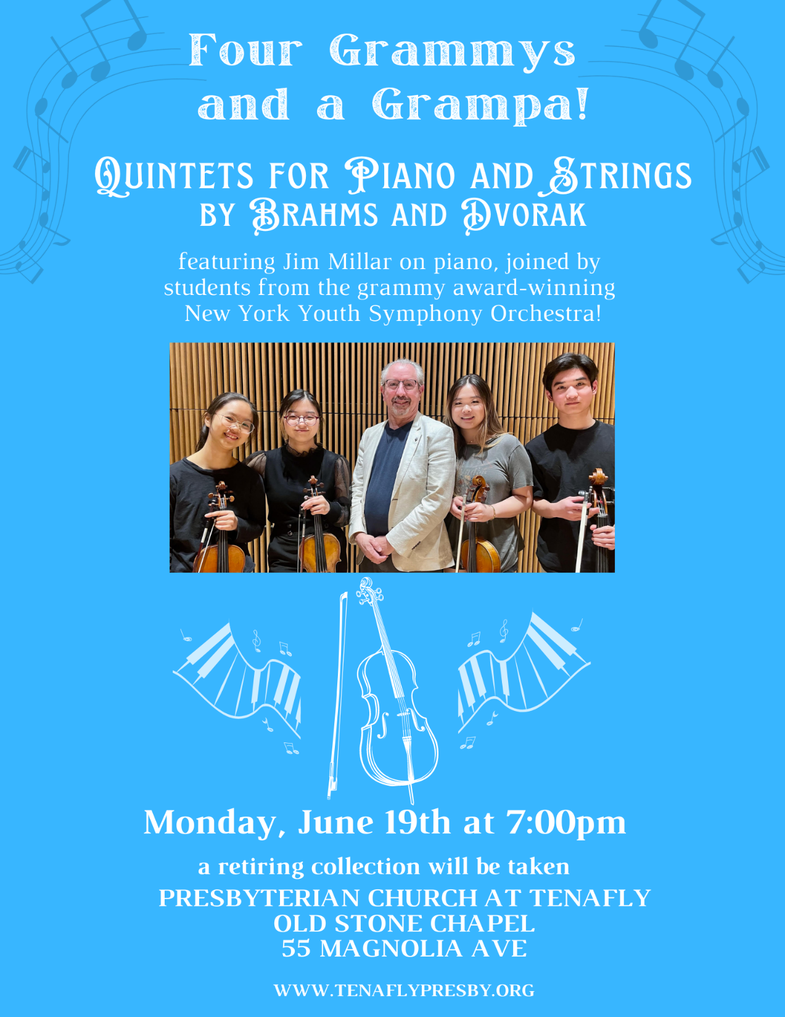
Doodle away . . .
We all have different personalities, and we engage in worship in different ways.
This space is left for you to use in any way that you would like during the service.
You may like to write notes or you may wish to draw in response to how you hear God speaking. You can use the pencils which are in the pews or bring your own.
We are providing this space every week.

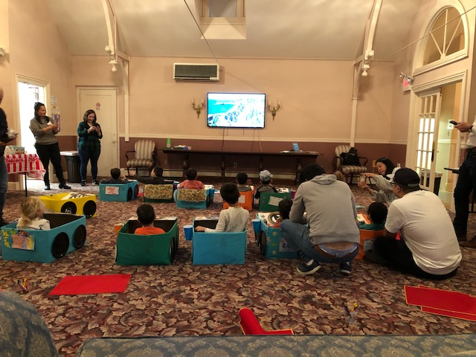
“DRIVE IN” MOVIE NIGHT!

