**The Presbyterian Church**

**at Tenafly**

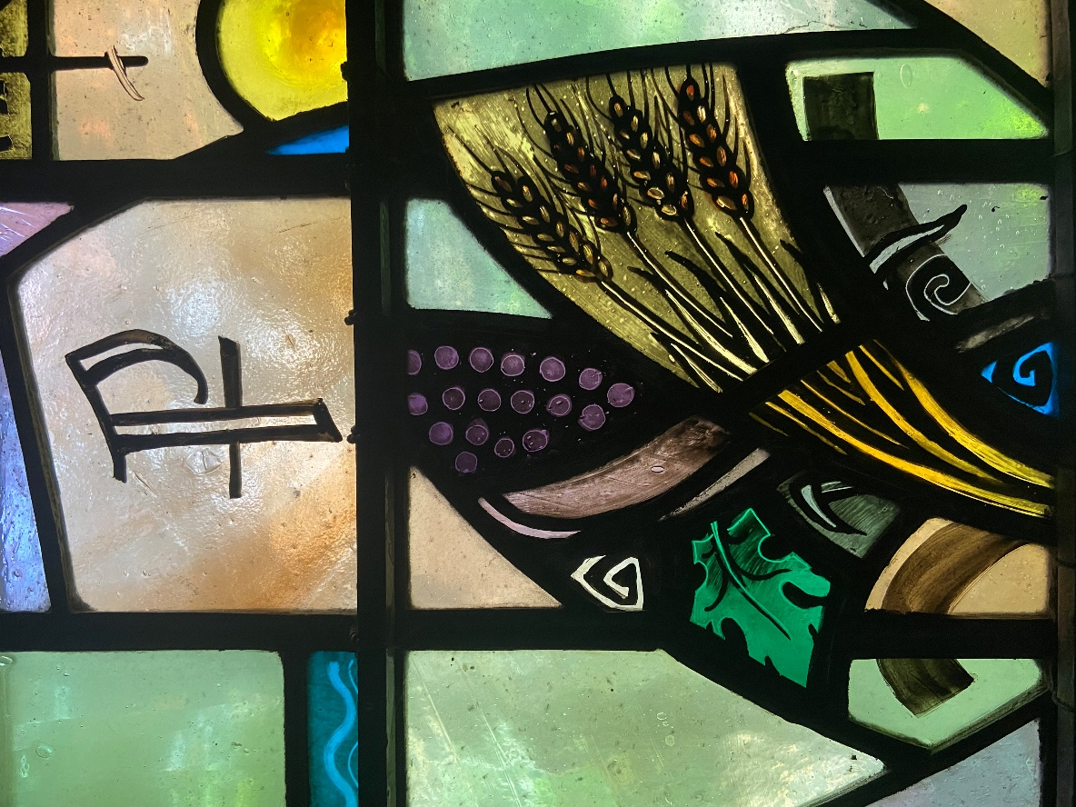

***For Every Heart a Home***

**June 4, 2023 Trinity Sunday 10:30am**

**Sacrament of the Lord’s Supper**

**Liturgist: Marilyn Coats-Thomas Rev Dr Martin Ritchie**

**Coffee Hour Host:** **Christina Chan**

*Welcome to worship! If you are visiting or here for the first time and would like to stay in touch with us, please consider filling in one of the contact cards that you will find alongside the hymnals or you can use this QR code. These can be placed in the offering plate or handed to an usher. Child-care is available as usual, but there is no Church School for older children today. Children are welcome in the service as always and activity books are available for them in the narthex. Please ask an usher.*

*All are welcome at the Lord’s table. The gluten free bread and grape juice will be served together during the distribution. Please wait to eat and drink together on the Pastor’s cue. He will say “the body of Christ”, then we eat. “The blood of Christ”, and then we drink.*

**Prelude**

**Processional Call to Worship: Hymn #388** *Come All You People*

Come all you people,  
come and praise your Maker;  
come all you people,  
come and praise your Maker;  
come all you people,  
come and praise your Maker;  
come now and worship the Lord. (repeated many times!)

**Welcome and Announcements**  Liturgist

**Joys & Concerns** Rev Dr Martin Ritchie

**Bell Choir** *My Heart Ever Faithful*

**Prayer of Approach and Confession (unison)** Liturgist

**God of our beginnings and our endings, and all that lies between. You are more than what we can know and understand. Yet we trust that you encircle us with your love. Be open to us now as we bring the details of our lives before you.**

**There are times when we have wandered from your paths of love and care. There are times when our communities and nation have also chosen paths that do not honor your hopes for us and the world.**

**Silence…….**

**KYRIE ELEISON**

**Martin sings:** Kyrie Eleison

**Congregation & Cantor:** Kyrie Eleison

**Martin sings:** Christe Eleison

**Congregation & Cantor:** Christe Eleison

**Martin sings:** Kyrie Eleison

**Congregation & Cantor:** Kyrie Eleison

**Declaration of Forgiveness**

**The Lord’s Prayer**

**Choir Anthem** *For the Beauty of the Earth*

musicby John Rutter, words by F.S. Pierpoint

*For the beauty of the earth, for the beauty of the skies, for the love which from our birth, over and around us lies, over and around us lies. Lord of all, to thee we raise, this our joyful hymn of praise. For the beauty of each hour, of the day and of the night, hill and vale and tree and flower, sun and moon and stars of light: sun and moon and stars of light. For the joy of human love, brother, sister, parent, child, friends on earth, and friends above, for all gentle thoughts and mild, for all gentle thoughts and mild. For each perfect gift of thine, to our race so freely given, graces human and divine, flow’rs of earth and buds of heav’n. Lord of all, to thee we raise, This our joyful hymn of praise.*

**Reading** Genesis 1:1-2:4a

When God began to create the heavens and the earth, the earth was complete chaos, and darkness covered the face of the deep, while a wind from God swept over the face of the waters. Then God said, “Let there be light,” and there was light. And God saw that the light was good, and God separated the light from the darkness. God called the light Day, and the darkness he called Night. And there was evening and there was morning, the first day.

And God said, “Let there be a dome in the midst of the waters, and let it separate the waters from the waters.” So God made the dome and separated the waters that were under the dome from the waters that were above the dome. And it was so. God called the dome Sky. And there was evening and there was morning, the second day.

And God said, “Let the waters under the sky be gathered together into one place, and let the dry land appear.” And it was so. God called the dry land Earth, and the waters that were gathered together he called Seas. And God saw that it was good. Then God said, “Let the earth put forth vegetation: plants yielding seed and fruit trees of every kind on earth that bear fruit with the seed in it.” And it was so. The earth brought forth vegetation: plants yielding seed of every kind and trees of every kind bearing fruit with the seed in it. And God saw that it was good. And there was evening and there was morning, the third day.

And God said, “Let there be lights in the dome of the sky to separate the day from the night, and let them be for signs and for seasons and for days and years, and let them be lights in the dome of the sky to give light upon the earth.” And it was so. God made the two great lights—the greater light to rule the day and the lesser light to rule the night—and the stars. God set them in the dome of the sky to give light upon the earth, to rule over the day and over the night, and to separate the light from the darkness. And God saw that it was good. And there was evening and there was morning, the fourth day.

And God said, “Let the waters bring forth swarms of living creatures, and let birds fly above the earth across the dome of the sky.” So God created the great sea monsters and every living creature that moves, of every kind, with which the waters swarm and every winged bird of every kind. And God saw that it was good. God blessed them, saying, “Be fruitful and multiply and fill the waters in the seas, and let birds multiply on the earth.” And there was evening and there was morning, the fifth day.

And God said, “Let the earth bring forth living creatures of every kind: cattle and creeping things and wild animals of the earth of every kind.” And it was so. God made the wild animals of the earth of every kind and the cattle of every kind and everything that creeps upon the ground of every kind. And God saw that it was good.

Then God said, “Let us make humans in our image, according to our likeness, and let them have dominion over the fish of the sea and over the birds of the air and over the cattle and over all the wild animals of the earth and over every creeping thing that creeps upon the earth.” So God created humans in his image, in the image of God he created them; male and female he created them.

God blessed them, and God said to them, “Be fruitful and multiply and fill the earth and subdue it and have dominion over the fish of the sea and over the birds of the air and over every living thing that moves upon the earth.” God said, “See, I have given you every plant yielding seed that is upon the face of all the earth and every tree with seed in its fruit; you shall have them for food. And to every beast of the earth and to every bird of the air and to everything that creeps on the earth, everything that has the breath of life, I have given every green plant for food.” And it was so. God saw everything that he had made, and indeed, it was very good. And there was evening and there was morning, the sixth day.

Thus the heavens and the earth were finished and all their multitude. On the sixth day God finished the work that he had done, and he rested on the seventh day from all the work that he had done. So God blessed the seventh day and hallowed it, because on it God rested from all the work that he had done in creation.

These are the generations of the heavens and the earth when they were created.

**\* Hymn #15 v.1-3** *All Creatures of our God and King*

**Sermon**  Rev Dr Martin Ritchie

**Offering** during which we hear the bell choir play *Simple Gifts*

**Doxology**

**Prayer of Dedication**

**Sharing the Peace and Welcome New Members**

**Invitation to Communion**

**\*Song**  *We Are Coming, Lord, to the Table*

We are coming, Lord, to the table. We are coming, Lord, to the table.

With the gift of bread, we are coming, Lord.

With the gift of wine, we are coming, Lord.

Oh, we are coming, Lord. Oh, we are coming, Lord.

Oh, we are coming, Lord. Oh, we are coming Lord.

We are coming, Lord, to the table. We are coming, Lord, to the table.

To receive the bread, we are coming, Lord.

To receive the wine, we are coming, Lord.

Oh, we are coming, Lord. Oh, we are coming, Lord.

Oh, we are coming, Lord. Oh, we are coming Lord.

(*Remain Standing*)

**The Great Thanksgiving**

The Lord be with you

**And also with you**

Lift up your hearts

**We lift them to the Lord.**

Let us give thanks to the Lord our God

**It is right to give our thanks and praise.**

Worship and praise belong to you, maker of light and darkness.

Your wisdom draws beauty from chaos, brings a harvest out of sorrow

and leads the exiles home.

In Christ your Son enemies are reconciled, debts forgiven and strangers made welcome. Your Spirit frees us to live as sons and daughters in our Father's house.

We who by Christ's power follow the way of the Cross, sharing the joy of his obedience, now offer you our praise, with angels and archangels

and the whole company of heaven saying the hymn of your unending glory:

**Sanctus and Benedictus (unison)**

**Holy, Holy, Holy Lord, God of power and might. Heaven and earth are full of your glory, hosanna in the highest. Blessed is he who comes in the name of the Lord. Hosanna, in the highest.**

(the congregation sits)

**Telling the Story**

Glory and thanksgiving be to you, most loving Father,

for Christ in whom the world is reconciled.

Lifted on the Cross, his suffering and forgiveness

spanned the gulf our sins had made.

Through that dark struggle death was swallowed up in victory,

that life and light might reign.

Before he was given up to suffering and death, recalling the night

of Israel's release, the night in which the sons of Egypt died,

your Chosen One, himself the First-Born, freely offered his life.

At supper with his disciples he took bread and offered you thanks.

He broke the bread, and gave it to them, saying:

"Take, eat. This is my Body: it is broken for you."

After supper, he took the cup, he offered you thanks, and gave it to them saying: "Drink this, all of you. This is my Blood of the new covenant;

it is poured out for you, and for all, that sins may be forgiven.

Do this in remembrance of me."

We now obey your Son's command.

We recall his blessed passion and death,

his glorious resurrection and ascension;

and we look for the coming of his Kingdom.

Made one with him, we offer you these gifts

and with them ourselves, a single, holy, living sacrifice.

**(unison)** **Hear us, most merciful Father,**

**and send your Holy Spirit upon us**

**and upon this bread and this wine,**

**that, overshadowed by your life-giving power,**

**they may be for us spiritual food and drink,**

**and we may be kindled with the fire of your love**

**and renewed for the service of your Kingdom.**

**Help us, who are baptized into the fellowship of Christ's Body**

**to live and work to your praise and glory;**

**may we grow together in unity and love**

**until at last, in your new creation,**

**we enter into our heritage in the company of the apostles,**

**and prophets, and of all our brothers and sisters**

**living and departed.**

(Pastor) Through Jesus Christ our Lord, with whom, and in whom,

in the unity of the Holy Spirit, all honour and glory be to you,

Lord of all ages, world without end.

Amen.

**Agnus Dei**

Jesus, Lamb of God

**Have mercy on us**

Jesus bearer of our sins

**Have mercy upon us**

Jesus redeemer of the world

**Grant us your peace.**

**Sharing the Bread and Wine, during which we hear organ music for reflection**

(The Elders will serve the bread and wine to you in your seats. Please wait to eat and drink all together.)

**Post-Communion Prayer (Unison)**

**Father of all, we give you thanks and praise that when we were still far off you met us in your Son and brought us home. Dying and living, he declared your love, gave us grace, and opened the gate of glory. May we who share Christ's body live his risen life; we who drink his cup bring life to others; we whom the Spirit lights, give light to the world. Keep us firm in the hope you have set before us, so we and all your children shall be free, and the whole earth live to praise your name; through Christ our Lord. Amen.**

**\*Hymn** (Psalm 103) *Praise God My Soul*

**Charge, Benediction and Celtic Amen**

***Amen, Amen, Alleluia, Amen (x2)***

**Postlude**

*****

**\*Those who are able, please stand.**

**Livestreaming of Worship.** Today’s service is broadcast live online. You can watch the service again later via our website homepage if you wish to. Huge thanks to our entire technical team.

**Deacons’ Strawberry Festival -** Join us on Sunday June 18th following our Intergenerational worship for strawberries and ice cream on the front lawn as we celebrate the beginning of summer season!

**Four Grammys and a Grampa!** A beautiful concert of music for piano and strings by Brahms and Dvorak featuring Jim Millar and star young players from Tenafly who play in the grammy award-winning New York Youth Symphony Orchestra.  **Monday, June 19th at 7pm in the chapel**.

**PresbyReaders** will meet again on July 9th at 4pm at the Shima’s home. We will be discussing *North: A Novel* by Brad Kessler. “In Brad Kessler's fine new novel, *North*...the seemingly disparate lives that converge on a snowy Vermont night—Sahro, a Somali refugee seeking asylum, and Father Christopher, the abbot of a mountain monastery—are woven together with intricate threads of home, flight, sanctuary, danger, hope, faith, storytelling and much more.”―***Shelf Awareness***

**Summer Worship** pattern begins on July 2nd when our service will begin at 10am.

**THE PRESBYTERIAN CHURCH AT TENAFLY**

55 Magnolia Avenue, Tenafly, NJ 07670

Phone (201) 567-0111 / Fax (201) 567-0529

Office Email : [tenaflypresbyterianchurch@gmail.com](mailto:tenaflypresbyterianchurch@gmail.com)

Pastor Martin’s email : [pastorpcat@gmail.com](mailto:pastorpcat@gmail.com)

Pastor’s Cell # (551) 755-0950

Sherrie Reilley, Director of Children, Youth and Family Ministry

Email: [Reilleysherrie@gmail.com](mailto:Reilleysherrie@gmail.com)

Web page: [www.tenaflypresby.org](http://www.tenaflypresby.org)

Look for us on Facebook, Instagram, and Twitter



Doodle away . . .

We all have different personalities, and we engage in worship in different ways.

This space is left for you to use in any way that you would like during the service.

You may like to write notes or you may wish to draw in response to how you hear God speaking. You can use the pencils which are in the pews or bring your own.

We are providing this space every week.