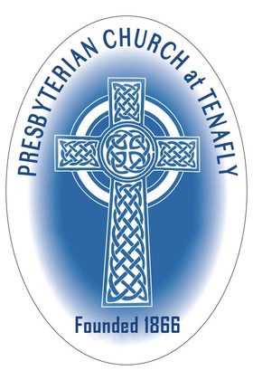

**PRESBYTERIAN CHURCH AT TENAFLY, NEW JERSEY**

**Choir Section Leaders**

The Presbyterian Church at Tenafly (PCUSA) is looking to recruit alto and tenor section leaders to join our existing soprano and bass section leaders during the session September 2022 – June 2023.

Our vision is to use our choral music programme to deepen and enrich our blended worship, and to extend outreach through participation in the voluntary choir. Led by our experienced Director of Music, Anna Lim, the choir works across a range of styles *a cappella* and with piano, organ and other instrumental accompaniment. We encourage applications from adventurous singers comfortable working with quality music from different periods.

The Presbyterian Church at Tenafly is a beautiful suburban church situated in the north of Bergen County, only a few miles from New York City across the Hudson River and George Washington Bridge. The diverse congregation is enriched by the presence of an unusual number of members who work in the creative arts sector. This has led us to place creativity and the arts at the centre of our congregational life.



*Music in Preparation on Easter Day 2022*

The section leaders are the core of the choir and work with the Director of Music and volunteer singers over 40 weeks starting on the second Sunday in September and through the second Sunday in June. Additionally, the section leaders are expected to sing at evening services on the special church calendar days of Ash Wednesday (beginning of Lent in the Spring), Maundy Thursday (Thursday before Easter), on Christmas Eve, and other special services for which additional payment is made. There are additional rehearsals periodically, for which there is additional payment. There is no regular midweek rehearsal, but the choir meets to rehearse every Sunday at 9am prior to the 10.30am Sunday worship service.

The pay is $160 per week for 40 weeks, with additional payments for the special services and rehearsals as required.

Participation in events and services such as weddings and funerals attracts an additional fee, which is currently $175.



If you are interested in discussing the section leader opportunities, then please contact the church office as soon as possible in the first instance. Letters of application should be marked “Choir Section Leader Post”, including a resume of training and experience.

Email: [tenaflypresbyterianchurch@gmail.com](mailto:tenaflypresbyterianchurch@gmail.com)

Phone: 201 567 0111

Church address: 55 Magnolia Avenue, Tenafly, New Jersey, 07670.

Our Director of Music is Anna Lim

Our office manager is Nancy Benell

Our pastor is Rev Dr Martin Ritchie