The
Presbyterian Church
at Tenafly
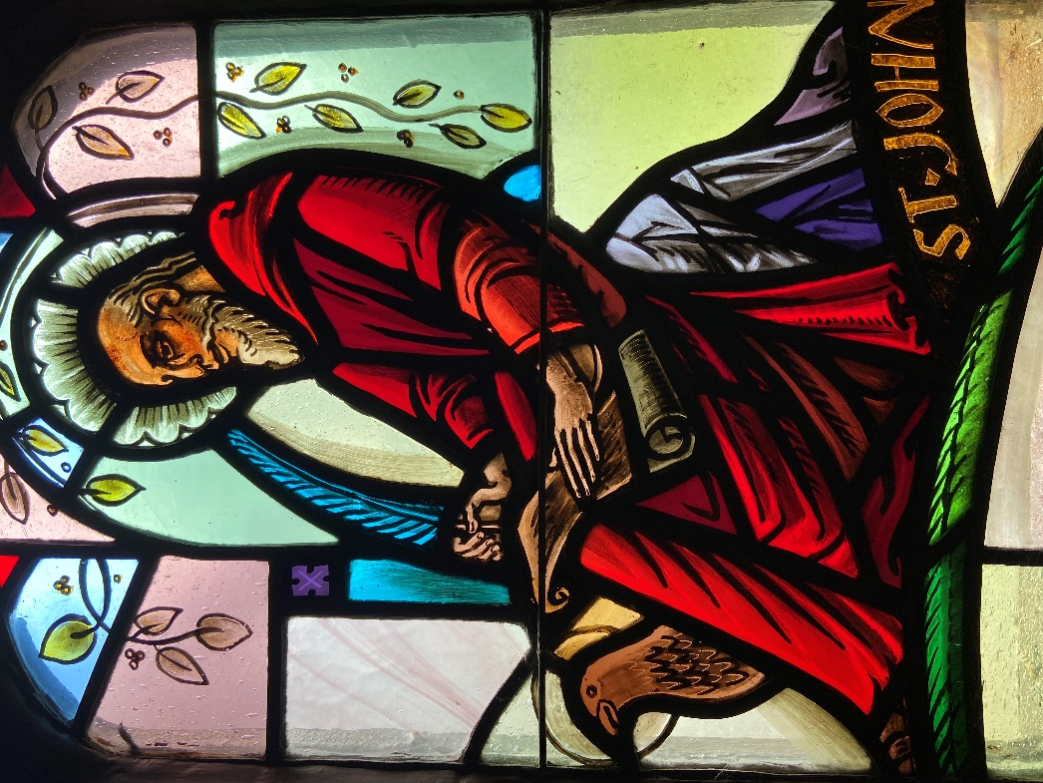
John the Evangelist, by Lamb Studios in PCAT Chapel

OUR PURPOSE
We are here to continue Christ’s work, inviting people to personally experience God and be transformed into followers of Christ,
reaching out in love and compassion to a world in need.
May 15, 2022 The Fifth Sunday of Easter 10:30am
Liturgist: Carolyn Rocco Cantor: Carroll VanCleave
Preacher: Nicola Whyte
Organ Prelude

Gathering Music A New Hallelujah

Welcome and Announcements Carolyn Rocco

MINUTE FOR MISSION Al Rocco

Call to Worship Carolyn Rocco
Leader: In a world of ‘us and them'
All: God commands us to love
Leader: In a Church too often characterized by division
All: God commands us to love
Leader: In our lives, full of petty grudges and neglected relationships
All: God commands us to love
Leader: So come, beloved ones, let us learn again how to love as God loves us
All: Let us worship the loving God!

*Hymn Be Thou My Vision

Prayer of Confession (unison) Carolyn Rocco
Loving and gracious God, in whom we live and move and have our being,
in whom we are made new, we come before you this morning to confess.
We have not loved you with our whole heart. We have not loved our neighbors as ourselves, we have not loved your good creation.
For all that we have done that is unloving, for all loving things that we have left undone, we are truly sorry, and we humbly repent.

ASSURANCE OF PARDON
Beloved children of God, hear and believe the Good News:
In Jesus Christ, we are forgiven.

CHOIR ANTHEM Holy, Holy, Holy F. Schubert/P. Liebergen

First Reading Leviticus 19:9-18 Carolyn Rocco
*HYMN Lift Up Your Gates Eternal (Psalm 24) 364

Second Reading John 13:31-35 Nicola Whyte

*HYMN Jesu, Jesu, Fill Us With Your Love 203

Sermon Nicola Whyte

Sharing our Gifts
Solo: Get Together
Carroll Van Cleave
Doxology
Prayer of Dedication
Generous God, all that we have is given by you: the gift of life, the gift of love,
the gifts of creation in which we share. Accept these our offerings, and all that they represent: the offerings of our time, of our talents, of our hopes and our dreams
that they may be used to your glory, and in the sharing of your great love.
Amen.

Prayers of the people during which we sing HYMN 205 Ubi caritas et amor
(where charity and love is, God is there) Rev Dr Martin Ritchie

The Lord’s Prayer Rev Dr Martin Ritchie

*Hymn of Dedication Christ Has Risen While Earth Slumbers

Charge and Benediction Nicola Whyte
with
SUNG AMEN
Amen, Amen, Alleluia, Amen
Amen, Amen, Alleluia, Amen

Postlude

****

*Those who are able, please stand.

We welcome Nicola Whyte who is a doctoral candidate at Princeton Theological Seminary.

Covid is still with us and we would like to remind you that masks are required at all times. Please give each other enough space. Also, we are cracking open windows to keep the airflow going. Please don’t close the windows during worship, but feel free to move to another spot if it’s uncomfortable.

Easter Reflection - Everyone is welcome to our Easter season event White and Gold, Reflections on Easter this Thursday, May 19th at 7:30pm in the chapel.
We have recorded reflections, memories, experiences and thoughts on Easter in our lives in the past and today. Expect a beautiful hour with candlelight and reflective recorded music.

Presby Readers - Our next meeting will be Sunday, June 5 at 4:00 p.m. Zoom vs. in-person has not yet been determined. We will be discussing Dear Edward by Ann Napolitano. “A surprisingly uplifting story, full of hope and dry humor, with an underlying, noncloying message about the decency of strangers.”
—The New York Times Book Review Please come with discussion questions.

Scholarships- Applications and the guidelines can be picked up in the church office, downloaded from our webpage or please call and Nancy will email one to you. Applications are due back in the office by June 10, 2022.

Strawberry Festival - Happy news of the return of the Deacons’ Strawberry festival. We’ll be treated to strawberries and ice cream after the 10.30am service on June 12th, outside in the gardens, or if wet in Jim Henry Hall. It’s wonderful to see this coming back, and a big thank you to Melissa and the Deacons!

17 June concert postponed. Due to scheduling issues this concert is now postponed to a date in the fall.

Livestreaming of Worship
Today’s service is broadcast live online. You can watch the service again later via our website homepage if you wish to. Huge thanks to our entire technical team.

