The
Presbyterian Church
at Tenafly
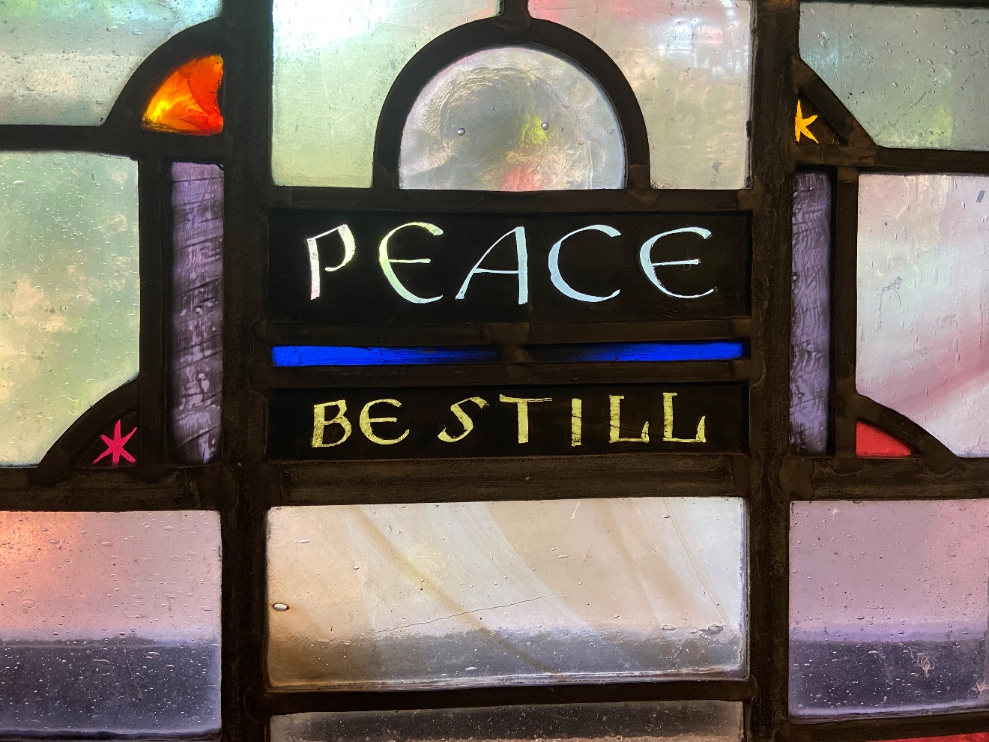
by Lamb Studios in PCAT Chapel

OUR PURPOSE
We are here to continue Christ’s work, inviting people to personally experience God and be transformed into followers of Christ,
reaching out in love and compassion to a world in need.

May 22, 2022 The Sixth Sunday of Easter 10:30am
Liturgist: Tim Patryk Cantor: Cathy Coppolino
Preacher: Nicola Whyte

Organ Prelude

Gathering Music The River is Here

Welcome and Announcements Tim Patryk

Call to Worship Tim Patryk
Liturgist: Those who love Jesus keep his words;
All: Those who love Christ will make their home with God.
Liturgist: Those who know Jesus will know his peace;
All: Those who know Jesus will be taught in the ways of peace.
Liturgist: Come, follow and love Jesus our Lord, who has come to be among us.
All: Come, worship God, who lives among us, loves us, and
calls us home. Amen.

*Hymn Come Down, O Love Divine 282
CALL TO CONFESSION Tim Patryk
As we gather before God in worship this morning,
We come carrying burdens, hurts, and the knowledge that we have sinned.
Together, let us confess our sins to the God of peace:

Prayer of Confession (unison) Tim Patryk
Forgiving God, You call us to follow you: to walk in the ways of peace, to love our neighbours, to pray for our enemies. We confess that we have often stumbled: we have chosen the paths of division, we have harboured ill-will against those you love, we have prayed selfishly, or not thought of you at all. For the harms we have done by our actions and by our inaction we are truly sorry, and we ask your forgiveness.

ASSURANCE OF PARDON Tim Patryk
Friends in Christ, hear and believe the Good News of the Gospel:
In Jesus Christ we are forgiven, In Jesus Christ we are granted peace.
Amen.
First Reading Deuteronomy 34:1-12 Tim Patryk

solo Even If Mercyme
Cathy Coppolino

Second Reading John 14:23-29 Nicola Whyte

*HYMN Longing for Light, We Wait in Darkness 314 v. 1,2,5

Sermon Nicola Whyte

Sharing our Gifts
Choir Anthem Bring Us Peace
*Doxology
Prayer of Dedication Tim Patryk
God, you have given us all good things. You have loved us generously, and have filled our lives with abundant gifts. You have shown us your way, and you help us to walk it. Accept these our offerings, and all that they represent:
Our time, our talents, our money, our love for you given that your peace may be known throughout the earth. In the name of our Lord Jesus Christ,
Amen.

Prayers of the people and The Lord’s Prayer

*Hymn of Dedication Put Peace Into Each Other’s Hands

Charge and Benediction Nicola Whyte
with
SUNG AMEN
Amen, Amen, Alleluia, Amen
Amen, Amen, Alleluia, Amen

Postlude

****

*Those who are able, please stand.

We welcome back Nicola Whyte who is a doctoral candidate at Princeton Theological Seminary.

Covid is still with us and we would like to remind you that masks are required at all times. Please give each other enough space. Also, we are cracking open windows to keep the airflow going. Please don’t close the windows during worship, but feel free to move to another spot if it’s uncomfortable.

Presby Readers - Our next meeting will be Sunday, June 5 at 4:00 p.m. The Rocco’s have generously offered to host – their address: 131 Magnolia Ave, Tenafly.
We will be discussing Dear Edward by Ann Napolitano. “A surprisingly uplifting story, full of hope and dry humor, with an underlying, noncloying message about the decency of strangers.”
—The New York Times Book Review Please come with discussion questions.

Scholarships- Applications and the guidelines can be picked up in the church office, downloaded from our webpage or please call and Nancy will email one to you. Applications are due back in the office by June 10, 2022.

Strawberry Festival - Happy news of the return of the Deacons’ Strawberry festival. We’ll be treated to strawberries and ice cream after the 10.30am service on June 12th, outside in the gardens, or if wet in Jim Henry Hall. It’s wonderful to see this coming back, and a big thank you to Melissa and the Deacons!

Memorial Service for Pat Nostrand - We will give thanks for the life of our friend Pat Nostrand in a service of thanksgiving and remembrance in the sanctuary of PCAT on Thursday June 23rd at 11am. All friends are warmly invited. There will be visiting with the family at Barrett Leber Funeral Home on Wednesday June 23 from 2-4pm and 7-9pm.

White & Gold Reflections on Easter - thank you to everyone who took part in a beautiful time last Thursday evening.

Livestreaming of Worship
Today’s service is broadcast live online. You can watch the service again later via our website homepage if you wish to. Huge thanks to our entire technical team.

