When we didn’t include you, God, in our day.
LOVING GOD, FORGIVE US
When we interrupted others and failed to listen
LOVING GOD, FORGIVE US
When we lacked courage to speak out or act
LOVING GOD, FORGIVE US
When we failed to serve others before ourselves
LOVING GOD, FORGIVE US
When we didn’t trust in your strength and love to lead us each day
LOVING GOD, FORGIVE US

DECLARATION OF FORGIVENESS
To all and to each, on his community and on his friends, where regret is real,
God pronounces his pardon and grants us the right to begin again.
Thanks be to God!
In Jesus name we are forgiven, and by his Cross and Resurrection we can be saved.

First Reading 2 Kings 2:1-2, 6-14 Mickey Diekjobst

*HYMN O God, In a Mysterious Way (Psalm 77) 30

Second Reading Luke 9:51-62 Chris Lawrence

*HYMN Lord, You Have Come to the Seashore 721

Sermon Chris Lawrence

Sharing our Gifts
Solo God Will Take Care of You
Gay Willis
*Doxology
Prayer of Dedication Mickey Diekjobst Lord Jesus, take and use these gifts, and the dedication of our whole lives,
nothing held back, for your Kingdom, for our neighbor, for those whose lives
we impact, near and far.

Prayers of the people Chris Lawrence
Recall now the gifts of this last week, the good things that have happened to us ….
Holy Spirit our Joy-Giver / Receive our gratitude
Remember now those whom we are concerned about, and those in trouble both near and far…
Holy Spirit our Companion / Hear our cry

The Lord’s Prayer

*Hymn Will You Come and Follow Me 726

Charge and Benediction Chris Lawrence
with
SUNG AMEN
Amen, Amen, Alleluia, Amen
Amen, Amen, Alleluia, Amen

Postlude

*****
*Those who are able, please stand.

Covid is still with us and we would like to remind you that masks are required at all times. Please give each other enough space. Also, we are cracking open windows to keep the airflow going. Please don’t close the windows during worship, but feel free to move to another spot if it’s uncomfortable.

Sunday worship will be held at 10am from Sunday 26th June until we return to 10:30am 11th September.

Presby Readers next meeting will be Sunday, July 24 at 4:00 p.m. at Carolyn and Al Rocco’s home. We will be discussing The Book Woman of Troublesome Creek by Kim Michele Richardson.

Livestreaming of Worship
Today’s service is broadcast live online. You can watch the service again later via our website homepage if you wish to. Huge thanks to our entire technical team.

The
Presbyterian Church
at Tenafly
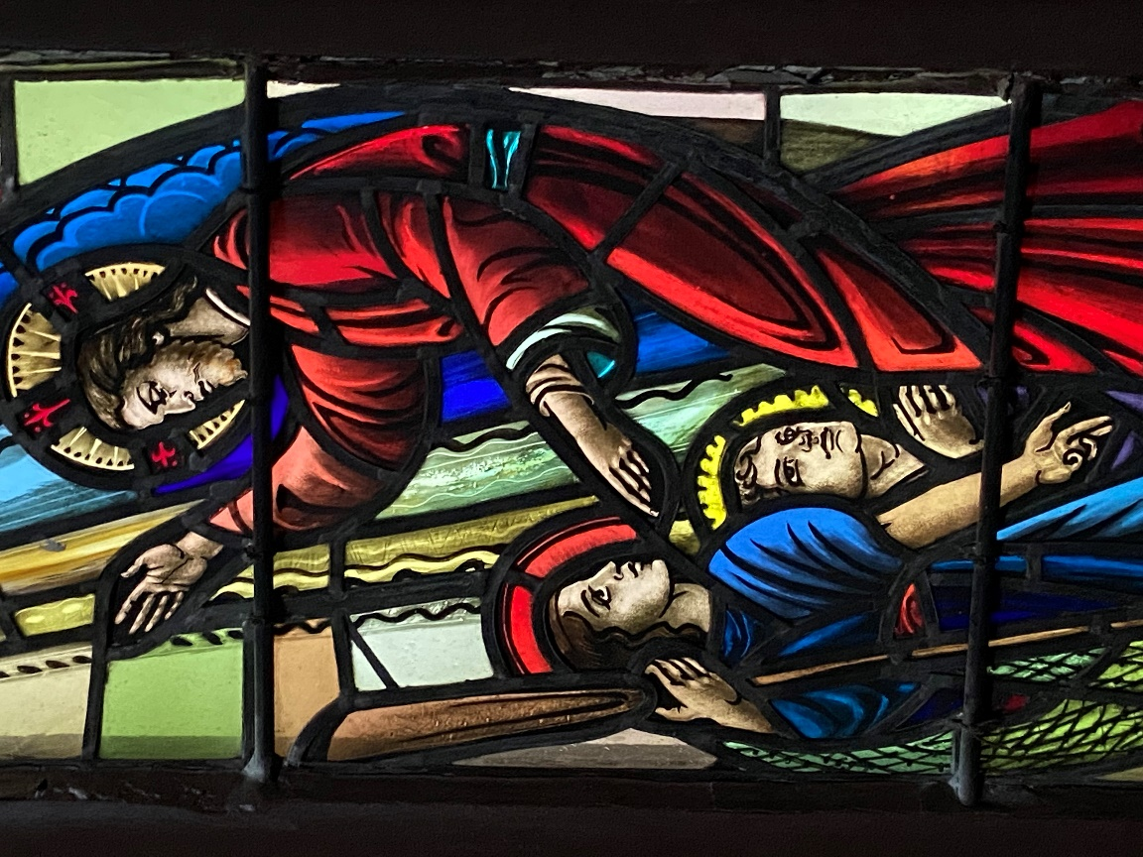

OUR PURPOSE
We are here to continue Christ’s work, inviting people to personally experience God and be transformed into followers of Christ,
reaching out in love and compassion to a world in need.
June 26, 2022 The Fourth Sunday of Pentecost 10:00am
Liturgist: Mickey Diekjobst Cantor: Gay Willis
Preacher: Rev. Chris Lawrence

Organ Prelude

Welcome and Announcements Mickey Diekjobst

Call to Worship Mickey Diekjobst Leader: The world belongs to God
People: THE EARTH AND ALL ITS PEOPLE
Leader: How good and how lovely it is
People: TO LIVE TOGETHER IN UNITY
Leader: Love and faith come together
People: JUSTICE AND PEACE JOIN HANDS
Leader: If Christ’s disciples keep silent
People: THESE STONES WOULD SHOUT ALOUD

*Hymn Great Are You Lord 614
CALL TO CONFESSION Mickey Diekjobst
Dear Lord, here we are, all unprepared, stumbling.
We are supposed to be “ready” but we know we just have to show up as we are.
We feel judged and threatened by that love which risks all for all.
But, truth be known, you are more eager to forgive than we are to receive your mercy. As we ponder and consider what it is that you may see, the truth about ourselves which we would rather keep hidden help us to ask that you repair us and mend us. Help us to come near to you now.

Prayer of Confession (Responsive)
Dear God, be with us as we ponder our week;
for those times we were impatient and unkind
LOVING GOD, FORGIVE US
When we could have said “Hello” but didn’t
LOVING GOD, FORGIVE US
When we held on to our anger or frustration
LOVING GOD, FORGIVE US

