The
Presbyterian Church
at Tenafly
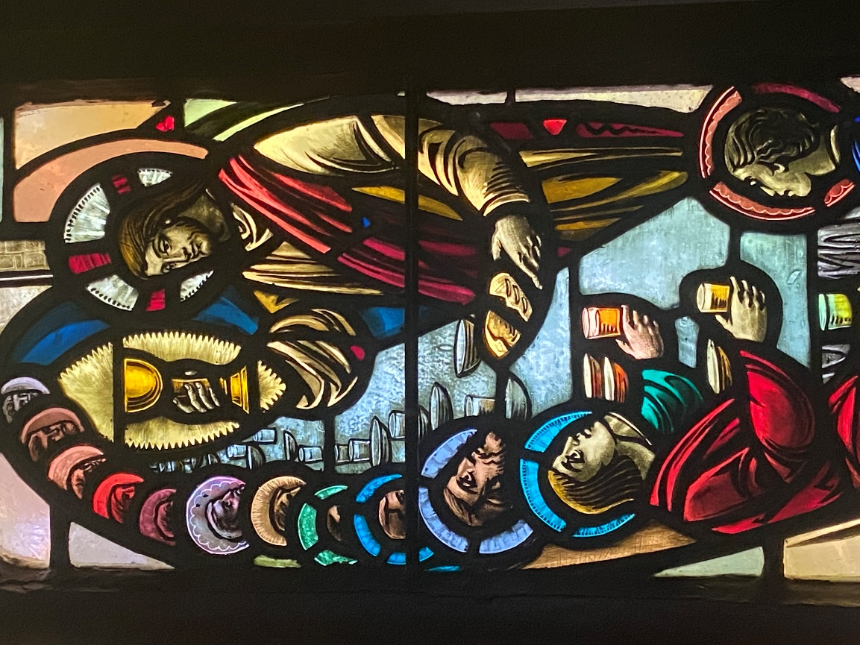

OUR PURPOSE
We are here to continue Christ’s work, inviting people to personally experience God and be transformed into followers of Christ,
reaching out in love and compassion to a world in need.

August 7, 2022 9th Sunday of Pentecost 10:00am
Sacrament of the Lord’s Supper
Liturgist: Mickey Sechrist Cantor: Ann Van Cleave
Preacher: The Rev. Dr. Martin Ritchie

Organ Prelude

Welcome and Announcements Mickey Sechrist

Call to Worship
Come now, children of God, people of The Way, and bring your whole selves in worship, trusting that we are welcome and safe in God’s arms.

*HYMN Cornerstone

CALL TO CONFESSION Mickey Sechrist
We join in confession, bringing the story of our lives in this last week, or since we last shared them with God. Let us pray.

Prayer of Confession (unison)
God of love, our lives are a mixture of the joyful and the positive, the messy and the mangled. All of this is life, and we are assured that you see us and hear us. We may have found ways to live out your heart of love in our lives. We may have struggled. We may have missed opportunities. We may have hurt others with careless or cruel words or actions. We may have lost patience, or been driven by anger. In the mystery of your being, you know and share our stories with us.

DECLARATION OF FORGIVENESS Mickey Sechrist
God’s promise is for new beginnings each and every day. Receive that promise, with the pledge of a fresh start for all of us. Rise up with confidence and walk in the light of a new dawn with God. AMEN

THE LORD’S PRAYER (unison)

First Reading Genesis 15:1-6 Mickey Sechrist

*HYMN O Sing to the Lord 637 v. 1-3

Second Reading Luke 12:32-40 Rev. Dr. Martin Ritchie
*HYMN Days of Elijah

Sermon Rev. Dr. Martin Ritchie

Sharing our Gifts
Duet How Deep the Father’s Love for Us
Ann Van Cleave and Julia Viktrup
*Doxology
Prayer of Dedication Mickey Sechrist
Generous God, we share in the riches of your world in so many ways. As we think of all the good things of our lives, and the ways in which we have resources of time, energy, money, and talents, we return a portion to you in thanksgiving. May it be for the work of building your kingdom of love in our time and place. May we be wise stewards of all that is given in your name. AMEN

SHARING THE PEACE

Invitation to Communion

The table of bread and wine has been made ready. It is the table of company with Jesus, and all who love him. So come to this table, you who have much faith and you who would like to have more; you who have been here often and you who have not been for a while. You who have tried to follow Jesus, and you who have failed. Come. It is Christ who invites us to meet him here.

*Song We Are Coming, Lord, to the Table

The Great Thanksgiving
The Lord be with you
And also with you
Lift up your hearts
We lift them to the Lord.
Let us give thanks to the Lord our God
It is right to give our thanks and praise.

Worship and praise belong to you,
maker of light and darkness.
Your wisdom draws beauty from chaos,
brings a harvest out of sorrow
and leads the exiles home.

In Christ your Son enemies are reconciled,
debts forgiven and strangers made welcome.
Your Spirit frees us
to live as sons and daughters
in our Father's house.

We who by Christ's power
follow the way of the Cross,
sharing the joy of his obedience,
now offer you our praise,
with angels and archangels
and the whole company of heaven
singing the hymn of your unending glory:

Sanctus and Benedictus (unison)
Holy, Holy, Holy Lord, God of power and might. Heaven and earth are full of your glory, hosanna in the highest. Blessed is he who comes in the name of the Lord. Hosanna, in the highest.
(the congregation sits)

Telling the Story
Glory and thanksgiving be to you, most loving Father,
for Christ in whom the world is reconciled.
Lifted on the Cross, his suffering and forgiveness
spanned the gulf our sins had made.
Through that dark struggle
death was swallowed up in victory,
that life and light might reign.

Before he was given up to suffering and death,
recalling the night of Israel's release,
the night in which the sons of Egypt died,
your Chosen One, himself the First-Born,
freely offered his life.
At supper with his disciples
he took bread and offered you thanks.
He broke the bread, and gave it to them, saying:
"Take, eat.
This is my Body: it is broken for you."
After supper, he took the cup,
he offered you thanks, and gave it to them saying:
"Drink this, all of you.
This is my Blood of the new covenant;
it is poured out for you, and for all,
that sins may be forgiven.
Do this in remembrance of me."

We now obey your Son's command.
We recall his blessed passion and death,
his glorious resurrection and ascension;
and we look for the coming of his Kingdom.
Made one with him, we offer you these gifts
and with them ourselves, a single, holy, living sacrifice.

Hear us, most merciful Father, and send your Holy Spirit upon us
and upon this bread and this wine,
that, overshadowed by your life-giving power,
they may be for us spiritual food and drink,
and we may be kindled with the fire of your love
and renewed for the service of your Kingdom.

Help us, who are baptized into the fellowship of Christ's Body
to live and work to your praise and glory;
may we grow together in unity and love
until at last, in your new creation,
we enter into our heritage in the company of the apostles,
and prophets, and of all our brothers and sisters living and departed.

Through Jesus Christ our Lord, with whom, and in whom,
in the unity of the Holy Spirit, all honour and glory be to you,
Lord of all ages, world without end.

Amen.

Agnus Dei

Jesus, Lamb of God
Have mercy on us
Jesus bearer of our sins
Have mercy upon us
Jesus redeemer of the world
Grant us your peace.

Sharing the Bread and Wine
(The Elders will serve the bread to you in your seats. The wine glasses are pre-set in the pews. Please wait to eat and drink all together.)

Post-Communion Prayer (Unison)
Father of all, we give you thanks and praise that when we were still far off you met us in your Son and brought us home. Dying and living, he declared your love, gave us grace, and opened the gate of glory. May we who share Christ's body live his risen life; we who drink his cup bring life to others; we whom the Spirit lights, give light to the world. Keep us firm in the hope you have set before us, so we and all your children shall be free, and the whole earth live to praise your name; through Christ our Lord. Amen.

*Hymn Keep Your Lamps Trimmed and Burning 350

Charge and Benediction Rev. Dr. Martin Ritchie
with
SUNG AMEN
Amen, Amen, Alleluia, Amen
Amen, Amen, Alleluia, Amen

Postlude

*Those who are able, please stand.

Covid is still with us and we would like to remind you that masks are required at all times. Please give each other enough space. Also, we are cracking open windows to keep the airflow going. Please don’t close the windows during worship, but feel free to move to another spot if it’s uncomfortable.

The Presby Readers will be meeting Sunday, August 28th at 4:00 p.m. at the home of Viki Shima. We will be discussing The Paris Seamstress by Natasha Lester. Per Amazon, “For readers of Lilac Girls and The Nightingale comes an internationally bestselling World War II novel that spans generations, crosses oceans, and proves just how much two young women are willing to sacrifice for love and family.” All are welcome. Please come with a few questions and suggestions for our September read!

More After the Break NBC news reporter Jen Maxfield will be in conversation about her new book at PCAT on Saturday 24th September at 4pm in the Sanctuary. It’s really exciting to have Jen visit us, as she grew up in our church. Jen’s book revisits 10 unforgettable news stories that she covered from 2003 – 2018.
Come and hear her talk about what has happened in the lives of the people involved in those stories since then.

Service of Installation - The Presbytery of Northeast NJ will hold a service of installation for Pastor Martin here at PCAT on Sunday 18th September at 4pm in the sanctuary. Please help spread the word! Feel free to invite family, friends and neighbors and also any PCAT members who have not been around for awhile. There will be hospitality after the service.

Livestreaming of Worship
Today’s service is broadcast live online. You can watch the service again later via our website homepage if you wish to. Huge thanks to our entire technical team.

THE PRESBYTERIAN CHURCH AT TENAFLY
55 Magnolia Avenue, Tenafly, NJ 07670
Phone (201) 567-0111 / Fax (201) 567-0529
Emails : tenaflypresbyterianchurch@gmail.com
pastorpcat@gmail.com
Web page: www.tenaflypresby.org

