**The Presbyterian Church**

**at Tenafly**

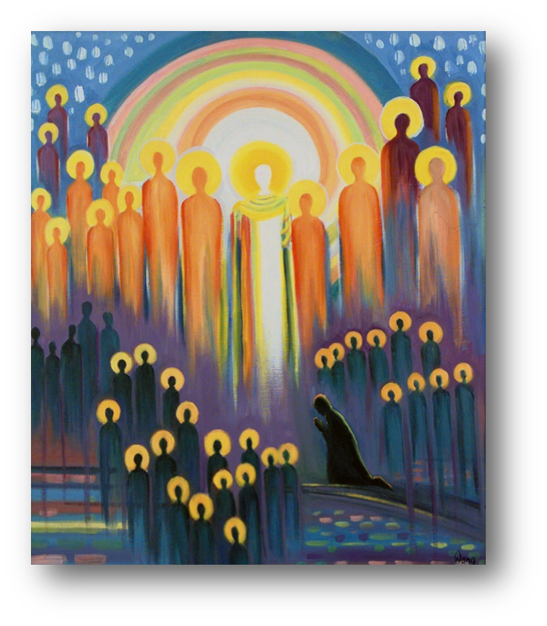

***For Every Heart a Home***

**November 6, 2022 23rd Sunday of Pentecost 10:30am**

**All Saints**

Liturgist: Cantor: Ray McCarthy

Preacher: Rev Dr Martin Ritchie

*Welcome to worship! If you are visiting or here for the first time and would like*

*to stay in touch with us, please consider filling in one of the contact cards that*

*you will find alongside the hymnals. These can be placed in the offering*

*plate or handed to an usher.*

**ORGAN PRELUDE**

**WELCOME AND ANNOUNCEMENTS**

**JOYS AND CONCERNS**

**CALL TO WORSHIP**

**Liturgist:**From East and West, from North and South, the rainbow people of God are called to worship.

**All:** We respond to God’s call and are here in God’s temple.

**\*HYMN**  *O Lord, You Are My God and King* 270

**PRAYERS OF APPROACH TO GOD AND CONFESSION (unison)**

**God of the years, on this day when we remember all those who have gone before us in the faith, those we have loved and who have loved us, and travelled life’s journey with us, we remember that we are amongst a great cloud of witnesses. So, as we settle before you, we are in company in the mystery of prayer.**

**How can we describe who you are to us? Words run out. You are beyond compare. You are the sum of all that we can know, and even more. Though we run to the limits of the east or west, to the north or south, we will never quite pin you down. So we rest knowing that for now we see as if “in a mirror dimly”.**

**You know us so well, but we take a moment to bring our deepest thoughts and feelings about our lives. For all that is good, and true and beautiful, we are deeply thankful. For what is rough and painful, we ask your help. And for those things that we regret, where we have not lived up to your law of love, we bring our confessions in a moment of quiet.**

*Shared silence*

**KYRIE ELEISON**

**Martin sings:** Kyrie Eleison

**Congregation & Cantor:** Kyrie Eleison

**Martin sings:** Christe Eleison

**Congregation & Cantor:** Christe Eleison

**Martin sings:** Kyrie Eleison

**Congregation & Cantor:** Kyrie Eleison

**DECLARATION OF FORGIVENESS**

**THE LORD’S PRAYER**

**CHOIR ANTHEM** *At this Table,* by Allen Pote

Stephanie Chan, flute

In the singing, in the silence, in the hands expectant, open,

in the blessing, in the breaking, in the Presence at this table,

Jesus Christ, Jesus Christ, be the wine of grace:

Jesus Christ, Jesus Christ, be the bread of peace.

In the question, in the answer, in the moment of acceptance,

in the heart's cry, in the healing, in the circle of your people,

Jesus Christ, Jesus Christ, be the wine of grace:

Jesus Christ, Jesus Christ, be the bread of peace.

In the singing, in the silence, in the hands expectant, open,

in the blessing, in the breaking, in the Presence at this table,

Jesus Christ, Jesus Christ, be the wine of grace:

Jesus Christ, Jesus Christ, be the bread of peace.

Be the wine of grace and the bread of peace.

**FIRST READING** Haggai 1:15b - 2:9

In the second year of King Darius, in the seventh month, on the twenty-first day of the month, the word of the Lord came by the prophet Haggai, saying: “Speak now to Zerubbabel son of Shealtiel, governor of Judah, and to Joshua son of Jehozadak, the high priest, and to the remnant of the people, and say: Who is left among you who saw this house in its former glory? How does it look to you now? Is it not in your sight as nothing? Yet now take courage, O Zerubbabel, says the Lord; take courage, O Joshua, son of Jehozadak, the high priest; take courage, all you people of the land, says the Lord; work, for I am with you, says the Lord of hosts, according to the promise that I made you when you came out of Egypt. My spirit abides among you; do not fear. For thus says the Lord of hosts: Once again, in a little while, I will shake the heavens and the earth and the sea and the dry land, and I will shake all the nations, so that the treasure of all nations will come, and I will fill this house with splendor, says the Lord of hosts. The silver is mine, and the gold is mine, says the Lord of hosts. The latter splendor of this house shall be greater than the former, says the Lord of hosts, and in this place I will give prosperity, says the Lord of hosts.”

**\*HYMN** *Give Thanks for Those Whose Faith is Firm* 731

**GOSPEL READING** Luke 20:27-38

Some Sadducees, those who say there is no resurrection, came to him and asked him a question: “Teacher, Moses wrote for us that if a man’s brother dies leaving a wife but no children, the man shall marry the widow and raise up children for his brother. Now there were seven brothers; the first married a woman and died childless; then the second and the third married her, and so in the same way all seven died childless. Finally the woman also died. In the resurrection, therefore, whose wife will the woman be? For the seven had married her.”

Jesus said to them, “Those who belong to this age marry and are given in marriage, but those who are considered worthy of a place in that age and in the resurrection from the dead neither marry nor are given in marriage. Indeed, they cannot die anymore, because they are like angels and are children of God, being children of the resurrection. And the fact that the dead are raised Moses himself showed, in the story about the bush, where he speaks of the Lord as the God of Abraham, the God of Isaac, and the God of Jacob. Now he is God not of the dead but of the living, for to him all of them are alive.”

**\*HYMN**  *Blest Are They* 172

**SERMON** Rev Dr Martin Ritchie

**SHARING OUR GIFTS**

**Solo**  *Hymn of Heaven*, by Phil Wickham

Ray McCarthy

\***Doxology**

**Prayer of Dedication**

**WELCOME TO NEW MEMBERS AND SHARING THE PEACE**

**Invitation to Communion**

The table of bread and wine has been made ready. It is the table of company with Jesus, and all who love him. So come to this table, you who have much faith and you who would like to have more; you who have been here often and you who have not been for a while. You who have tried to follow Jesus, and you who have failed. Come. It is Christ who invites us to meet him here.

**\*Song**  *We Are Coming, Lord, to the Table*

We are coming, Lord, to the table. We are coming, Lord, to the table.

With the gift of bread, we are coming, Lord.

With the gift of wine, we are coming, Lord.

Oh, we are coming, Lord. Oh, we are coming, Lord.

Oh, we are coming, Lord. Oh, we are coming Lord.

We are coming, Lord, to the table. We are coming, Lord, to the table.

To receive the bread, we are coming, Lord.

To receive the wine, we are coming, Lord.

Oh, we are coming, Lord. Oh, we are coming, Lord.

Oh, we are coming, Lord. Oh, we are coming Lord.

**The Great Thanksgiving**

The Lord be with you

**And also with you**

Lift up your hearts

**We lift them to the Lord.**

Let us give thanks to the Lord our God

**It is right to give our thanks and praise.**

Worship and praise belong to you, maker of light and darkness.

Your wisdom draws beauty from chaos, brings a harvest out of sorrow

and leads the exiles home.

In Christ your Son enemies are reconciled, debts forgiven and strangers made welcome. Your Spirit frees us to live as sons and daughters in our Father's house.

We who by Christ's power follow the way of the Cross, sharing the joy of his obedience, now offer you our praise, with angels and archangels

and the whole company of heaven saying the hymn of your unending glory:

**Sanctus and Benedictus (unison)**

**Holy, Holy, Holy Lord, God of power and might. Heaven and earth are full of your glory, hosanna in the highest. Blessed is he who comes in the name of the Lord. Hosanna, in the highest.**

(the congregation sits)

**Telling the Story**

Glory and thanksgiving be to you, most loving Father,

for Christ in whom the world is reconciled.

Lifted on the Cross, his suffering and forgiveness

spanned the gulf our sins had made.

Through that dark struggle

death was swallowed up in victory,

that life and light might reign.

Before he was given up to suffering and death,

recalling the night of Israel's release,

the night in which the sons of Egypt died,

your Chosen One, himself the First-Born,

freely offered his life.

At supper with his disciples

he took bread and offered you thanks.

He broke the bread, and gave it to them, saying:

"Take, eat.

This is my Body: it is broken for you."

After supper, he took the cup,

he offered you thanks, and gave it to them saying:

"Drink this, all of you.

This is my Blood of the new covenant;

it is poured out for you, and for all,

that sins may be forgiven.

Do this in remembrance of me."

We now obey your Son's command.

We recall his blessed passion and death,

his glorious resurrection and ascension;

and we look for the coming of his Kingdom.

Made one with him, we offer you these gifts

and with them ourselves, a single, holy, living sacrifice.

Hear us, most merciful Father, and send your Holy Spirit upon us

and upon this bread and this wine,

that, overshadowed by your life-giving power,

they may be for us spiritual food and drink,

and we may be kindled with the fire of your love

and renewed for the service of your Kingdom.

Help us, who are baptized into the fellowship of Christ's Body

to live and work to your praise and glory;

may we grow together in unity and love

until at last, in your new creation,

we enter into our heritage in the company of the apostles,

and prophets, and of all our brothers and sisters living and departed.

Through Jesus Christ our Lord, with whom, and in whom,

in the unity of the Holy Spirit, all honour and glory be to you,

Lord of all ages, world without end.

Amen.

**Agnus Dei**

Jesus, Lamb of God

**Have mercy on us**

Jesus bearer of our sins

**Have mercy upon us**

Jesus redeemer of the world

**Grant us your peace.**

**Sharing the Bread and Wine**

(The Elders will serve the bread to you in your seats. The wine glasses are pre-set in the pews. Please wait to eat and drink all together.)

**Post-Communion Prayer (Unison)**

**Father of all, we give you thanks and praise that when we were still far off you met us in your Son and brought us home. Dying and living, he declared your love, gave us grace, and opened the gate of glory. May we who share Christ's body live his risen life; we who drink his cup bring life to others; we whom the Spirit lights, give light to the world. Keep us firm in the hope you have set before us, so we and all your children shall be free, and the whole earth live to praise your name; through Christ our Lord. Amen.**

**\*HYMN** *For All the Saints* 326 v.1,3,5

**CHARGE AND BENEDICTION**

**with SUNG CELTIC AMEN**

***Amen, Amen, Alleluia, Amen (x2)***

**POSTLUDE**

*****

**\*Those who are able, please stand.**

**Please join us after worship for coffee hour on the front lawn or in the church**

**house, if inclement weather.**

The **flowers** this morning are given to the glory of God by Mickey Sechrist in honor of Emmie Parsells 101st birthday on November 9th! Happy birthday!!

**Advent Community Choir** – Beginning this Sunday in the chapel, join Pastor Martin for rehearsals from 4:30pm – 6:00pm as he forms a special choir to sing at the Service of Advent Music and Readings. The candlelit service itself is on **Advent Sunday, November 27th at 6:30pm.**

After 18 years, we will celebrate **Anna Lim’s** tremendous contribution to PCAT life on Sunday December 11th in the 10.30am service that day. We would like to offer PCAT members and friends the chance to contribute to a farewell collection for Anna. If you would like to do that, please send a check to the office payable to “The Presbyterian Church at Tenafly” noting “Anna Lim Gift” in the memo line or deliver a cash donation in an envelope also marked “Anna Lim Gift”.

**Sunday December 4th at 5pm** we welcome in the holiday season with the **lighting of our BIG outdoor Christmas tree** with new lights and the blessing of our creche. We’ll sing well known carols and then head inside for those who wish to share in a **fish and chip dinner catered by Argyle Fish and Chips**! Help us to plan for the dinner by signing up in advance. Tickets for the meal are $20 per meal and can be purchased by calling the church on 201 567 0111. Cash or check made out to PCAT. **Deadline to book is Wednesday November 30th.** Please specify fish or chicken. Half order for children is available for $10. Sign up today in the Narthex.

**Livestreaming of Worship**

Today’s service is broadcast live online. You can watch the service again later via our website homepage if you wish to. Huge thanks to our entire technical team.

**COMING SOON . . . . DATES FOR THE CALENDAR!**

**Sunday November 13th - Intergenerational Worship at 10.30am**

**Sunday November 20th - Stewardship Sunday, Worship at 10.30am**

**Tuesday November 22nd - Interfaith Thanksgiving Service, Temple Sinai at 7.30pm**

**Saturday November 26th at 9am - Greening of the Church for Advent -** volunteers needed this morning!

**Sunday November 27th - Advent Sunday Worship at 10.30am**

**Sunday November 27th - Candlelit Advent Service of Music and Readings in the Sanctuary led by our Community Choir at 6.30pm.**

**Wednesdays November 30th, December 7th, 14th and 21st 7-7.30pm Reflective Advent Space in the Chapel.**

**Wednesdays November 30th, December 7th and 14th - *The Art of Advent* study at 12noon and 7.30pm** (choose either session). Our advent study series explores the themes of the Profits, Mary, and the Nativity in visual art.

**Sunday December 4th - Communion at 10.30am Please remember your shelf staple food donations for the Center for Food Action.**

**Sunday December 4th- Community Carol Singing and lighting of the Christmas Tree at 5pm,** followed by a **Fish and Chips dinner catered by Argyle Fish and Chips** at around 6pm in Jim Henry Hall.

**Sunday December 11th -** Worship at 10.30am featuring our bell choir and with a farewell presentation to Anna Lim, our retiring Director of Music.

**Sunday December 11th - Carol Singing at homes of seniors.** Late afternoon, time tbc.

**Sunday December 18th - Christmas Pageant at 10.30am**

**Sunday December 18th – Candlelit Christmas Concert in our beautiful chapel at 4pm**, featuring soprano Erin Schwab and Pastor Martin on organ/piano.

**Saturday December 24th - Christmas Eve worship at 5pm and 9pm in the Sanctuary. Come celebrate with family at the 5pm worship service and later at 9pm beautiful choral music and readings.**

**Sunday January 1st, 2023** - The Gate of the Year is a service of music and readings to say farewell to the old year and welcome in the new with hope. In the Sanctuary at 10.30am.

**THE PRESBYTERIAN CHURCH AT TENAFLY**

55 Magnolia Avenue, Tenafly, NJ 07670

Phone (201) 567-0111 / Fax (201) 567-0529

Emails : [tenaflypresbyterianchurch@gmail.com](mailto:tenaflypresbyterianchurch@gmail.com)

pastorpcat@gmail.com

Web page: [www.tenaflypresby.org](http://www.tenaflypresby.org)

Doodle away . . .

We all have different personalities, and we engage in worship in different ways. This space is left for you to use in any way that you would like during the service. You may like to write notes or you may wish to draw in response to how you hear God speaking. You can use the pencils which are in the pews or bring your own.

We are providing this space every week.