**The Presbyterian Church**

**at Tenafly**

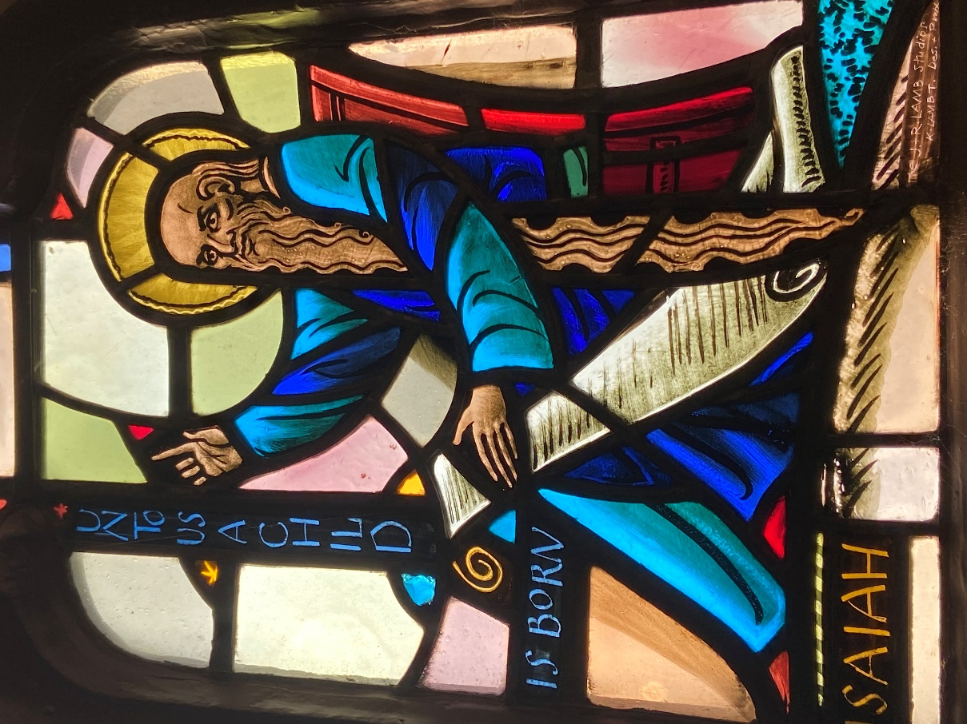

**FOR EVERY HEART A HOME**

**November 27, 2022 First Sunday of Advent 10:30am**

Liturgist: Indiana Diaz Cantor: Ray McCarthy

Preacher: Rev Dr Martin Ritchie

*Welcome to worship! If you are visiting or here for the first time and would like*

*to stay in touch with us, please consider filling in one of the contact cards that*

*you will find alongside the hymnals. These can be placed in the offering*

*plate or handed to an usher.*

**ORGAN PRELUDE**

**WELCOME AND ANNOUNCEMENTS**

**JOYS AND CONCERNS**

**LIGHTING OF ADVENT WREATH** The Motai Family

*Long Ago, Prophets Knew v.1*

Long ago, prophets knew Christ would come, born a Jew, come to make all things new, bear his people’s burden, freely love and pardon.

**Refrain**: Ring, bells, ring, ring, ring! Sing, choirs, sing, sing, sing!

When He comes, when he comes, who will make him welcome?

**PRAYERS OF APPROACH TO GOD AND CONFESSION (unison)**

**God of new beginnings, we come to you in worship at the start of a new church year. We praise you for your creativity that has brought us into being, and for the wonder of being alive in your incredible world. As we gaze out on a crisp and clear moonlit night, we see into the depths of your time, which is beyond all that we can understand. You are bigger than any galaxy, more powerful than any storm, more majestic and beautiful than any sight we can see. And yet you are mindful of us, your children. So we take a moment to bring to you the realities of our lives. Where there is any darkness, we lay it before you in sorrow. Where there is light, we acknowledge it with thanksgiving and joy.**

***Shared silence***

**KYRIE ELEISON**

**Martin sings:** Kyrie Eleison

**Congregation & Cantor:** Kyrie Eleison

**Martin sings:** Christe Eleison

**Congregation & Cantor:** Christe Eleison

**Martin sings:** Kyrie Eleison

**Congregation & Cantor:** Kyrie Eleison

**DECLARATION OF FORGIVENESS**

Gracious God, even the darkness is light to you. Help us to see your light shining in even the darkest places, a light that does not go out. May that light lead us on to new and better times in our journeys of life, confident that you hear us and forgive all that we bring in confession. All this in Jesus’ name we pray. **AMEN**

**CHOIR ANTHEM** *In Silence We Wait*

In silence we wait for the day of God's mercy,

In silence we wait for Emmanuel to come.

In silence we wait for the gift for God's promise.

In silence we wait and pray.

Lord, hear our prayer:

"Deliver your people.

Send us a Savior to show us the way!

Guide us in mercy,

shepherd us in love."

In silence we wait and pray.

In darkness we wait for the light of the Christchild.

In darkness we wait for the Day Star to shine.

In darkness we wait for the glory of morning.

In darkness we wait and pray.

Lord, hear our prayer:

"Deliver your people.

Send us a Savior to show us the way!

Guide us in mercy,

shepherd us in love."

In silence we wait and pray.

In silence we wait.

In silence we pray.

Lord, send your Christ today.

Amen.

**FIRST READING** Isaiah 2:1-5

The word that Isaiah son of Amoz saw concerning Judah and Jerusalem.

In days to come  
    the mountain of the Lord’s house  
shall be established as the highest of the mountains  
    and shall be raised above the hills;  
all the nations shall stream to it.  
    Many peoples shall come and say,  
“Come, let us go up to the mountain of the Lord,  
    to the house of the God of Jacob,  
that he may teach us his ways  
    and that we may walk in his paths.”  
For out of Zion shall go forth instruction  
    and the word of the Lord from Jerusalem.  
He shall judge between the nations  
    and shall arbitrate for many peoples;  
they shall beat their swords into plowshares  
    and their spears into pruning hooks;  
nation shall not lift up sword against nation;  
    neither shall they learn war any more.  
O house of Jacob,  
    come, let us walk  
in the light of the Lord!

**\*HYMN** *I Rejoiced When I Heard Them Say (Psalm 122)* 400

CHOIR

1 I rejoiced when I heard them say: “Let us go to the house of God.”  
And now our feet are standing in your gates, O Jerusalem!

**CONGREGATION**

**Refrain:  
Shalom, shalom, the peace of God be here.  
Shalom, shalom, God’s justice be ever near.**  
  
CHOIR

2 Like a temple of unity is the city, Jerusalem.  
It is there all tribes will gather, all the tribes of the house of God. **(Refrain)**  
  
CHOIR

3 It is faithful to Israel’s law, there to praise the name of God.  
All the judgment seats of David were set down in Jerusalem. **(Refrain)**  
  
CHOIR

4 For the peace of all nations, pray: for God’s peace within your homes.  
May God’s lasting peace surround us; may it dwell in Jerusalem. **(Refrain)**  
  
CHOIR

5 For the love of my friends and kin I will bless you with signs of peace.  
For the love of God’s own people I will labor and pray for you. **(Refrain)**

**SECOND READING** Matthew 24:36-44

“But about that day and hour no one knows, neither the angels of heaven, nor the Son, but only the Father. For as the days of Noah were, so will be the coming of the Son of Man. For as in the days before the flood they were eating and drinking, marrying and giving in marriage, until the day Noah entered the ark, and they knew nothing until the flood came and swept them all away, so, too, will be the coming of the Son of Man. Then two will be in the field; one will be taken, and one will be left. Two women will be grinding meal together; one will be taken, and one will be left. Keep awake, therefore, for you do not know on what day your Lord is coming. But understand this: if the owner of the house had known in what part of the night the thief was coming, he would have stayed awake and would not have let his house be broken into. Therefore you also must be ready, for the Son of Man is coming at an hour you do not expect.

**\*HYMN** *Days of Elijah*

(Song leader)

These are the days of Elijah, declaring the Word of the Lord;

And these are the days of Your servant, Moses, righteousness being restored;

And though these are days of great trials, of famine and darkness and sword;

Still we are the voice in the desert crying, "Prepare ye the way of the Lord."

(All sing)

Behold He comes, riding on the clouds, shining like the sun at the trumpet call; Lift your voice, it's the year of Jubilee, and out of Zion's hill salvation comes.

(Instrumental)

(Song Leader)

And these are the days of Ezekiel, the dry bones becoming as flesh;

And these are the days of Your servant, David, rebuilding a temple of praise;

And these are the days of the harvest, the fields are as white in the world;

And we are the labourers in Your vineyard, declaring the Word of the Lord.

(All sing)

Behold He comes, riding on the clouds, shining like the sun at the trumpet call; Lift your voice, it's the year of Jubilee, and out of Zion's hill salvation comes.

(Instrumental)

(Song leader)

There is no god like Jehovah,

There is no god like Jehovah,

There is no god like Jehovah,

There is no god like Jehovah,

There is no god like Jehovah,

There is no god like Jehovah,

There is no god like Jehovah,

There is no god like Jehovah,

(All sing)

Behold He comes, riding on the clouds, shining like the sun at the trumpet call; Lift your voice, it's the year of Jubilee, and out of Zion's hill salvation comes.

(All sing)

Behold He comes, riding on the clouds, shining like the sun at the trumpet call; Lift your voice, it's the year of Jubilee, and out of Zion's hill salvation comes.

**SERMON**   Rev Dr Martin Ritchie

**SHARING OUR GIFTS**

**Solo**  *Even So, Come*

Ray McCarthy

\***Doxology**

**Prayer of Dedication**

**PRAYERS OF THANKSGIVING AND INTERCESSION** Rev Dr Martin Ritchie

**THE LORD’S PRAYER**

**\*HYMN** *Come, Thou Long Expected Jesus* 82

**CHARGE AND BENEDICTION** Rev Dr Martin Ritchie

**with SUNG CELTIC AMEN**

***Amen, Amen, Alleluia, Amen (x2)***

**POSTLUDE**

*****

**\*Those who are able, please stand.**

Please join us for **coffee hour** in the church house following worship.

**THE PRESBYTERIAN CHURCH AT TENAFLY**

55 Magnolia Avenue, Tenafly, NJ 07670

Phone (201) 567-0111 / Fax (201) 567-0529

Emails : [tenaflypresbyterianchurch@gmail.com](mailto:tenaflypresbyterianchurch@gmail.com)

pastorpcat@gmail.com

Web page: [www.tenaflypresby.org](http://www.tenaflypresby.org)

**Tonight - Service of Music and Readings for Advent Sunday**. **The candlelit service is this evening at 6:30pm in the chapel.**

**The Angel Tree** is ready to receive your gifts for the Centre for Hope & Safety. Please note the tag system is no longer being used. You can choose any gift you like, for any age and drop the unwrapped gift by Sunday December 11th under the Angel Tree in the Narthex. Thank you!

**Sunday December 4th at 5pm** we welcome in the holiday season with the **lighting of our BIG outdoor Christmas tree** with new lights and the blessing of our new creche. We’ll sing well known carols and then head inside for those who wish to share in a fish and chip dinner catered by Argyle Fish and Chips! We will provide dessert and soft drinks. There will also be an Advent activity for children and a photo “booth” spot with nativity costumes for the kids to have fun dressing up!

This is a great event to invite friends and neighbours along.

**Help us to plan for the dinner by signing up in advance.**

Tickets for the meal are $20 per meal and can be purchased by calling the church on 201 567 0111 during office hours, 9am-3pm (closed for lunch 12-1) Monday through Friday. Cash or check made out to PCAT. **Deadline to book is Wednesday November 30th.** Please specify fish or chicken. Half order for children is available for $10. Sign up with our Outreach Team in the Narthex following worship!

**Wednesdays in Advent:**

**Our advent study group**, ***The Art of Advent***, will be looking at the themes of the Prophets, Mary, and the Christ Child through visual art. We meet twice on Wednesdays. You can choose to take part at either 12 noon (bring your lunch) or 7:30pm.

**Advent Space** each Wednesday at 7:00 – 7:30pm. It is a time for quiet reflection in our chapel. Enjoy the peace and beauty of the candlelight, recorded music and silence.

**Livestreaming of Worship**

Today’s service is broadcast live online. You can watch the service again later via our website homepage if you wish to. Huge thanks to our entire technical team.

Doodle away . . .

We all have different personalities, and we engage in worship in different ways. This space is left for you to use in any way that you would like during the service. You may like to write notes or you may wish to draw in response to how you hear God speaking. You can use the pencils which are in the pews or bring your own.

We are providing this space every week.

**UPCOMING EVENTS FOR YOUR CALENDAR . . . .**

**Tonight - Candlelit Advent Service of Music and Readings in the Sanctuary led by our Community Choir at 6.30pm.**

**Wednesdays November 30th, December 7th, 14th and 21st 7-7.30pm Reflective Advent Space in the Chapel.**

**Wednesdays November 30th, December 7th and 14th - *The Art of Advent* study at 12noon and 7.30pm** (choose either session). Our advent study series explores the themes of the Profits, Mary, and the Nativity in visual art.

**Sunday December 4th - Communion at 10.30am Please remember your shelf staple food donations for the Center for Food Action.**

**Sunday December 4th- Community Carol Singing and lighting of the Christmas Tree at 5pm,** followed by a **Fish and Chips dinner catered by Argyle Fish and Chips** at around 6pm in Jim Henry Hall.

**Sunday December 11th -** Worship at 10.30am featuring our bell choir and with a farewell presentation to Anna Lim, our retiring Director of Music.

**Sunday December 11th - Carol Singing at homes of seniors.** Late afternoon, time tbc.

**Sunday December 18th - Christmas Pageant at 10.30am**

**Sunday December 18th – Candlelit Christmas Concert in our beautiful chapel at 4pm**, featuring soprano Erin Schwab and Pastor Martin on organ/piano.

**Saturday December 24th - Christmas Eve worship at 5pm and 9pm in the Sanctuary. Come celebrate with family at the 5pm worship service and later at 9pm beautiful choral music and readings.**

**Sunday January 1st, 2023** - The Gate of the Year is a service of music and readings to say farewell to the old year and welcome in the new with hope. In the Sanctuary at 10.30am.

