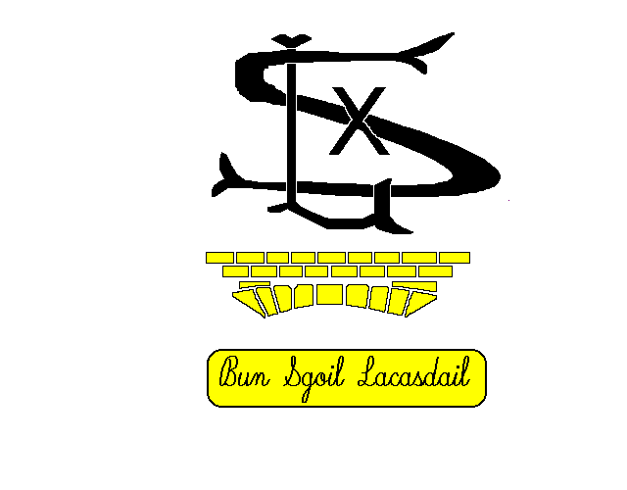
Uhuh
Faidhle-Fiosrachaidh Bheathaichean Innse Gall /Hebridean Animal Fact File
Dean dealbh anns na bogsaichean gu h-ìosal. Draw a picture in the boxes below:
Beathach/Animal | Ainm / Name | A’ fuireach / Where I live | Ag ithe / I like to eat
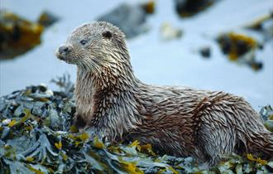 | Biast Dhubh / Otter | 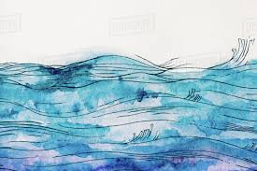 | 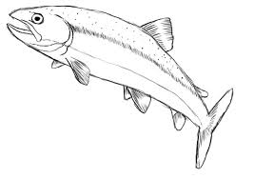
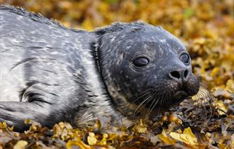 | Ròn / Seal
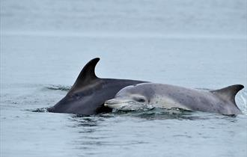 | Leumadair / Dolphin

Dean dealbh anns na bogsaichean gu h-ìosal. Draw a picture in the boxes below:
Beathach/Animal | Ainm/Name | A’ fuireach/ Where I live | Ag ithe/I like to eat
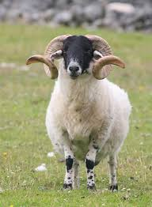 | Caora / Sheep
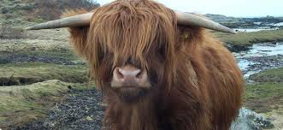 | Bò Gàidhealach / Highland Cow
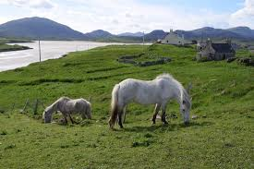 | Each Eirisgeidh / Eriskay Pony

Dean dealbh anns na bogsaichean gu h-ìosal. Draw a picture in the boxes below:
Beathach/Animal | Ainm/Name | A’ fuireach/ Where I live | Ag ithe/I like to eat
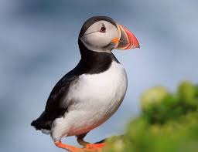 | Buthaid / Puffin
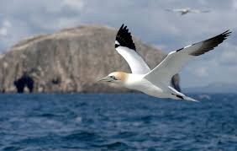 | Sùlaire / Gannet
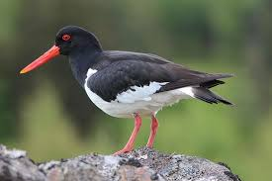 | Drìlleachan / Oyster catcher

A-nis dean dealbh den a’ bheathach Innse Gall is fheàrr leat. Now draw a picture of your favourite Hebridean animal:

