Uhuh
Faidhle-Fiosrachaidh Bheathaichean Innse Gall /Hebridean Animal Fact File
Cuir an fhiosrachach anns na bogsaichean. Insert information into the boxes:
Beathach/Animal | Ainm/Name | Àite-fuirich / Habitat | Bidh mi ag ithe / Diet | Meud / Size
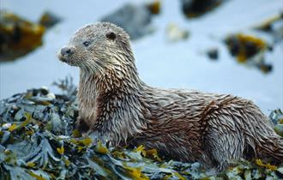 | Biast Dhubh / Otter
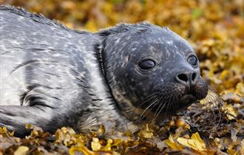 | Ròn / Seal
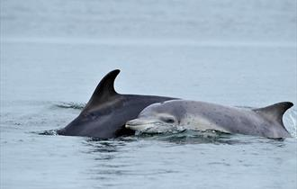 | Leumadair / Dolphin

Cuir fiosrachach anns na bogsaichean. Insert information into the boxes:
Beathach/Animal | Ainm / Name | Àite-fuirich / Habitat | Bidh mi ag ithe / Diet | Meud / Size
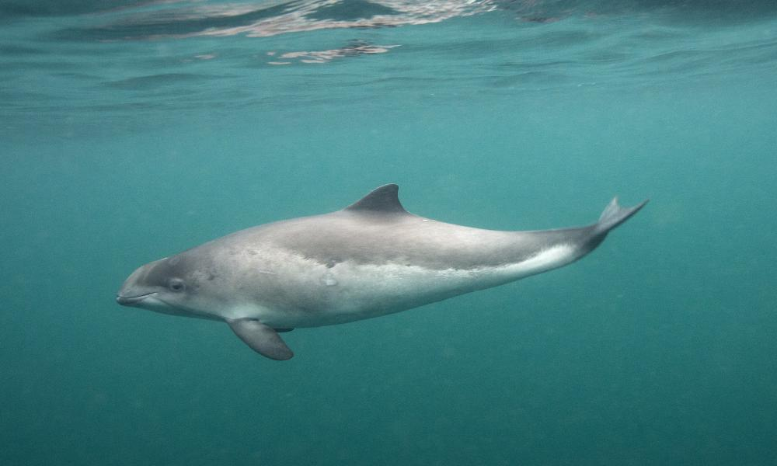 | Puthag / Porpoise
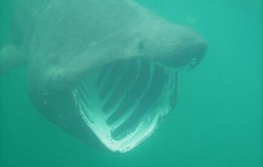 | Cearbanach / Basking Shark
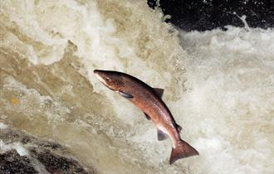 | Bradan / Salmon

Cuir fiosrachach anns na bogsaichean. Insert information into the boxes:
Beathach/Animal | Ainm / Name | Àite-fuirich / Habitat | Bidh mi ag ithe / Diet | Meud / Size
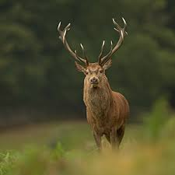 | Fiadh / Deer
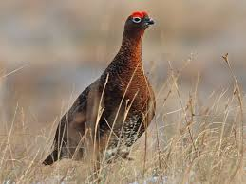 | Eun-fraoich / Grouse
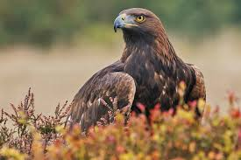 | Iolaire-bhuidhe / Golden Eagle

Cuir fiosrachach anns na bogsaichean. Insert information into the boxes:
Beathach/Animal | Ainm / Name | Àite-fuirich / Habitat | Bidh mi ag ithe / Diet | Meud / Size
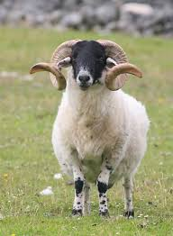 | Caora / Sheep
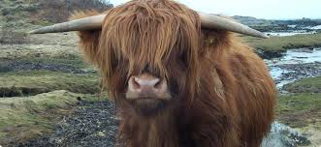 | Bò Gàidhealach / Highland Cow
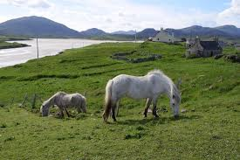 | Each Eirisgeidh / Eriskay Pony

Cuir fiosrachach anns na bogsaichean. Insert information into the boxes:
Beathach/Animal | Ainm / Name | Àite-fuirich / Habitat | Bidh mi ag ithe / Diet | Meud / Size
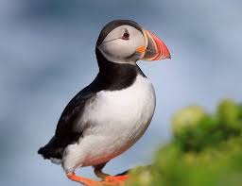 | Buthaid / Puffin
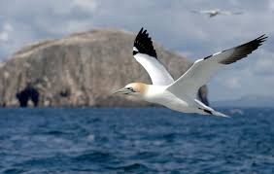 | Sùlaire / Gannet
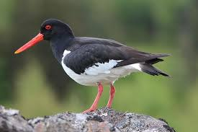 | Drìlleachan / Oyster catcher

Cruthaich am beathach agad fhèin a dh’ fhaodadh fuireach anns na h-eileanan againne. Dean dealbh agus sgrìobh beagan mu dheidhinn.
Create your own animal that would be suited to life in our Islands. Draw a picture and write a little bit about it.

