Animals and Plants Tràth ìre Early Level

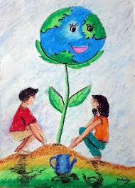
https://www.youtube.com/watch?v=F000UK_kUq4&list=RDlKkG8Xbb8Fc&index=3 | 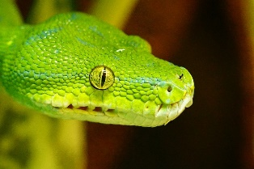
https://www.youtube.com/watch?v=lKkG8Xbb | 