Animals and Plants First Level
You can choose to do all or some of the activities for the day.
https://www.youtube.com/watch?v=0eqxgvZNn0I
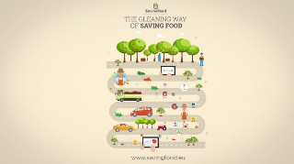

Following on from the video:
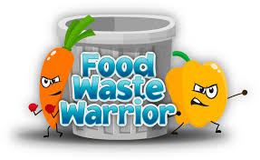
Keep a note of any food you are wasting for a day/week. Discuss this together at home and plan how you can reduce food waste.

https://www.youtube.com/watch?v=lKkG8Xbb | 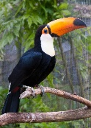
https://www.youtube.com/watch?v=F000UK_kUq4&list=RDlKkG8Xbb8Fc&index=3 | 