Animals and Plants Second Level
You can choose to do all or some of the activities for the day.
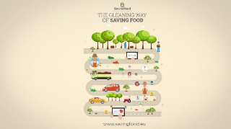
https://www.youtube.com/watch?v=0eqxgvZNn0I
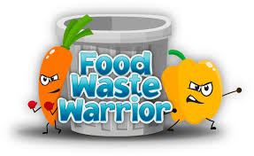
Following on from the video:
Keep a note of any food you are wasting for a day/week. Discuss this together at home and plan how you can reduce food waste.

Use by and Best Before:
Find 5 items at home that have ‘use by’ written on them

Find 5 items at home that have ‘best before’ written on them

Create an information poster explaining the difference between ‘use by’ and ‘best before’
https://www.youtube.com/watch?v=lKkG8Xbb | 