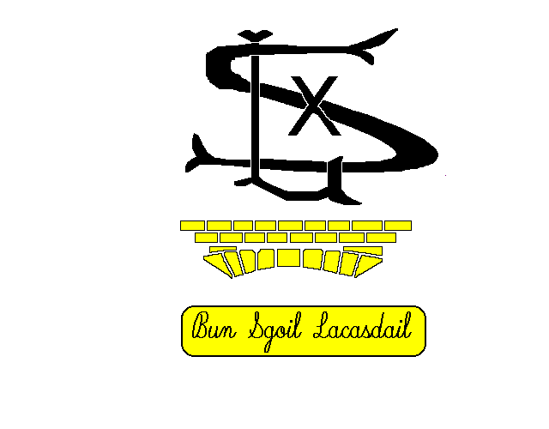
Uhuh
Càite a’ bheil mi a’ fàs? / Where do I grow?
Cuir aodann toilichte dhan bhogsa ceart / put a smiley face in the correct box:
Measan agus glasraich / Fruit and Vegetables | Ainm / Name | Anns an talamh / in the ground | Air mullach an talamh / above the ground
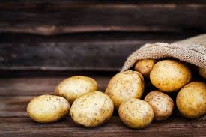 | Buntata / potato
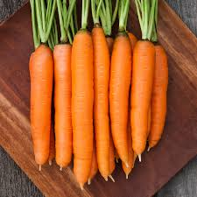 | Curran / carrot
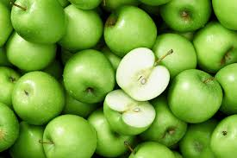 | Ubhal / apple

Cuir aodann toilichte anns am bogsa ceart / put a smiley face in the correct box:
Measan agus glasraich / Fruit and Vegetables | Ainm / Name | Anns an talamh / in the ground | Air mullach an talamh / above the ground
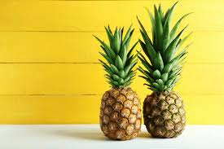 | Annan / pineapple
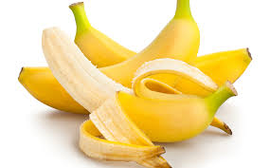 | Banana
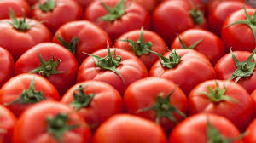 | Tomàto / tomato

Cuir aodann toilichte anns am bogsa ceart / put a smiley face in the correct box:
Measan agus glasraich / Fruit and Vegetables | Ainm / Name | Anns an talamh / in the ground | Air mullach an talamh / above the ground
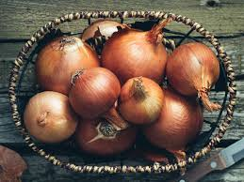 | Uinnean / Onion
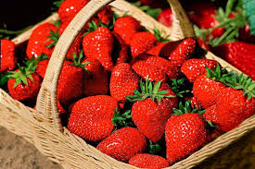 | Sùbh-làir / Strawberries
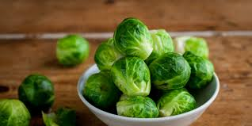 | Buinneag-bhruisealach / Brussel sprout

Dean dealbh de na measan agus glasraich is fheàrr leat / Draw a picture of your favourite fruits and vegetables:

