Biadh agus sgudal
Food and Waste First Level
Have a One Planet Picnic and take a photo

https://www.youtube.com/watch?v=FVArB2cnB4Y | 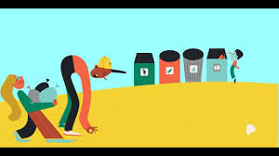
Find out how far your food has travelled to get to your house, which country did it originate in before being sold in the shops in Stornoway? eg. Bananas, coffee, sugar…which food has travelled the furthest?

Recycling
Double click

A food chain usually begins with a plant (which gets its energy from sunlight and nutrients from the soil). The plant could then be eaten by an insect. The insect is eaten by a bird. The bird is eaten by a large mammal. The mammal could die after being hit by a car. It decomposes and is broken down and used as food by bacteria and fungi

