Wednesday
Food and Waste Second Level
Have a One Planet Picnic and take a photo

https://www.youtube.com/watch?v=FVArB2cnB4Y | 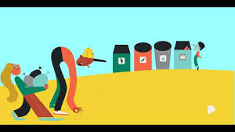
Find out how far your food has travelled to get to your house, which country did it originate in before being sold in the shops in Stornoway?

Most of us enjoy eating, and taking the calories and nutrition from the food we eat is important for life.
Eating food gives us energy and this energy powers everything we do, from playing a favourite sport to studying for a maths test or playing a game. It helps us fight off illness and helps us think. It makes us grow and keeps our hearts beating and the blood circulating through our bodies. Without energy from food, we could not live. This applies to every living thing on earth. Microbes, beetles, mice, hawks, flowers, salmon, grass, trees … if it’s alive, it needs energy.
Energy passes from one animal to another as they eat plants or one another. This flow of energy from one living thing to another is called a "food chain."

