Diciadain 17^{mh} an t-Og Mhios
One Planet Picnic Day

Dean deiseil airson Là Picnic air Diciadain!
It’s time to start planning your picnic for Wednesday!

Dè a tha eadar-dhealaichte mu dheidhinn One Planet Picnic?
What is different about a One Planet Picnic?

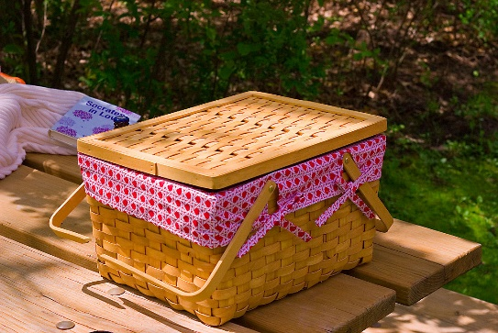
It’s a picnic that is good for you and good for the planet. That means:
- Choose as much food as you can that is produced locally
- Think of seasonal fruit like strawberries
- Choose organic and sustainable
- Look out for fairtrade
- Reduce food waste
- Be careful with your packaging. Remember no plastic

Cuimhnich gun tog sibh deilbh! Remember to take photos!

