Monday Early Level

Day One is all about water and plastic pollution. You can choose to do all or some of the activities for the day.

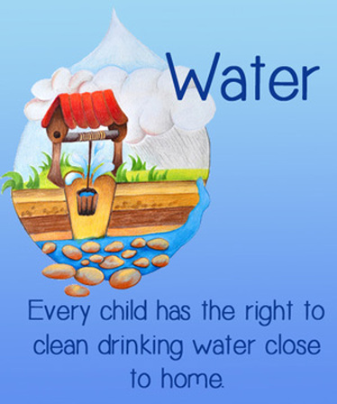

RRSA
Clean water is one of every child’s basic rights

Plastic in the sea

Double Click

Design your own poster to show at least three facts you have learned about plastics in the sea. |  | 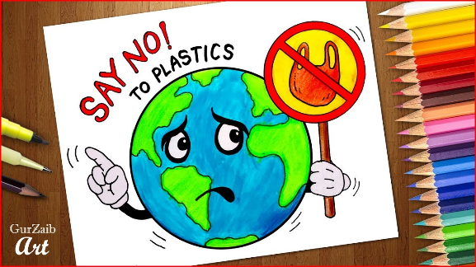
One Plastic Bag story:  https://www.youtube.com/watch?v=_B6p04Zph04 | 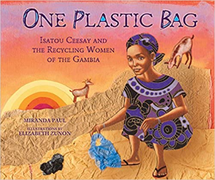
Design and make a replacement for a plastic bag:  You could use paper, fabric, cardboard etc.  Make it as strong as you can. |  | 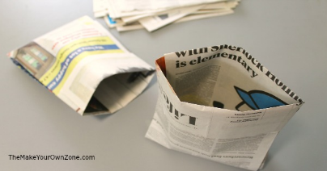
https://www.youtube.com/watch?v=xFPoIU5iiYQ  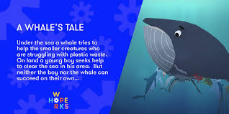 |  | Read and answer  Story time

