Monday First Level

Day One is all about water and plastic pollution. You can choose to do all or some of the activities for the day.

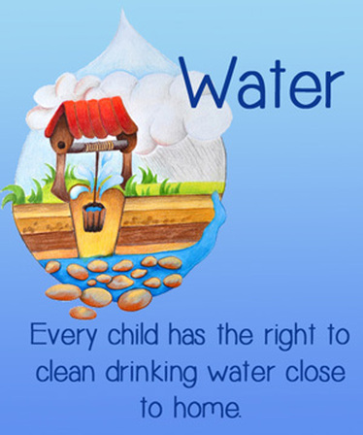

RRSA
Clean water is one of every child’s basic rights

Oxfam is one Charity which is working to make sure that all people can have clean water. |  | double click
Design your own poster to show some facts you have learned about plastics in the sea. |  | 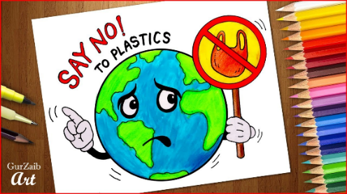
 |  | Water Wordsearch
Read for information

Design and make a replacement for a plastic bag:  You could use paper, fabric, cardboard etc.  Challenge: Your bag must be able to hold a tin of food. | 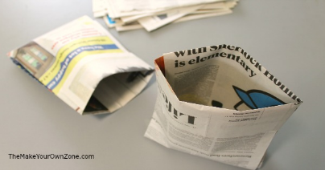
Read and answer questions

