Monday Second Level

Day One is all about water and plastic pollution. You can choose to do all or some of the activities for the day.

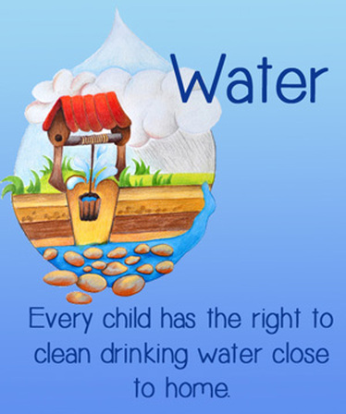

RRSA
Clean water is one of every child’s basic rights

Oxfam is one Charity which works towards ensuring clean water is accessible to all people.

The Mariana Trench is the deepest point on our planet. |  | Plastic pollution is one of the biggest threats to Climate Change and pollution.
Design something useful using plastic:  Children could make a bracelet like in the story (One Plastic Bag) or come up with their own idea. Lots of ideas online e.g.  http://handyhometips.com/things-you-can-make-using-plastic-bottles/ |  | 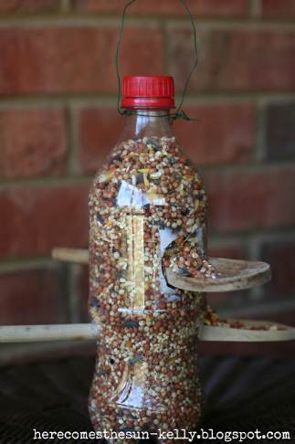
Water Wordsearch

Design and make a replacement for a plastic bag:  You could use paper, fabric, cardboard etc.  Challenge: It must be able to hold a tin of food |  | 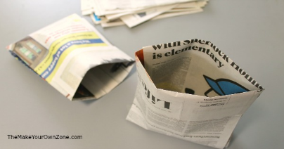
 | Read and answer questions

