Thursday - Animals
Make a bug hotel e.g.  https://www.redtedart.com/simple-bug-hotel-for-kids/  http://7474fab53f1b6ee92458-8f3ac932bad207a00c83e77eaee8d15c.r12.cf1.rackcdn.com/INSECT-HOTEL.jpg | 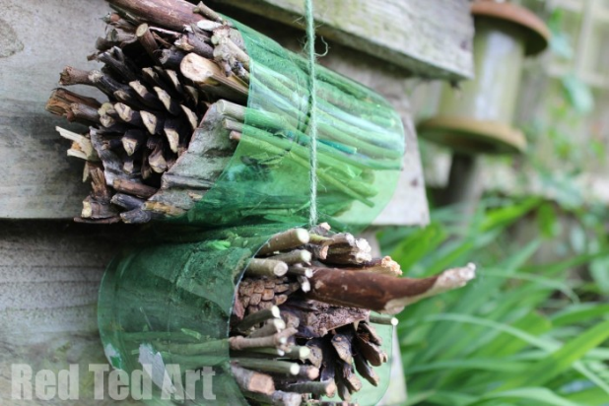
Make a butterfly feeder e.g.  https://www.diycraftsy.com/diy-butterfly-feeder-ideas/  http://628202242a032dff9975-8a88a36bd5b80e36c3634e14eb705770.r12.cf1.rackcdn.com/BUTTERFLY-TABLE.jpg | 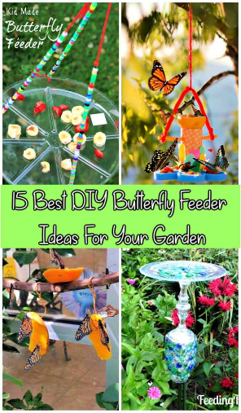
Go on a nature scavenger Hunt e.g.  https://www.quickhunts.com/topic-page/insects | 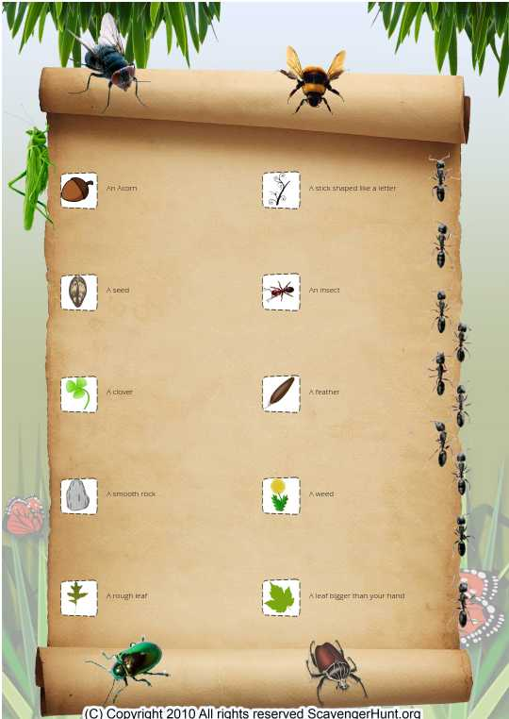
Make your own binoculars and investigate wildlife in your local area e.g.  http://7474fab53f1b6ee92458-8f3ac932bad207a00c83e77eaee8d15c.r12.cf1.rackcdn.com/Make%20your%20own%20binoculars%20(2).jpg | 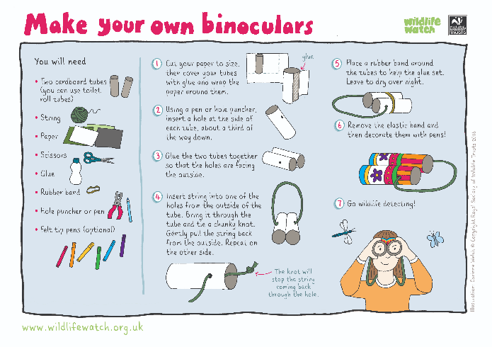
Make a wild area in your garden e.g.  http://7474fab53f1b6ee92458-8f3ac932bad207a00c83e77eaee8d15c.r12.cf1.rackcdn.com/WILD-GARDEN.jpg | 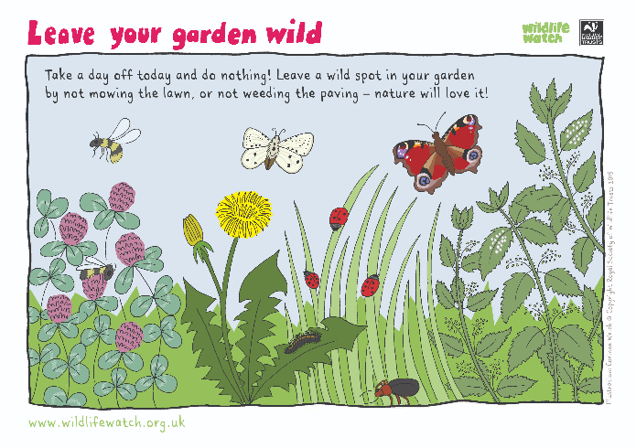
Make a mini nature reserve e.g.  http://7474fab53f1b6ee92458-8f3ac932bad207a00c83e77eaee8d15c.r12.cf1.rackcdn.com/MINI-NATURE-RESERVE.jpg | 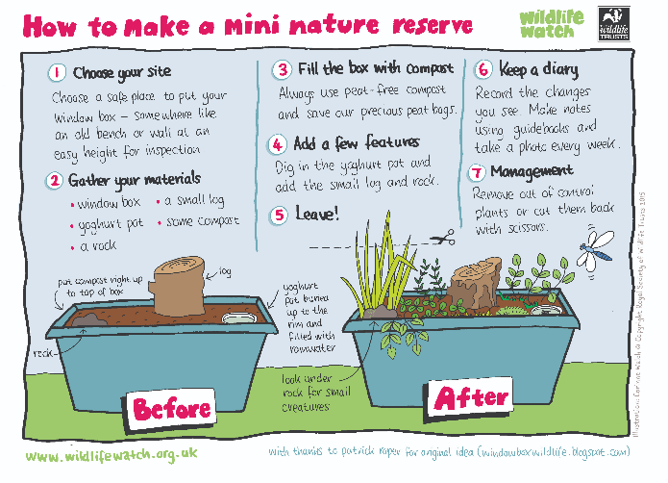
Make a bee watering hole e.g.  http://kidsinthegarden.co.uk/making-a-bee-watering-hole/ | 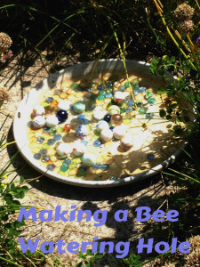
Make a terrarium e.g.  http://allparenting.com/my-me-time/articles/970451/how-to-make-a-terrarium-in-a-mason-jar | 