Dimàirt Tràth ìre
Tuesday Early Level

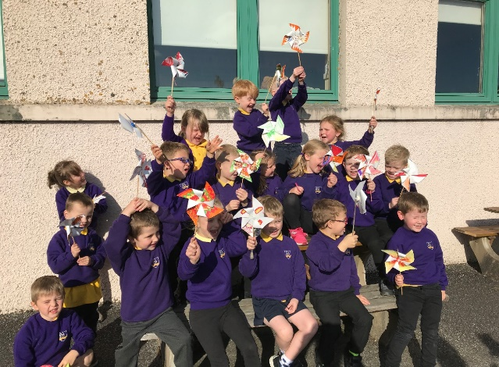
Day Two is all about electricity and energy. You can choose to do all or some of the activities for the day.

Tha sinn ag ionnsachadh mu dheidhinn Dealan agus Lùth an-diugh.

Double Click – this pdf will open in a separate window

https://www.youtube.com/watch?v=0zif9w_vqx0 | 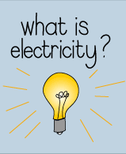
Cùm leabhar-latha dealain / Keep an electricity diary:  As you go through the day keep a note of all the ways you use electricity | 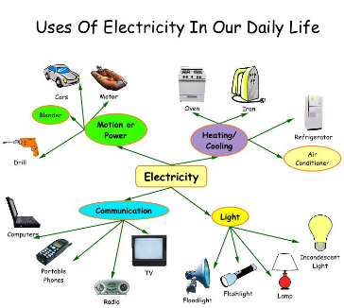
 | Double Click and choose which ones are renewable.
Lùth ath-nuadhachail / Renewable Energy:  Make a wind turbine e.g  https://www.easy-crafts-for-kids.com/paper-windmill.html | 