Tuesday P1-2

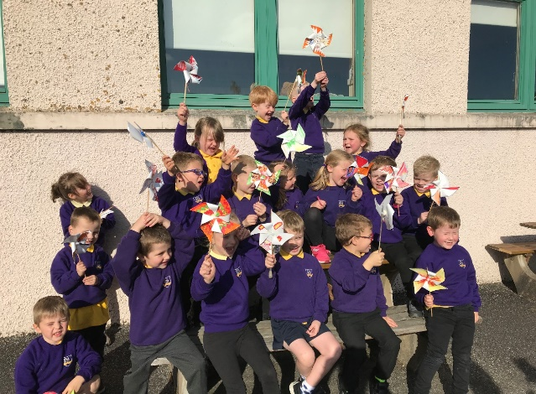
Day Two is all about electricity and energy. You can choose to do all or some of the activities for the day.

Double Click – this pdf will open in a separate window

https://www.youtube.com/watch?v=0zif9w_vqx0 | 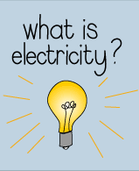
Keep an electricity diary:  As you go through the day keep a note  of all the ways you use electricity | 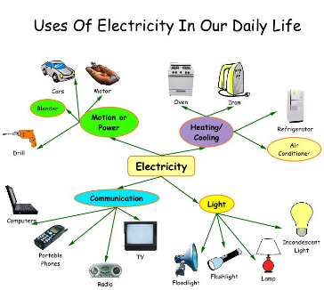
 | Double Click and choose which ones are renewable.
Renewable Energy:  Make a wind turbine  https://www.easy-crafts-for-kids.com/paper-windmill.html | 