You can choose to do all or some of the activities for the day.

Tuesday P3-4

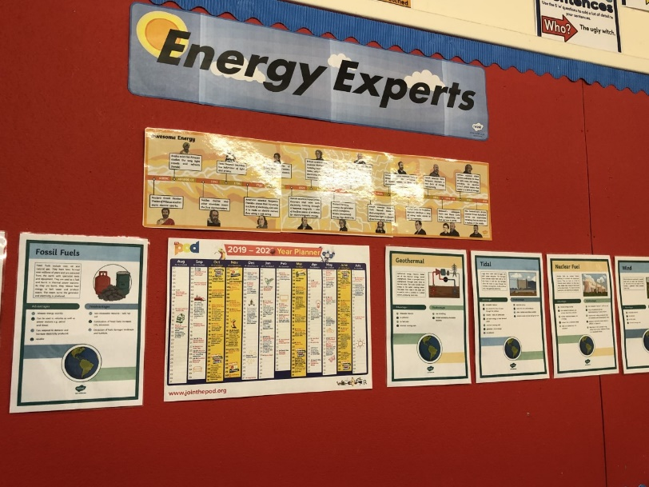
Day Two is all about electricity and other forms of energy. You can choose to do all or some of the activities for the day. Mrs Morrison’s class are already experts, so if you could write a paragraph about your project on energy it could be included to help with renewing our Eco Green Flag. Send your writing back to Mrs Hepburn on Glow.

How is electricity made?
How is electricity stored?
Look for Dangers

Screen free day  https://www.shebearconnection.com/screen-free-activities/ | 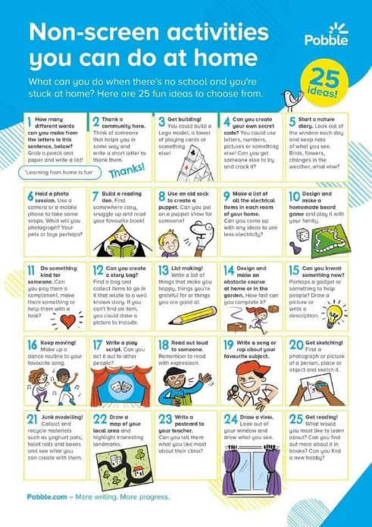
Double click | Unscramble words
https://www.bbc.co.uk/bitesize/topics/zdwmsbk/resources/1

bbc clips on power stations and wind farms

