You can choose to do all or some of the activities for the day.
Tuesday P5 - 7

Day Two is all about electricity and other forms of energy. You can choose to do all or some of the activities for the day.
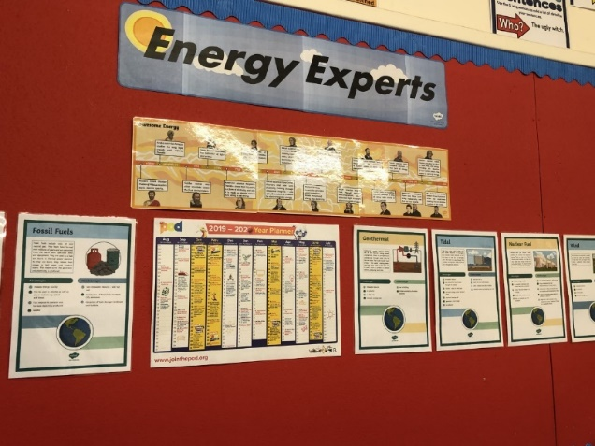
Mrs Morrison’s class are already experts, so if you could write a paragraph about your project on energy it could be included to help with renewing our Eco Green Flag. Send your writing back to Mrs Hepburn on Glow.

https://www.bbc.co.uk/bitesize/clips/zj3myrd | BBC – clips on Biodiesel, Biomass, Hydrogen and Renewables
Those of you with studyladder passwords can find work on circuits there.
 | Thomas Edison

