Attire & Shoe Policy

Shoes, Tights and Leotards are available for sale at the studio while supplies last.
We carry Bloch Brand Shoes.

Type of Dance Class | Required Attire and Footwear | Shoes as pictured
All Ballet  (Preschool – Grade 2) | Leotard and tights (skirt optional)  PINK Leather Ballet Shoes  (laces cut or tucked in) | 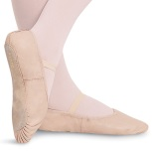
Tap with Intro to Jazz  (Ages 3 - 6) | Leotard and tights (See below)  BLACK Tap Shoes (Mary Jane with Elastic or Velcro Strap or tap ties, no laces please)  Intro Jazz portion of class:Footless tights and barefeet ORFooted tights with ballet shoes | 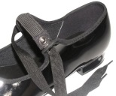
TAP  (Grades 1 & up) | Leotard and tights (skirt/shorts optional)  TAN Tap Shoes (Mary Jane with buckle) | 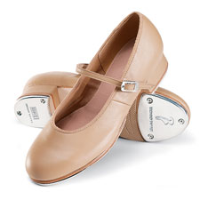
LYRICAL  (Grades 3 & up) | Leotard with tights (skirt/shorts optional)  Footless or convertible tights  NUDE Canvas Lyrical Turner | 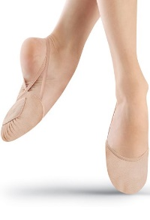
JAZZ  (All levels) | Leotard with shorts AND tights  OR Leotard with leggings  TAN Leather Jazz Shoes (slip on) | 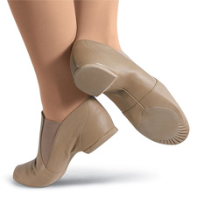
HIP HOP  (All Levels) | Leotard with shorts AND tights  OR Leotard with leggings  BLACK Hip Hop Sneakers | 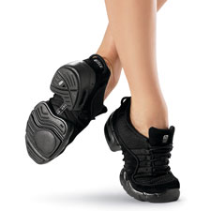

Please see below for additional information

Attire & Shoe Policy

- The above dress code and shoe requirements are mandatory for all classes.

- Leotards and tights must be clean and free of rips or holes.

- Hair MUST be securely tied back out of face.

- DO NOT wear your dance shoes outside.

- Children not dressed properly for class, without tied back hair, or found coming in from outside wearing their dance shoes, will be asked to sit out of class.

- All shoes must be brought to class in a dance bag.

- Names must be placed inside shoes and dance bags. We are not responsible for unlabeled shoes or belongings.

- If you have dance shoes in a different color from a previous level, you may wear them to start the season, however you must replace them with the correct shoe color by 12/1/17.

Street Clothes, Knotted or Baggy T-shirts, Sweats and
Street shoes are NOT permitted.

