Attire & Shoe Policy

Shoes, Tights and Leotards are available for sale at the studio while supplies last.

Type of Dance Class | Required Attire and Footwear | Shoes as pictured
BALLET  Monday 5:30  Wednesday 4:30  Saturday 9:30  Saturday 10:30 | Leotard and tights (skirt optional)  PINK Leather Ballet Shoes  (laces cut or tucked in) | 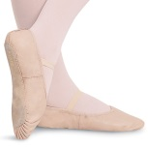
TAP  Wednesday 4:00  Saturday 9:00  Saturday 10:00 | Leotard and tights (skirt/shorts optional)  BLACK Tap Shoes (Mary Jane with Elastic or Velcro Strap, no laces please)  Wednesday & Saturday: Jazz portion of class - Footed tights with ballet shoes | 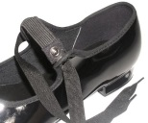
TAP  Monday 5:00  Tuesday 5:00 | Leotard and tights (skirt/shorts optional)  TAN Tap Shoes (Mary Jane with buckle) | 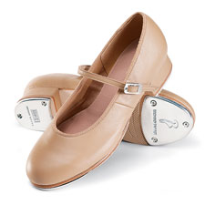
TAP  (Grades 6 & up)  Tuesday 7:00 | Leotard with shorts AND tights  Black Lace Up Tap Shoes | 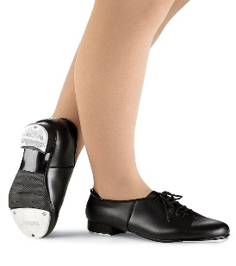
LYRICAL  Tuesday 5:30  Tuesday 7:30  Saturday 11:45 | Leotard (skirt/shorts optional)  Footless or convertible tights  NUDE Canvas Lyrical Turner | 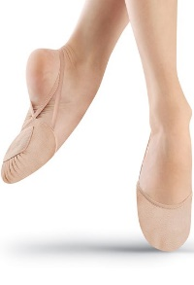
JAZZ/ HIP HOP  Monday 4:15  Tuesday 4:15  Tuesday 6:15  Saturday 11:00 | Leotard with shorts AND tights  OR Leotard with leggings  BLACK Jazz Sneakers | 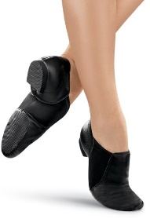

Please see below for additional information

Attire & Shoe Policy

- The above dress code and shoe requirements are mandatory for all classes.

- Leotards and tights must be clean and free of rips or holes.

- Hair MUST be securely tied back out of face.

- DO NOT wear your dance shoes outside.

- Children not dressed properly for class, without tied back hair, or found coming in from outside wearing their dance shoes, may be asked to sit out of class.

- All shoes must be brought to class in a dance bag.

- Names must be placed inside shoes and dance bags. We are not responsible for unlabeled shoes or belongings.

- If you have dance shoes in a different color from a previous level, you may wear them to start the season, however you must replace them with the correct shoe color by 12/1/20.

Street Clothes, Knotted or Baggy T-shirts, Sweats and
Street shoes are NOT permitted.

