From the desks of
David L Mellman MD &
Jeannette GUerrasio MD

Nov 3, 2020

To Our Patients,

Well today is finally here. From my conversations with our patient community, I know that the election has brought a lot of stress into our cummulative lives. May the results of the election be determined quickly and allow us to move on to the next chapter so that we have more reserve to focus on other things.

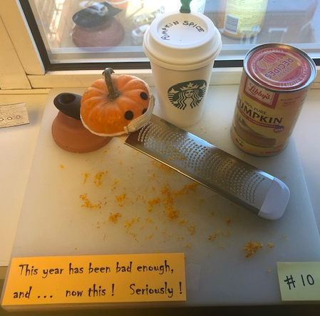
While COVID-19 may have hindered your usual Halloween plans, here are some shared photos:

A pumpkin decorating contest:

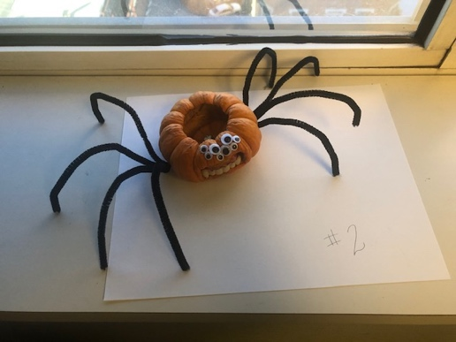

Pet corner:

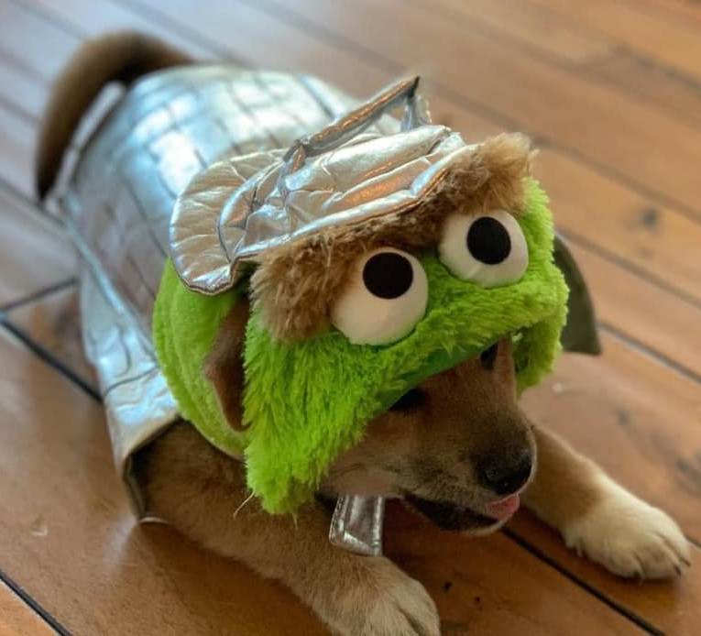

From a woman with the spirit of an angel and the legs of a witch, who loves wearing the socks her late mother gave her each Halloween for over 50+ years:

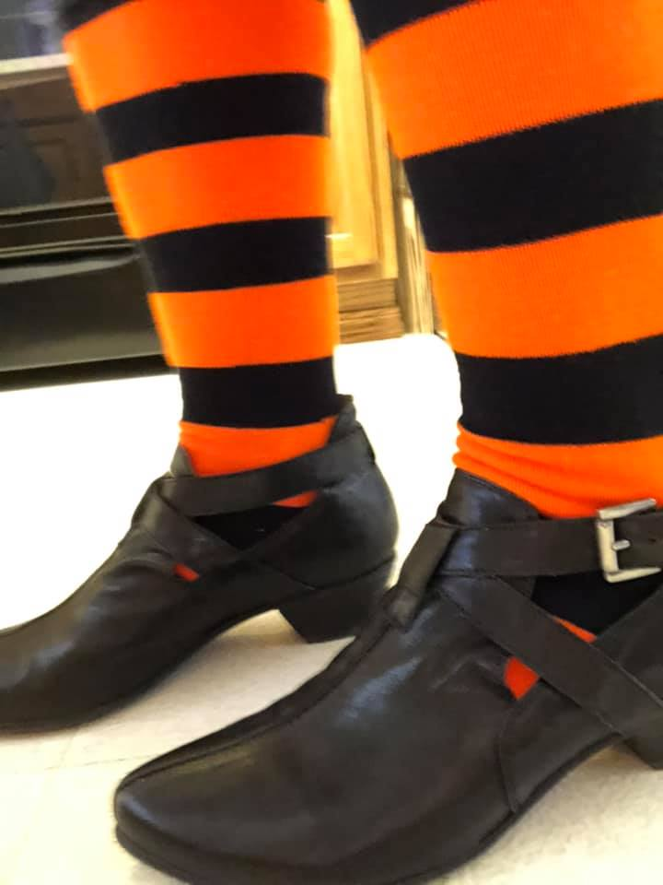

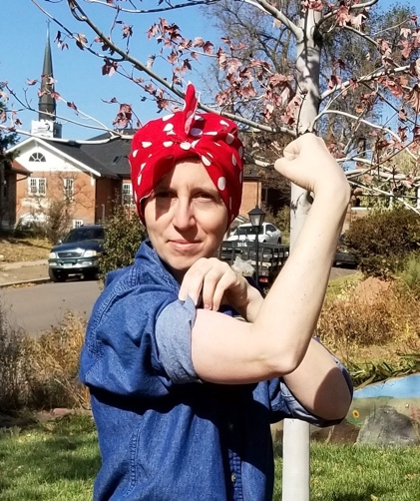
One out of two doctors enjoy celebrating Halloween:

Another Halloween idea sparked by a patient comment about the comic from the last newsletter:
My cousin is a pediatric dentist. She trades with her patient’s toys for candy to encourage better eating and less cavities!

Office Updates:

Our Nancy would not let me take her photo, but she dressed up as a patient for Halloween. The silver bonnet on her way into the operating room was truly priceless. Her surgery went well and she is on the path to recovery. She is already doing laps around the nurses’ station. She has just a few more days in the hospital and wants to write an article for the newsletter based on her experience as a patient in the hospital… stay tuned. I’ll let you all know when she is back home resting comfortably.

You may notice that the office staff are rotating in and out of the office. Many of the staff are working from home again now that the COVID-19 numbers are on the rise. We are doing this to protect you as well as our workforce. Thankfully, we have all remained COVID-19 free! You may have to leave messages when you call and the staff will call you right back!

COVID- 19 Updates:

I received 5 calls from neighbors, friends, in-laws and patients this weekend all about COVID-19 positive contacts. Here are the rules:
- If you come into contact with someone who has COVID-19 develop symptoms, you must isolate for 14 days. (that means you can’t even leave your home to get groceries). If you develop suspicious symptoms, you must isolate for 14 days.
- You may only leave the house to get tested.
  - If you test positive, you must notify your contacts from the past 14 days, that they must isolate and get tested.
  - If you test negative, you still have to isolate because the test is only 60-75% accurate depending on which test you get. The rapid tests are less accurate.
I know how hard these rules are to follow but it is essential for us as a community to get on top of the spread of this virus!

This Week’s Topic: Falls

“I’ve fallen and I can’t get up.” It was a catch phrase on a television commercial for Life Alert bracelets from the late 1980s/early 1990s. Actress Edith Fore became famous for playing Mrs. Fletcher, though the fall was actually performed by a stunt double. Maybe you remember that line, repeated it jokingly or even chuckled at it. Over 30 years later, it doesn’t seem quite as funny.

When I moved from New York to Colorado, I was shocked at how fit everyone around me was (and is). I used to joke with my mother, “In New York, my friends would invite me for dinner. In Colorado, my friends ask if I want to run a marathon and then get some breakfast or hike a 14,000-foot mountain and grab lunch.” I marveled at the athleticism all around me. Then all of a sudden, my marathon running, ultra-mountain climbing, mountain peak to mountain peak 100-mile bicycling friends, hit their late 50s and 60s and started falling. Sometimes on ice, sometimes on loose rocks and gravel, and sometimes on uneven pavements. And they didn’t just fall, they hurt themselves – broken bones, torn rotator cuffs, strained muscles and injured backs. What about age makes people more likely to fall? What about age makes people more likely to get injured?

There are three main categories and they overlap like this Venn diagram. As people age, there are two potential behavior changes that can occur. Patients who have fallen before or who are afraid of falling tend to lean forward and lower, as if carrying themselves closer to the ground will reduce injury. In fact, this posture causes one’s center of gravity to hover ahead of their body, rather than over their feet, making them more likely to fall. Secondly some patients, especially those with dementia and even mild cognitive impairment become more impulsive. They jump up and move faster, not allowing time for their bodies to find their balance, not lifting their feet high enough, forgetting canes and walkers, and not allowing time for their blood pressure to equilibrate causing dizziness. My 20-year-old niece is a chef and is on her feet all day. The muscles in her young healthy blood vessels keep the blood exactly where her body needs it at all times as she quickly moves around the kitchen. As people age their blood vessels calcify and become stiff, so that when patients stand up, they are not able to squeeze the blood from the legs up to the brain, resulting in dizziness. Any quick movement doesn’t give time for the body to compensate.

Arthritis causes stiffness and limits movement of the joints and muscle loss (sarcopenia) reduces strength, making it harder to catch oneself if they become off balance. Also, as people age, their reflexes greatly diminish. If I attempt to push my 18-year-old nephew over from behind, hard enough to knock him over, he will reach out his arms to catch himself and land with his hand close together near his face with his palms down. 80-year-olds fall more like an unconscious boxer or a felled tree. If I attempt to push my 80-year-old neighbor from any direction (I never would), he will invariably hit his face first. His reflexes will not be fast enough to even attempt to lift his arms and he will be left with a severely bruised face. One that I have sadly seen innumerable times in my career.

Other physical changes that result in falls include diminished vision, where visual acuity, depth perception, ability to detect contrast and vision in the dark is lost. Hearing and vestibular impairments affect balance by altering perception of one’s location relative to their environment. It becomes harder to tell, for example, if you are leaning too far backwards or too far forwards. Feet are also less sensitive so it can be more difficult to feel slopes and bumps in the terrain that need to be accounted for to avoid falls. There is also some evidence to suggest that poor nutrition, which is more prevalent in the elderly, increases one’s risks for falls. All of these physical changes are just a natural part of the aging process. Any additional illness would only make the risks higher.

Lastly, older people tend to be on more medications to manage a growing list of medical ailments that they have accumulated throughout their long lives. Any medication that can make the brain a bit foggy can contribute to falls. Even medication as simple as Benadryl for allergies, sedatives for insomnia, opioids for pain, benzodiazepines for anxiety, muscle relaxants, and alcohol can greatly increase the risk of falls. Any medication that can cause you to urinate at night (or the physical change of an enlarged prostate), making in necessary to get up and navigate in the dark, increases your risk of falls. While you may have taken these medications your entire life, as people age, the side effects become greater.

If you have fallen, you doctor will inquire about injuries and whether or not you have hit your head. They will take your vital signs. Then the physical exam will be very much tailored to you as an individual. It might include a consideration of your vision and hearing. The exam may test your gait, your balance, your strength, and your nerves. You might not even notice the doctor do this part of the exam as they are subtle about watching you enter the exam room and move from the chair to the exam table. The exam may include a closer look at certain joints, the bottoms of your feet, and your skin. Sometimes labs are indicated. Sometimes patients need additional cardiac testing, x-rays or EEGs. The diagnostic work-up is really based on the judgment of your doctor and all of these tests are by no means required nor are they helpful for most patients. I just wanted to give you an idea as to what you might encounter.

With falls come some dreaded risks. Most patients fear hip fractures for themselves or
their older relatives and friends. The one-year mortality rate of hip fracture is fairly high. Though you can die from the hip fracture itself, that is rare. Most people end up dying from the consequence of decreased mobility in the months following the injury. After hip fractures, patients tend to move less and lie in bed more. They can develop pressure ulcers on their buttock that become infected. If you stay in a bed for long periods of time, the bottoms of your lungs begin the collapse (atelectasis). The collapsed lung tissue becomes a warm moist place for bacteria to grow and patients develop pneumonia. It’s these infections that often lead to death.

Sometimes when patients fall, they land on furniture breaking ribs. Broken ribs are also
very dangerous, because the pain causes splinting and patients don’t want to take deep breaths. Shallow breaths lead to lung collapse and just like we discussed, pneumonia follows.

What if a patient falls and lies on the floor for 6 or 8 hours before someone finds them? Then in addition to the cuts and bruises, patients can develop bed sores, rhabdomyolysis and kidney failure. While lying on the ground, bed sores form on all of the bony parts of the body that are in contact with the floor. It is not uncommon to see bedsores develop on a person’s forehead, shoulder, elbow, knee and ankle. Muscles then breaks down causing extra protein to float around in the blood. This is called rhabdomyolysis. These proteins can then clog the kidneys and cause kidney failure. All of these conditions worsen the longer a person is on the ground without water, getting dehydrated.

The other thing that doctors worry about when a patient falls is bleeding in the brain. It is natural for our brains to shrink with age. This allows the brain to rattle more within the skull when someone falls, and puts them at increased risk of a torn blood vessel and developing bleeding called a subdural hematoma. These can be minor causing no symptoms, cause stroke like symptoms or lead to someone’s death.

But there is also hope and many, many things that you can do to avoid falls.
- Foot wear - Thin, hard sole shoes were the best for improving balance and reducing falls, though perceived as less comfortable than thick soft shoes. Athletic shoes or sneakers are also a great choice and much better than barefoot, high heels, stockings or slippers.
- Turn on the lights – Give yourself the best chance of seeing things that you might trip on… like the ever so quiet sneaky cat. Does the bathroom have a night light?
- Wear sensory aids – Make sure your glasses are the right prescription and that your hearing aids have batteries and wear them.
- Clear your paths – Identify direct paths from the bed to the bathroom, your favorite chair to the bathroom, the kitchen to the living room and then widen and unclutter the paths. This may require removing furniture and tying up or tucking extension cords behind furniture
- Safety devices – Consider hand rails going up all stairs inside and outside your home, in the shower and bathtub, next to the bed and around the toilet. Consider a shower chair. Raise the toilet seat. If you need a cane or walker use one. Many Coloradoans use a hiking pole instead of a cane to maintain their youthful appearance since everyone uses them descending steep mountain trails.
- Remove hazards – Eliminate throw rugs and mats that can easily be tripped on. Go with wall to wall carpet or just plain flooring. Empty high cabinets in the kitchen to avoid reaching and climbing.
- Exercise - You want to focus on balance and thigh strength starting in your 50s. Some people benefit from working with a trainer or physical therapist. Some people prefer to join a yoga or other balance fitness class. Others practice standing on one foot while brushing their teeth, heel lifts where you stand on the ball of your feet, tandem walking (heel to toe in a straight line) and standing from a deep seated position. To do this, sit on the bottom step of set of stairs or curb and simply stand up… as many times as you can. Don’t forget to make sure that you use good form – don’t let your knees pass your toes, stand straight up aiming your head at the ceiling the entire time and ideally don’t use your hands to help.
- Stay hydrated – Water is your friend, caffeine and alcohol are very dehydrating.
- Review your medication list with your physician at your physical - If certain pills, like diuretics or water pills make you get up at night to urinate, ask your doctor if you can take them earlier in the day.

If you have fallen, there are things you can do to help yourself.
- If your risk of falling is high, have an alert button accessible or a phone so that you can call for help and don’t have to lie on the floor.
- After an injury while you are less mobile, use an incentive spirometer inhalation device or just take a deep breaths and hold for 3 seconds. Do this 10-12 times an hour while you are awake.
- If you are on the floor or lying in bed recovering, rotate your body position every 2 hours to avoid bedsores.
- Even if you didn’t injure yourself, request physical therapy to help with strength and balance. If you did injure yourself the exercises will help restore you to your best level of functioning and much more quickly than if you try to do it on your own.
- See your doctor. Your injuries may be more severe than you thought.

Questions for Dave and I

- Do you have or recommend a first aid self help guide? I used to use The Barefoot Doctor overseas, but it now seems dated. Any suggestions?

I’m crowd sourcing this one. I know there are many travelers and adventurers in our practice. Does anyone have a favorite first aid self help guide that they like. I will get a copy and then review it on my website.

Well it’s 4:30am. The dogs have woken me up too early, so I’m going back to bed. Hopefully by now you have remembered to turn back your clocks. Will someone tell the furry children! Headed back to bed for another snooze. Take care of yourself. Enjoy the next few warm days. If you have any tips for others that would make being hospitalized more pleasant, please reply to this email. I’d like to include lots of tips in the next newsletter!

Best,

Jeannette and Dave

David L Mellman MD & Jeannette Guerrasio MD
David L Mellman MD, PLLC

