From the desks of
David L Mellman MD &
Jeannette GUerrasio MD

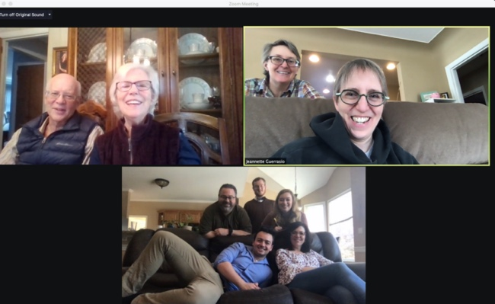
Dec 2, 2020

To Our Patients:

Thanksgiving is a day of giving thanks for the harvest of the preceding year. As tumultuous as 2020 has been, there is still much to be thankful for. I want to assure you that Dave and I listen to our own advice. Unlike a certain politician, we did not travel for the holidays and made full use of my Zoom account. Many of you will recognize my parents. I suppose it is time for you to meet the rest of the family. In the screen shot below is my brother with his wife, his daughter, who is an amazing chef, and his son, who is a musical theatre superstar. The tall guy in the back is my niece’s boyfriend and he is a professional brass player.

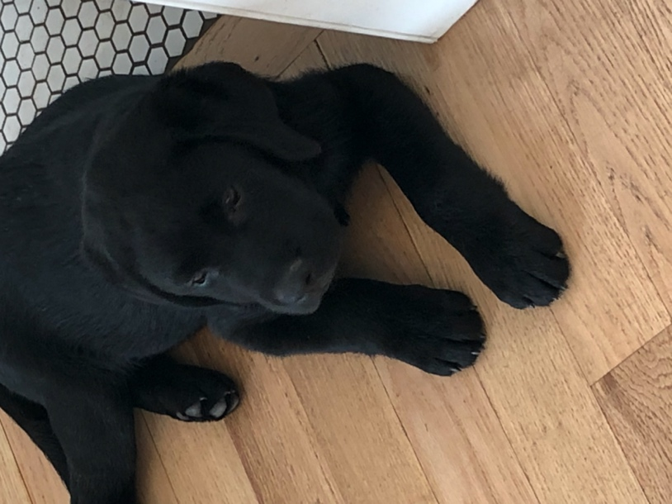
As an aside, my neice also loves to teach and she is trying to put together a program for our patient community. Stay tuned!
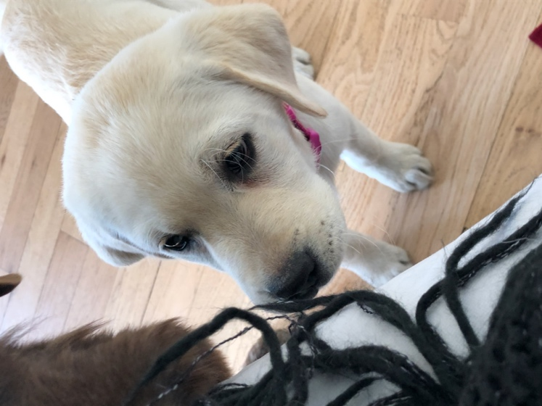
Meanwhile at Dave’s house, there has been nothing but pure puppy chaos! Did you know that puppies don’t sit still well for photos? No rest for their 15 year old chocolate English lab Mia!
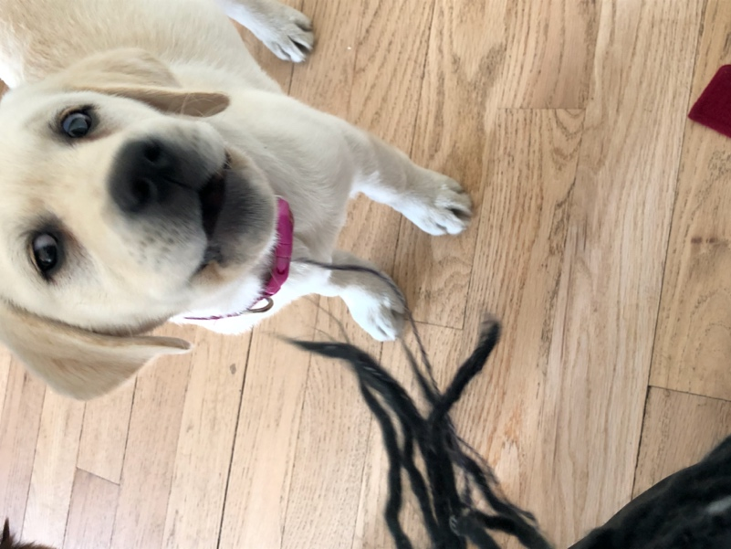
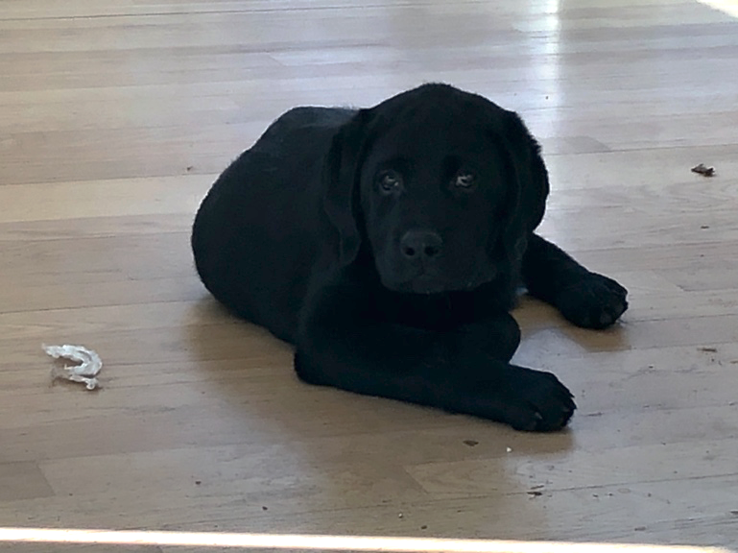
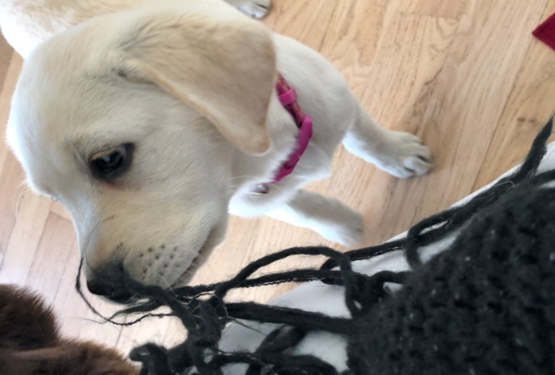
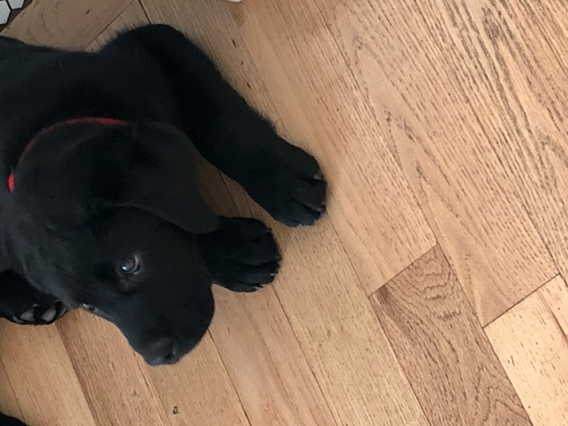
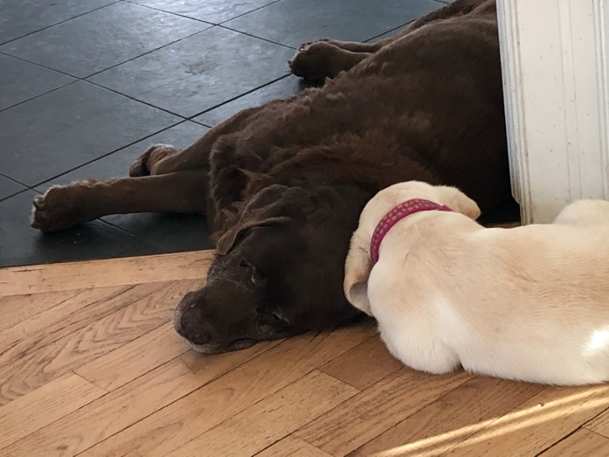
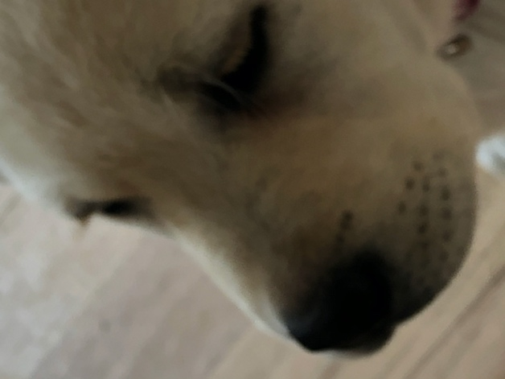

Our patients had a few great ideas for the holiday that they wanted to share.
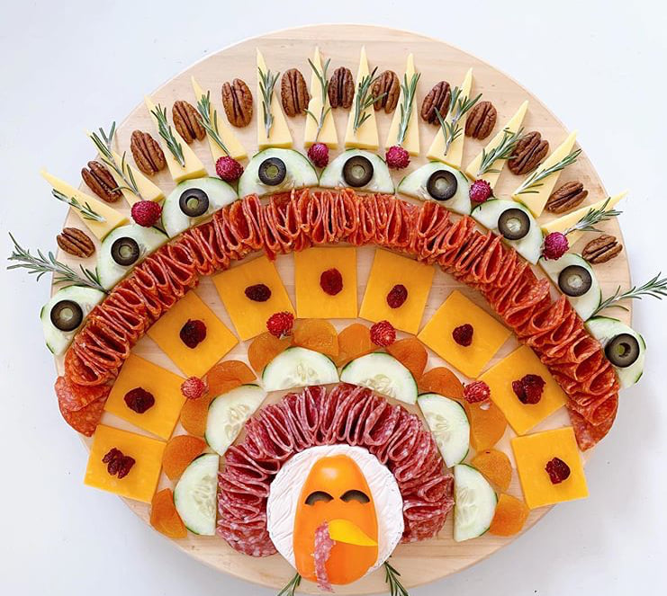
Patient Contributions:

- Appetizer ideas for next year!

- COVID-free guests to invite to your next party

- This is a beautiful moving art sculpture with an umbrella shared by one of our patients, who also highlighted the last sentence of the article, “There’s so much division going on in the world…something like this, where people could be together, people could be united in one project, and people could feel really good about being human for a few moments, that’s uplifting.” Be sure to click on the video imbedded in the article: https://www.nytimes.com/2020/11/20/arts/design/artist-elizabeth-turk-retirement-community.html

- After the resilience talk, the following YouTube video was recommended by a patient: Frida Kahlo Brooklyn Museum
https://www.youtube.com/watch?v=IWKSEvgAR58

Summary of the Talk on Resiliency

My mother would often reminisce about a game she played with her great grandfather when she was a small child. When she went to her great grandfather’s home, he would have a rubber ball set aside and a single shiny penny. To play the game, he would sit in a lawn chair on the cement patio and she would stand about 8 feet away. Between them on the ground would rest the shiny penny. They would bounce the rubber handball back and forth to each other trying to hit the penny, scoring 1 point each time the penny moved! It was a simple game for a grandparent to play with their grandchild and it left wonderful, happy lasting memories. It was also a game that I played with my grandmother and mother.
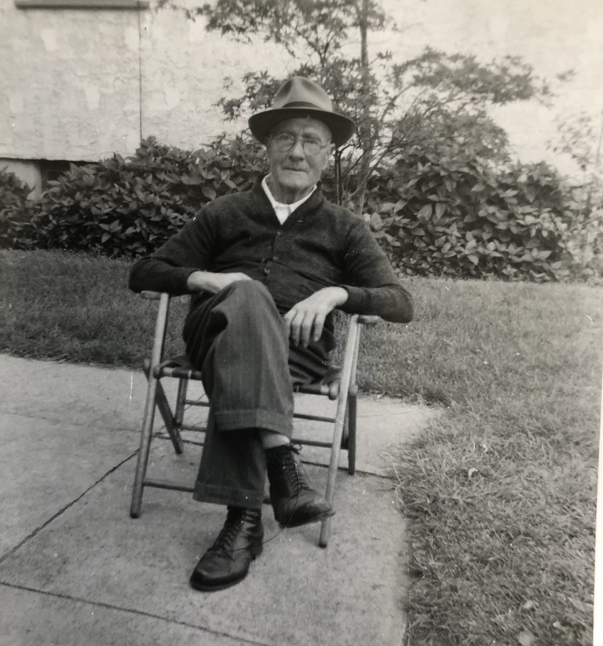
What made the rubber ball so much fun in this game was that it bounced. Despite being thrown to the ground, being disfigured with each impact, it always rebounded. It demonstrated great resilience, as did my competitive relatives who sometimes lost the game. It was a great way for my mother to develop a relationship with her great grandparents who only spoke a language she didn’t understand - Italian. It was also a great way for him to play with his great grandchildren even though he could no longer run around like he used to.

During this pandemic, I sometimes have entire days where every patient appointment is directly related to the stress of COVID-19 and its related life style changes. Patients present with anxiety, fear, depression, loneliness, helplessness, fatigue, lack of motivation, marital strain, worry over their children, feelings of being overwhelmed, financial stress, and despair from job loss. Other patients are coming in for their usual check-ups and seem to be taking all of the turmoil and change in remarkable stride.
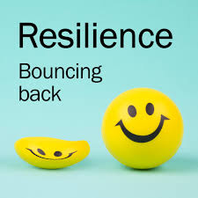
It made me reflect on what resilience means and what makes some people more resilient. I started by reading a series of articles in the New York Times about resilience and reflecting on what I had learned approximately 20 years ago about surviving residency training. Resilience is the ability to recover from difficult experiences, setbacks, and tragedies and to be able to move forward, learn, adapt and grow from one’s challenges. The first patient that I lost unexpectedly as a resident was 102 years old. He came in to the hospital with congestive heart failure. I was giving him medicine to take the extra fluid off of his heart. Each day he was getting better. His labs were improving and he felt great, and then unexpectedly he died. The heart monitor he was on did not reveal the cause of death and his family declined an autopsy. A loss of life is always difficult, and I was able to move forward and continue to take care of other patients that day, but I really wanted to know why he died. I called his primary care doctor, who was one of the smartest and most experienced doctors I knew. I wanted to understand so that I could learn for subsequent patients. I wanted to grow as a person from every patient interaction. The great doctor said to me, “Sometime people’s bodies just wear out and they die. Don’t think so hard. He was 102.” That in and of itself was a lesson, that I had never read in a medical school text book. Every loss, every challenge, and every mistake has made me the doctor that I am today.

Then I remembered a conversation I had with yet another one of my physically and mentally healthy patients in their 90s. Nancy is a 92-year-old woman and I asked her that cliché question, “How does one get to be 92 years old?” She responded, “I work out 3 times a day. I do 45 minutes of stretching in the morning, 45 minutes of weights in the afternoon and 45 minutes of treadmill in the evening. Don’t you wish you were retired too?” She is where I find my resilience. I am inspired by my patients every day. It is because of them that I exercise even when I don’t want to.

Throughout my life I have watched tens of thousands of patients, some more resilient than others, and, for some time, I couldn’t help but wonder if resilience wasn’t in part genetic. Well, as it turns out, genetics plays a very, very small part in one’s degree of resilience. While genetics influence temperament and personality and diseases like depression, anxiety and PTSD, there doesn’t seem to be a genetic link to resiliency. This may be because almost any trait can be either positive or negative depending on the situation.

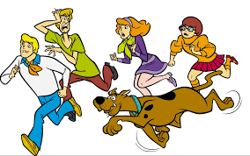
Say for example, you are hiking in the forest and you spot a wild animal. If you are genetically inclined to be impulsive or anxious or quick to startle, and take off running, this may be an advantage if you encounter a squirrel protecting its nest, but not if you encounter a bear protecting its cubs.

As it turns out resilience is taught. It is a set of skills that are learned from exposure to very difficult but manageable experiences. As a resident on a busy call night in the hospital, I learned that if I could cope with all that was happening, then by the next day I would be stronger and able to handle more. The actual story went like this. I was a second-year medical resident and it was my first night alone in the hospital without any senior physicians. I did have a brand new intern, but I knew all of the decisions, procedures, and life-saving code blues were my responsibility and that I had a team to lead. The way our hospital worked, I had already been working for 10 hours, when all of the other doctors left for the day. Within 15 minutes, I was called with 14 patients that needed to be admitted from the emergency department to the hospital. They each needed medications ordered, test and labs ordered, diets ordered, IV drips requested, consults called, and therapy requests placed. For 2 minutes, I was paralyzed and overwhelmed with the volume of work and the fear that I could get called with 30 more patients in the next hour. Then I rationalized that I could only see them one at a time and I asked the emergency room doctors and nurses to help me see the sickest people first. My intern and I survived that very busy night and so did all of our patients! After that night, there wasn’t anything that I didn’t feel I could handle. Each year of residency led to incrementally more responsibility and the development of resilience. By the time I was done, I was ready for the mass casualties that I would encounter every few years in my career. And now, I am ready for COVID-19.

People with more resilience often have a growth mindset rather than a fixed mindset. People with a fixed mindset see mistakes and challenges as signs of their own incompetence or failures and they give up. Those with a growth mind set see each setback as a way to learn and as an opportunity for growth. Of course, we all have characteristics of both, but tend to lean more in one direction than the other. If you try to build a dog house and the roof doesn’t fit, do you give up or do you keep working at it to either build a new roof or figure out how the make the current roof work?

People that are lucky enough to have quality close personal relationship and parents that they could form early healthy attachments to, find it easier to develop resilience. Attachment to others, especially at an early age is crucial. If you are not sure if you had healthy relationships as a child or now, ask yourself these questions. How loved did you feel as a child? How loved do you feel now? You would be surprised to learn how many adults have no close personal relationships.

Traumas and a person’s age at the time of the traumas impact one’s perception, interpretations and expectations. This also has a great impact on how resilience is fostered, developed and sustained. For example, if you lost your home in a hurricane, but your family remained tightly supportive, and you were able to move into secure housing and eventually a new home, you will experience resiliency differently than the person who loses their home and ends up homeless with their family. The impact on resilience is also very different for the trauma victim who is sexually abused as a child by a family member, loses their ability to rely on others and is left to develop their own adaptive system of self-reliance. Some are more successful at it than others and that largely depends on other features of their surrounding environment.

When we are faced with challenges so great that we become overwhelmed, we must resort to coping mechanisms. I use the word we, because it happens to all of us, all of the time. Some coping strategies are positive and adaptive and some are maladaptive. We all use strategies from each list, with the intentions of using less maladaptive strategies. I will admit that I indulged in a ridiculously large slice of apple-cranberry pie (al la mode) this evening for all of the wrong reasons… and that’s not the only one… today.

- Adaptive
  - Confronting problems directly
  - Making reasonable realistic appraisals of problems
  - Recognizing and changing unhealthy emotional reactions
  - Mindfulness
  - Trying to prevent adverse effects on the body
  - Planning, moral compass
  - Cognitive and emotional flexibility
  - Self compassion
  - Optimism (Positive reframing), Humor
  - Seeking care and reaching out for help in a health way
  - Social connectedness, degree of selflessness

- Maladaptive
  - Escaping problems, denial, avoidance
  - Distress
  - Anxiety
  - Blaming, venting
  - Risk taking behaviors
  - Lying
  - Fear
  - Rumination
  - Dwell on the negative
  - Physical symptoms

It turns out that these coping mechanisms become very deeply ingrained behavior, patterns that can be hard to change. But, it is not impossible! And, it’s never too late to change! How mindful can you be of your actions and emotions to identify the maladaptive behaviors? Can you consciously choose to replace them with an adaptive behavior instead? Most people need a life coach or a therapist to help make these changes.

What does this have to do with aging? Everything. Successful aging requires an incredible amount of resiliency because aging is full of change, challenges, setbacks, and obstacles. And there are benefits to consciously deciding how you are going to face these changes, especially the loss of your prior self-expectations. How might you react emotionally? How do you hope to react? What are you going to do when problems arise? Are you going to choose adaptive coping strategies? What are you going to do now to regain control and prevent problems from snowballing? What is most important to you? Can you be more flexible with your life and expectations? Are your showing yourself compassion? Are you continuing to build and feed your social network? How do you resist the social isolation that too commonly occurs with aging? There are many things that people have done to maintain and grow resilience as they age.

What You Can Do

- Dedicate time and energy to a worthy cause
  - Increases flexibility of thinking and puts your attention on something greater than yourself
- Celebrate small wins
- Learning something new – online course, learn to play the guitar
  - Also increases flexibility of thinking and refocuses your attention if having maladaptive thoughts
- Ask what can you change about your situation and ask positively
  - Even prisoners of war, who suffered greatly, were able to find areas of growth and meaning in their lives when they focused on what they could change or do with their situation
- How can you stay grounded in the present moment? Adapt your behavior. Hang on to what is most important in your life.
- Make a list of your skills and focus on your strengths
  - Include even the smallest things: ie. Kindness, loving animals, being an avid reader, making yummy pies
- Describe someone in your life who has been resilient that you admire
- Write or record stories of your life for the next generations
- Take a creative risk, without fear of making a mistake
  - Laugh at mistakes and enjoy them as opportunities (growth mindset)
- Listening to music and singing aloud
- Write in a journal daily, include not only what you did but reactions and emotions
- Finding ways to connect with others
  - It may be as simple as saying, “Hi” to the pharmacist or asking the checkout person at the grocery store about their day
- Practice finding words to express your emotions
- Exercise and eat healthy to build confidence and ability
- Seek help from professionals, psychiatrists, psychologists, therapist, religious leaders, life coaches

My father-in-law is 76 years old and we went hiking with him, and with his two granddogs at our heels. He kept up a shockingly fast pace for the 6 miles, faster than the lab-shepherd mix! He just retired less than a year ago, and we didn’t know what he was going to do. We worried because he is a quiet, humble man and work seemed all encompassing and it provided his social outlook as well. Now he spends more time camping and fishing. He hikes every day and studies the behavior of the wildlife - elk, deer, mountain lions, owls, and bald eagles - in the meadows behind his home. He’s made new friends with some of the neighbors and is making plans for future road trips. He is happy and carefree.

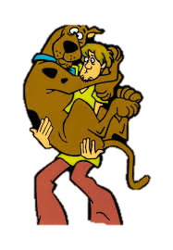
I’ve seen others, who have been asked to be resilient so many times in their life, lose the energy to fight out of pure fatigue of will. If you are there, how can this exhaustion be rescued or prevented in you? What keeps you going? What gives you resilience? Who gives you resilience? What allows you to dig deep and hold on in the most difficult moments so that you can get to the practices mentioned above? Let your doctor know so that they can help.

It is not always apparent when one needs support to be resilient. If you want to go it alone, okay. But, I would recommend that you reach out and ask for a hand. There are many people willing and able to help. There are certainly many in the same boat whom would love if you could team up and help keep each other afloat.

Questions for Dave and I
- I’ve read elsewhere that wearing glasses can be beneficial because they may shield one’s eyes against airborne COVID particles. The statement includes a time component that I hadn’t heard or read before. Is there something special about 8 hours?

The time component was only included because that was the criteria for the study. The more you wear eye glasses or eye protection, the more benefit you get from the airborne COVID-19. Cheers to by fellow 4-eyed friends! We are finally COOL!

- You wrote that “antibodies against COVID seem to be lasting at least five months.” My first question is: does that imply that the antibodies don’t generally last longer than five months, or is it that the information we have available at this time confirms only that they last as long as five months and in time, we may learn the antibodies provide protection much longer?

Right now, we can confirm that for most people the antibodies last at least five months, but are likely to learn as time goes by that the antibodies last much longer.

- Do we know how long the protection from the vaccines will last? Is the nature of the protection provided by the vaccines different than the nature of the protection provided by antibodies?

We do not know yet how long the vaccine will last. Currently, the virus appears to be mutating slower than the flu, meaning that the vaccine should last at least a year, but likely much longer. We will let you know as we learn more.

- Can we get a COVID vaccine at your office?

As of today, the answer is no. Last we heard, the state department was going to set up distribution centers throughout each county. However, this is in constant evolution now that the Moderna vaccine is a bit more portable. We will let you know as we learn more!

- Can I get one first?

I have seen two tiered recommendations for vaccine distribution. Both have health care workers first, with seniors at the top (Colorado). One list prioritized seniors who lived in community residences before seniors in general (Federal recommendation). I will let you know as we hear more.

- Are you and Dr. Mellman getting the vaccine?

Yes.

We love hearing from you! Keep sending newsletter pieces, ideas, questions, and concerns.

Hang in There!

Jeannette and Dave

David L Mellman MD & Jeannette Guerrasio MD
David L Mellman MD, PLLC

