From the desks of
David L Mellman MD &
Jeannette GUerrasio MD

May 1, 2020

To Our Patients:

We sure miss being able to smile at our patients. I (Jeannette) was so happy to see a patient that I hadn’t seen for a while, that I reached out to put my hand on her arm and she pulled away. It was the correct thing for her to do, but it made me so sad. I reacted from the heart, forgetting for a moment, despite breathing warm humid recycled air through my mask, that we are living in this new world. We miss the small human connections. Can you tell from my eyes alone that I’m smiling and happy to see you? Or that I grinned because I loved the comment you made, because it was so endearingly you? We must find new ways to recapture those connections.

And who else do we miss? Kris and Nancy! While they are still working hard and communicating with us regularly, their presence is so missed in the office. We miss their stories, the news updates, the political commentary, the social updates, the laughter, the sounding board, the advice, the support… and sharing bread and pie.

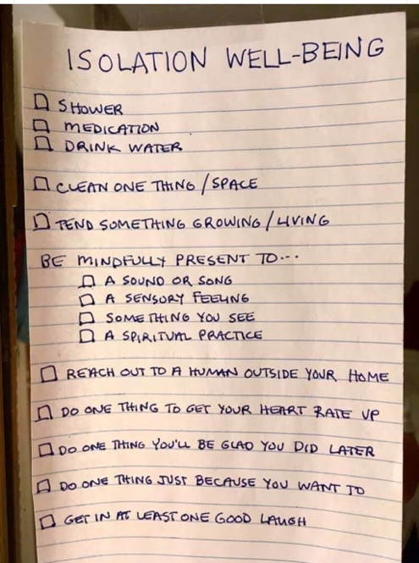
We are all overwhelmed by the love and care that you have sent our way, making sure that we are doing well and have stayed healthy. Thank you. Let us assure you that we feel so lucky to do the work we do and to be able to go to work every day.

Random Thoughts:
- As Shelter-in-Place turns to Safer-At-Home, days are becoming less structured for some and more amorphous
  - Continue to wake up at about the same time as you normally would, +/- 1 hour
  - Continue to go to bed at about the same time as you normally would, +/- 1 hour
  - Keep to a routine
  - Get dress every day, even if the closes are comfortable , don’t stay in your pajamas
  - Consider making Friday, button pants day… so you don’t lose track of you eating habits (Bra day still remains optional)
  - Consider going for evening walks if you have been working all day from home
  - If you are inclined to schedules create one for the day

- Pick on thing each day to look forward to.
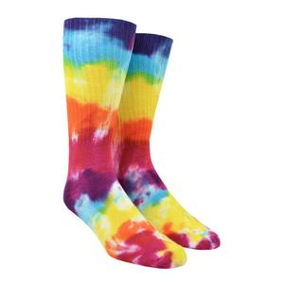
  - Don’t laugh. Residency was hard. The shifts were long and the 36-hour shifts were frequent, not to mention sandwiched between 12-hour work days. I received a pair of brightly colored socks for my birthday, that I began calling my “lucky” socks. Half way through a 36-hour shift I would look forward to putting on my warm, soft, happy and most importantly dry socks. They gave be a reason to smile on the hardest most exhausting days and carried me through the 2nd half of all of my longest shifts!

- Fitness tips of the week:
  - When the gym opens up again… start where you are, not where you were
  - If you are hunched over a computer all day, consider a plank or pushup to reset your shoulder posture.
  - If you spend a lot of the day sitting be sure to move frequently throughout the day even for short periods of time or take 20 minutes a day to stretch your back, hips flexors and hamstrings.

- You might remember, from a prior newsletter, that one of our patients got a puppy during the COVID 19 shelter in place order. Meet 3 month old Mickey the Shih Tzu who popped out of Mom’s purse to say, “Hello!”

Questions for Dave and I:
- There are two antibody tests for COVID 19 called IgM and IgG. What are the differences?
IgM tests to see if you currently have the virus, however, you have to be sick for about 7 days before IgM is detectable. The IgG tests to see if you have ever had COVID 19 in the past.
- There are questions about the quality and thus effectiveness of some current antibody testing regimens. What are the limitations of the test?
There are many different types of coronaviruses, many that cause a respiratory illness much like the common cold. Some of the tests may confuse COVID-19 with these other types of Coronaviruses. If for example the test is of poor quality, it may say yes you have IgG antibodies to COVID 19, when you really have antibodies to the common cold. In this instance it is dangerous because you may stop taking the proper precautions and you may end up getting COVID 19!
National Jewish is a great lab, but even they cannot completely rule out cross reactivity with 4 other similar looking coronaviruses. However, National Jewish’s test is about 95% accurate. Remember also that no test is 100% accurate. There will always be people with COVID 19 that have a negative test and people who don’t have COVID 19 who have a positive test.
- What does it mean if my IgG is negative?
You are NOT immune to COVID 19. Please continue to follow all of the precautionary measures that we have been discussing in prior newsletters.
- What does it mean if my IgG is positive?
You have antibodies to a coronavirus and it is most likely COVID-19. Remember, the National Jewish’s test is about 95% accurate. While we would love to say that this means you are immune, that is unclear. Our best guess is that you carry some level of immunity so that if you were re-exposed to COVID-19 in the next few months, you either would not get it or you would get a milder version. (more below)
- What does it mean if my IgM is negative?
You may have COVID 19 and it’s too early to tell OR you don’t have it.
- What does it mean if my IgM is positive?
You have coronavirus, most likely COVID 19, and must isolate yourself for 14 days. You should also notify everyone that you have been in contact with for the past 2 weeks, that they need to be in quarantine for 2 weeks.
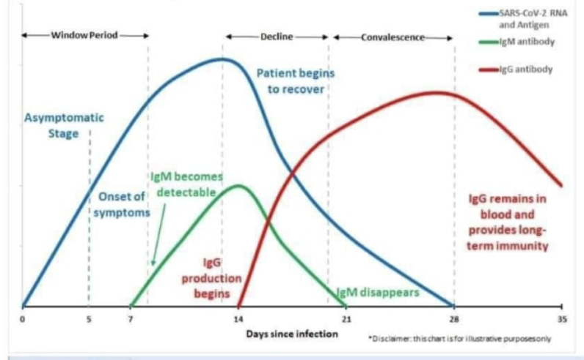
- Can you tell from the test how long a person has had their COVID-19 antibodies?
Not for IgG. If you test IgG positive, there is no way to tell how long you have had the antibodies or when you got COVID 19. IgM antibodies appear on day 7 of the illness and disappear around day 21. So, if your IgM is positive, you became infected sometime in the past 3 weeks.
- Is it true that over time, antibodies decline in their effectiveness? Perhaps, because they were not developed from a vaccination?
Yes, over time antibodies decline in effectiveness. Vaccines also decline in effectiveness, hence the need for booster shots.
- Why does the presence of antibodies prevent some viruses like the measles and smallpox, but not others like the flu?
Antibodies are virus specific. Having antibodies for measles prevents 90% measles infection. Having smallpox antibodies prevents smallpox infection. If you get the flu, you develop antibodies for the flu. Unfortunately, some viruses mutate or adapt more quickly than others. Those that mutate quickly, like the flu, become unrecognizable to the antibodies that your body currently has. A new vaccine for the flu is required each year so that you may develop new antibodies that recognize the most current strains or adaptations of the flu virus. Even with the yearly flu vaccine, your antibodies only prevents about 50% of flu infections because it keeps mutating. As an aside, HIV mutates even more rapidly that the flu. In fact, it mutates so rapidly that a vaccine has been elusive.
It is too early to tell how effective a COVID 19 vaccine will be, how long it will provide immunity and if you will need yearly shots like the flu. Similarly, it is too early to know if the IgG antibodies will provide immunity for months, years, or just partially immunity, because we don’t know how fast the virus will mutate/adapt. We are sure, that a vaccine is the answer to more social and economic freedom again!

Please feel free to send questions for upcoming newsletters, by replying to this email. We regret that the “Talks with Tea” have been put on hold. The next talk was going to be on Advance Directives. While a very serious discussion, we think it is very important. We have included a summary of the discussion in a separate attachment for those who are interested. It will also be available with downloadable forms on Jeannette’s website at www.jeannetteguerrasiomd.com.
Be well. Continue to social distance as much as possible and wear your masks! We are happy to help in any way that we can.
Sincerely,
Jeannette and Dave

David L Mellman MD & Jeannette Guerrasio MD
David L Mellman MD, PLLC

