From the desks of
David L Mellman MD &
Jeannette GUerrasio MD

May 12, 2020

To Our Patients:

Someone in our patient community said that before the pandemic we as a society had stopped looking into peoples’ eyes. Now that everyone is wearing a mask we have the opportunity to really notice peoples’ eyes, look into them and see people in a deeper way. Perhaps at a time that it is more important than ever, we will truly start to see others like we never have before.

We have seen tremendous strength in our patients who have been tested in a new way. While this seems a bit premature, I want to acknowledge our patients who have been infected with COVID-19 and report that they have all survived, from 35 to 95 years old! Additionally, we are grateful to all of our patients who have endured the “Stay at Home” orders for themselves and to honorably protect their community, and wish to recognize you. The past few weeks have been no small feat.

Random Suggestions:
- If you find yourself awake tonight unable to sleep from insomnia, worry, or just restless, take a good look up at the sky. The moon, Jupiter and Saturn will “closely” approach the earth.
  - On May 27th, Comet Swan will be arcing across the sky and will be visible to the naked eye.

- As we head back to busier in-person schedules, don’t try to tackle everything at once. You are not personally responsible to catch everything up.

- Some days are hard. Acknowledge it. Even when doing the right thing, there is uncertainty.
Know you are doing your best and that is all you can do.

Questions for Dave and I:
- It is getting very hot to wear a mask. None of my neighbors are wearing masks anymore and lots of people are gathering. Do I really need to keep wearing a mask?

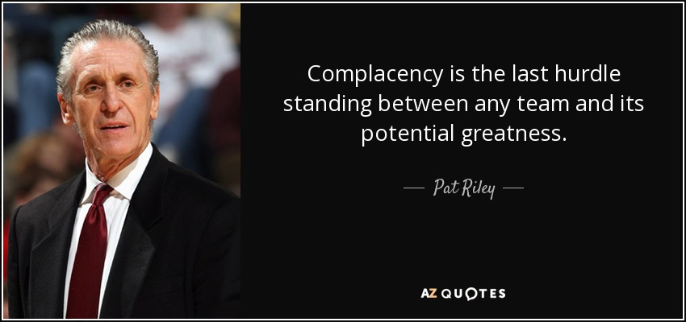
We remain big fans of wearing masks when you are around other people to limit the spread of cough, sneezes, and other spittle that we project from our mouths. A cough releases 3,000 droplets, a sneeze 30,000 droplets, speaking 500-5000 droplets and a breath 50-5000 droplets. Each droplet might contain 1000 virus particles… I’ll let you do the math.

We also need to make sure that simply wearing a mask doesn’t lull us into complacency. We can’t just go back to our former lives wearing masks. We need to continue to limit large gathering and contacts.

- Where am I most likely to get infected?

Restaurants, birthdays and social gatherings, weddings, funerals, workplaces especially those with open floor plans, conferences, indoor sports, churches, public transportation. In common, they are all indoor events with people closely spaced, talking, singing, or yelling for a duration of time. Spaces that are well-ventilated (like outdoors) and that you move through quickly (like the grocery store) pose a lower risk.

- How dangerous are people with no symptoms who don’t know they have the virus (COVID-19)?

44% of all infections have come from asymptomatic or pre-symptomatic.

- Is it safe for me to go get my hair and nails done at the salon?

Unfortunately, we cannot guarantee your safety or that the situation is going to be better in a few weeks or even a few months. However, we need to find the safest ways of returning to the activities that are of most value to us. If getting your hair and nails done at the salon is one of those activities for you, then wear a mask, wash your hands before and after your visit, avoid touching your face and spend as little time in the salon as possible. Also, make sure that your salon is being COVID-19 responsible. Are they wearing masks? Are they wearing them properly? Is the salon crowded? Are they wiping down stations between clients? Etc.

- Is it safer for my hairdresser to come to my house to do my hair if she wears gloves, mask and shoe booties?

Yes, it is safer for you to have your hair done at home. After you hairdresser leaves, wipe down the areas that he or she was working with >60% alcohol or diluted bleach and any touched surfaces, such as door knobs and faucets.

- I have a dental appointment and an appointment for a mammogram scheduled. I have no doubt they are taking great precautions, but I’m still feeling reluctant and would appreciate your advice.

First, please don’t delay necessary care. Dave and I have been in the office throughout the entire pandemic and will continue to be available to you. A few people have gotten very sick because they didn’t want to bother us. If you are sick or have a chronic condition that is worsening, please call us! We don’t want to see anyone get sick unnecessarily.
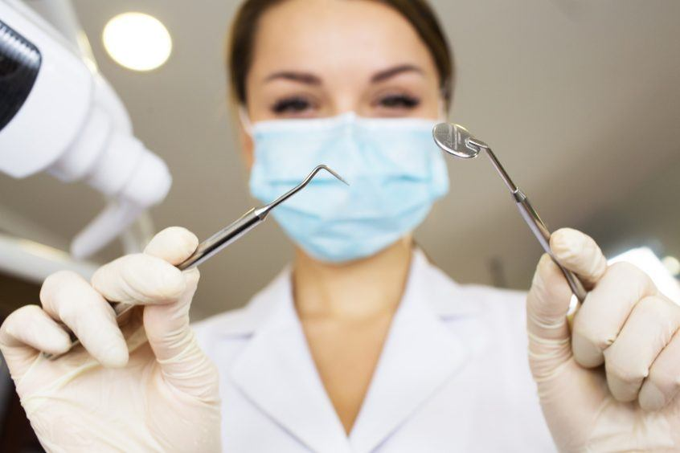
The same applies to going to the dentist. I hate to see a cavity turn into a root canal or a root canal turn into an abscess or a tooth extraction. Unfortunately, the situation with the pandemic is not likely to improve for a while. Take precautions and continue to take care of yourself, including getting your mammogram and dental cleanings.

- Does the scar tissue in my lungs mean I am more apt to die if I get COVID19?

Not necessarily. People can have scar tissue in their lungs for many reasons. People with extensive lung scarring from diseases like IPF (idiopathic pulmonary fibrosis) or CF (cystic fibrosis) are at greater risk of more serious lung complications from the disease. Someone who has scarring from an old infection, such as tuberculosis, probably wouldn’t be at higher risk.

People with lung diseases that scar and result in flare-ups, like COPD (chronic obstructive pulmonary disease), are more likely to struggle because in addition to COVID 19, they are likely to suffer from a flare-up of their underlying disease at the same time.

The biggest risk factors in general include: high blood pressure, diabetes, high cholesterol, coronary artery disease (plaques or stents or heart attacks), atrial fibrillation, serious heart disease, COPD, asthma, people on dialysis, cancer and congestive heart failure. (in that order) You will notice that lung conditions are not even on the top of the list.

While likely not your biggest concern, several people have noticed changes in their skin from the continuous masking of their beautiful faces. Fortunately, also thanks to the mask, others cannot see the new pimples, blackheads and wrinkles trying to decorate your chin and cheeks. Since the Skin Care talk will be cancelled, I’ve summarized the talk and included it along with this email for your “Safer at Home” reading pleasure. It will also be available along with previous talks on Jeannette’s website at www.jeannetteguerrasiomd.com.

As always, feel free to send questions for the next email update on COVID-19 or skin care!

Your faithful team,

Jeannette and Dave

David L Mellman MD & Jeannette Guerrasio MD
David L Mellman MD, PLLC

