From the desks of
David L Mellman MD &
Jeannette GUerrasio MD

May 19, 2020

To Our Patients:

I was driving to the office last week, listening to NPR/CPR as they reported that the rates of depression in Denver have increased from 7% to 20% since the start of the pandemic. This did not come as a surprise; I have seen the looks on your faces after sheltering in place for so long…

It did, however, give me an idea for this weekly update. Whether or not you have gotten COVID-19 or a new mental health disorder, the pandemic is impacting your mental and physical health. So, we thought it would be important to discuss how to combat the pandemic’s effects on your health.

We also have a few practice updates that we are looking forward to sharing. Anna is completing her additional college course work and will be returning to the office as my (Jeannette’s) Medical Assistant. Murphy, the office mascot, is as happy and sweet as ever, but may have out grown her space in the office. Betsy from the front desk has announced her retirement and while we are happy for her, she will be greatly missed. She was dedicated and cared very much for our patient community.

Combatting the Pandemic’s Effect on Your Health

In the initial months of the COVID-19 outbreak, when the virus was being compared to the flu, many people used the “Shelter in Place” restrictions as an opportunity. With less travel and less social commitments, we collectively reported a sense of relief from our fast-paced lives. It was a chance to recover. We stepped back from the chaos, took a deep breath, got caught up, and found balance once again.

But as the pandemic waxed on, it began to affect everyone in a deleterious way. We were inundated with news and medical updates, that were constantly being updated and revised. The inconsistent messaging and the list of unknowns filled our minds with uncertainty. When will the pandemic end? When can I see my family and friends? Who will get sick? Who will die? Will my job, business, and income remain secure? What else might be lost?

Unlike other tragic events which are one-time events, like a hurricane or the death of loved one, a pandemic poses unique stressors. In addition to all of the uncertainty, pandemics affects everyone. With no one unscathed to tend to the affected, we are left fighting something we can’t see, causing more distrust and conflict in communities. The long duration imposes more of an erosive effect on individual mental and physical health than if this was a single incident, Now, we live with a constant threat of danger. And most notably, this pandemic has taken away many of our healthy coping mechanisms. We are isolated from our social support groups, be it family or friends, athletics, playing in a band or having a drink with colleagues after work. We are devoid of human touch, even a hug or a hand on the shoulder.

We are living in a chronic state of higher stress with no opportunity to return to a lower baseline level. Even for individuals who are not as aware of their moods or anxiety, there may be subtle clues. Do you smile and laugh as much as you used to? Are you as easy going, or as we say in my family, are you getting a little crispy? Whether we like it or not, this chronic stress affects both our psychologic and medical health.

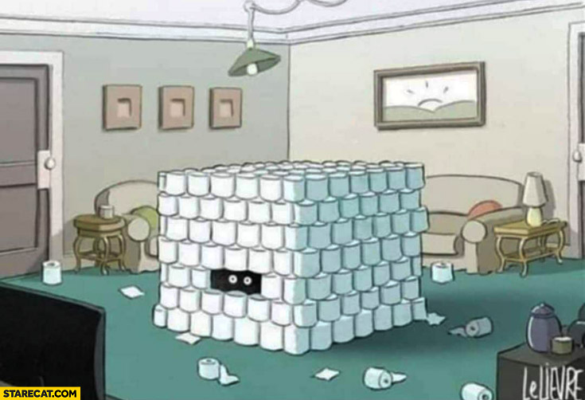
Anxiety is our body’s response to a vague future threat. Will I get it? Should I avoid others? Should I avoid my elderly relatives or grandkids? Is my sore throat from allergies or COVID-19? Where can I find some toilet paper (assuming you still have three rolls left)? Remember, anxiety feeds on uncertainty and “what ifs?” What if I get sick? What if I never see my friend again? Anxiety makes the most uncertain, unlikely and usually manageable threat seem incredibly certain and completely unmanageable.

Now, if you have no toilet paper left, “Where can I find some toilet paper?” becomes a fear. A fear is a response to a specific and imminent danger. My spouse is COVID-19 positive, how sick will my spouse get? Am I going to get sick? How many people have we crossed paths with in the past 14 days? Most of us are living with anxiety rather than fear.

Any chronic stress such as that caused by the pandemic makes us more vulnerable to anxiety and depression. Anxiety and depression often go hand-in-hand. When our brains perceive danger, they are hardwired to focus on the danger. This primitive response is counter-productive today, especially since being hyper-focused on the danger prevents other part of our brains from functioning normally. It struggles to compensate and adapt as it normally does, since all of its attention is focused on COVID-19.

The added risk factors depression is the isolation that we are all experiencing and may also include grief over our personal and societal losses, having to adjust to a new lifestyle (even if temporary), and for some, being trapped indoors in independent and assisted living facilities.

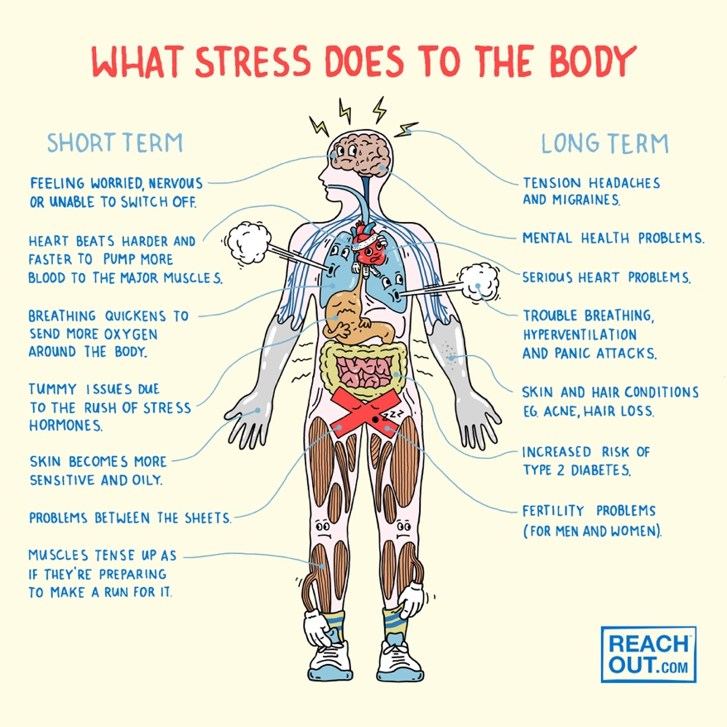
Many patients have asked about maintaining their strong immune system during the pandemic. Unfortunately, chronic stress also decreases your immune system. But that is not the only impact that it has on your physical health. Stress increases your fight-or-flight hormones (adrenaline and norepinephrine) and cortisol. These lead to an increase in your heart rate, blood pressure, blood sugars and abdominal weight, putting extra pressure on your organs and vascular system. This is why it is important to take care of your physical health, which includes managing any chronic medical diseases during the pandemic, and to follow the tips below to reduce your stress.

Pandemics leave people feeling helpless, powerless, overwhelmed, and paralyzed. Action helps to overcome these feelings and reduce stress, leading to overall better health. Here are some things that you can do:

Manage your anxiety and reduce your stress
- Focus on what you do know as oppose to what you don’t know
  - The majority of the people who get COVID 19 have symptoms that are minor and are manageable
  - Dave and I are always here to support you and help you with your medical needs
- Focus on what’s in your control as opposed to what isn’t
  - You can’t control others behaviors, but you can move away from the unmasked person in the grocery store
- Focus on what you can do as opposed to what you can’t
  - If you can’t play soccer, you can still work on drills and your foot work
- Exercise
  - It can be a stroll after dinner every night or an intense bike ride
  - I once heard that the same area of your brain that increases in size when you take antidepressants increases in size when you exercise
- Healthy eating
  - Limiting sweets and desserts helps with mood and healthy foods also boost the immune system
  - Zinc, carotenoids, Vitamins A, B, C, D, E, Probiotics, omega-3 fatty acids all help boost the immune system (More on this in the future)
  - Getting vitamins from your food is preferred over supplements!
- Help yourself by helping others
  - Did you ask the neighbor if they needed anything at the store before you went?
  - Did you call and check in with others this week just to see how they were doing?
- Limit your news consumption
  - Once a day is sufficient if not more than enough
  - Go to trusted news sources… or else Dave and I
- Take note of your coping mechanisms
  - Are they healthy?
  - Are you eating too much? Drinking too much? Too much marijuana? This was fine for a few weeks, but it is time to get back on track.
  - Are to communicating with people who lift you up rather than bring you down?
- Continue to seek medical care
- For new illnesses
- For your anxiety, depression and fears
- For follow-up of your chronic illnesses
- Reassurance
  - The world will return to a better place again.

The next issue of this communication will likely be delayed due to the holiday. But please stay tuned. We hope to cover the topics of genetics and proteomics. If you have any questions related to COVID-19 or genetics and proteomics, please reply to this email and we will gladly answer them in the next email update.
Be well. Continue to social distance as much as possible and wear your masks! We are happy to help in any way that we can.
Sincerely,
Jeannette and Dave

David L Mellman MD & Jeannette Guerrasio MD
David L Mellman MD, PLLC

References:
Winch. G. “Dear Guy:’I’m incredibly anxious about coronavirus. What can I do?’
from Mar 17, 2020. www.ideas.ted.com

Mind the Brain Podcast from the University Of Colorado from May 14, 2020 https://soundcloud.com/anschutz-dept-psychiatry/covid-19-a-unique-threat-to-mental-health

