From the desks of
David L Mellman MD &
Jeannette GUerrasio MD

July 10, 2020

To Our Patients,

For those of you who live in Denver, did you notice that there have been more fireworks this year? This photo, by Dr. Persoff a former colleague at the University of Colorado, shows you how many fireworks exploded across Denver in just 20 seconds!

Dr. Persoff is best known for his work in emergency preparedness and for his storm photography. His photos of snowflakes are among my favorites. If only they could make you feel cool during this heat wave. If you are interested, you can check out his images as https://stormdoctor.smugmug.com.

There are no pictures of animals this week. They are all still hiding under the bed.

Office Updates
- Shae Patnoe (left), physical therapist, will be bring back balance classes back to Lindsay Park directly across the street from the practice. Classes will be COVID conscious with distance, masks, hand sanitizer and gloves for specific activities. Watch for upcoming details!

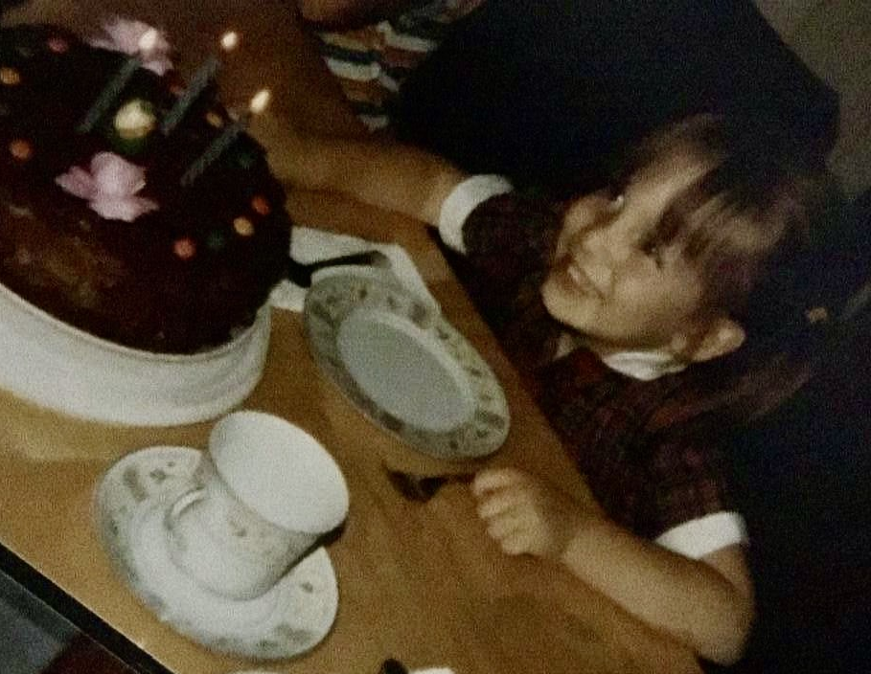
- With carrot cake and lots of love, Jeannette turned another year older this week in her desperate attempts to catch up to Dave. Almost there! (Yes, that’s really a photo of Jeannette on her third birthday, courtesy of Mom who found it and Dad who probably took the photo.)

Telemedicine
Telemedicine is the provision of health services via electronic information and telecommunication technologies. Specifically, Dave and I use multiple forms of technology to reach out to our patients. Before COVID-19, we readily called you with lab and test results, in response to your phone calls and questions, to check-in with you after an event and to follow-up on your care. Some of our patients utilize the portal to send us notes directly to our electronic health record and can respond to throughout the workday, while others send us emails that we tend to in the evenings. Most patient care visits, however, remained in person.

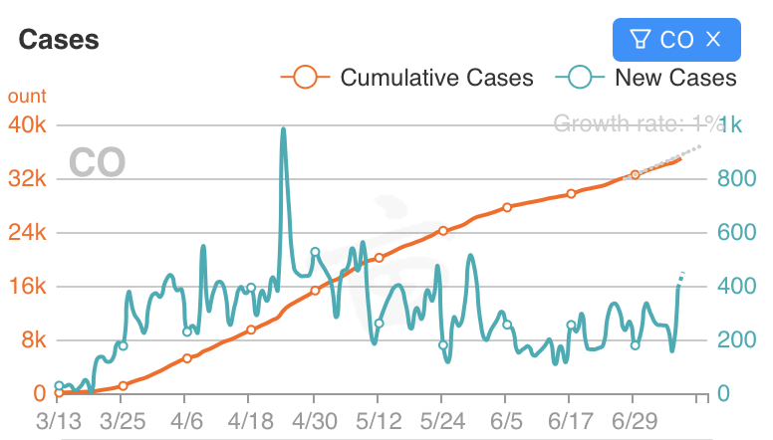
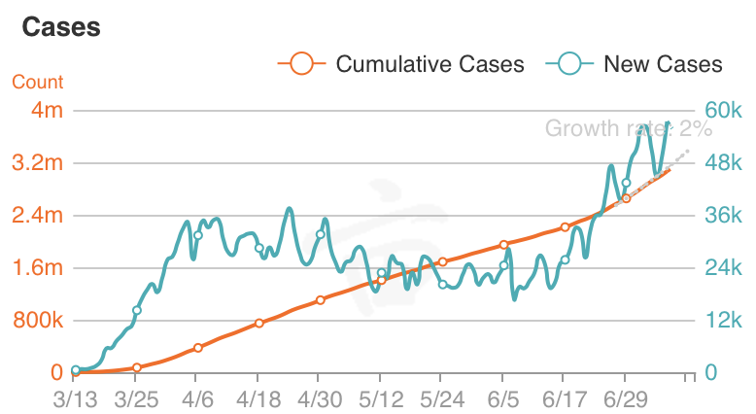
When COVID-19 arrived without invitation, we started conducting many “office visits” via the telephone, FaceTime or Zoom. Right now COVID-19 cases are relatively stable compared to the rest of the country. (see below, with Colorado on the left and the United States on the right) Many patients are taking advantage of this lull to get caught up on needed medical visits, screening test, dental visits and procedures.

We too have seen an increase in office visits and a decrease in telemedicine visits. We suspect however that this trend will oscillate as does the pandemic until it is over. As with any technology, there are advantages when it is used appropriately and disadvantages that are magnified when it is used inappropriately. Let’s review some of the pros and cons of telemedicine.

Pros
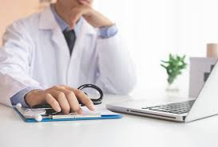
- Convenience - Some patients have found telemedicine to be much more convenient. Those who have trouble taking time off from work to come in for appointments are able to save travel time by interacting with Dave and I via technology. Also, patients who are more homebound, by personal limitation or COVID mandate, have a way of accessing care.
- Decreases expense – Some of our patients do not drive and travel to our office by Lyft or Uber. Telemedicine can save patients’ transportation expenses.
- Increased Engagement – Some patients report that they are more engaged in an online or telephone visit or conversation because they find it easier to ask questions. It is also a great means for quick checks in, like following up on an office visit.
- Timeliness – Telephone calls from Dave and I allow for prompt report of lab and test results. Other forms of technology also allow for a quick and convenient way for you to access your physicians. Studies have shown that just knowing you have good access to your doctors decreases depression, anxiety and stress.
- Reduces spread of illness – This is something that Dave and I have been very consciences about. We have made the appropriate changes to our office and are screening patients before they come into the office to reduce the spread of illness. If the number of cases in Colorado increase again, we may start doing more “office visits” over technology or home visit to reduce the spread of illness.
- Reduces cancellations – Our patients very infrequently cancel their appointments, and when they do, with good reason. The literature shows that the attendance rate for FaceTime and Zoom appointments is higher than for in-office visits. This makes sense as there are several fewer barriers to getting to your appointment – driving, driving time, traffic, parking, finding the office, etc.
- Limits unnecessary urgent and emergent care– Statistically, having telemedicine as on option decreases urgent care visits, emergency department visits and hospital admissions. Most notably hospital admissions are reduced by 38% when you are able to access your doctors by technology, including phone within 24 hours. Fortunately, this is something that the office has always provided even before COVID 19 and which has clearly benefitted our patients.
- Improves access in rural areas – For our rural patients, this improves access. It also improves access for patients who (sore subject) traveled a lot for business and will do so again.

Cons
- A barrier – On of the best things about medicine is the relationship you develop with your physicians. As they get to know you, they are better able to provide the care that will best serve you. Telemedicine creates a barrier between you and your doctor. Bottomline, care is better in person. However, some care is better than none and the occasional telemedicine visit should not affect your overall health.
- Another virtual encounter – Some patients are spending their work days glued to the computer. A trip to the doctor has been a welcome relief when we were all otherwise sheltering at home. A visit with your doctor on FaceTime or Zoom may feel like yet another work meeting.
- Requires technological devices – Some of us may take for granted the level of virtual connectivity that we have all relied on to maintain our social connections and mental health, by reducing our sense of isolation. However, about 15% of our patient community does not use email. Telemedicine presents a huge hurdle for patients without internet, reliable internet connectivity, technological devices, knowledge to download and use software, and savvy to navigate the system when the Zoom call doesn’t connect without a hitch.
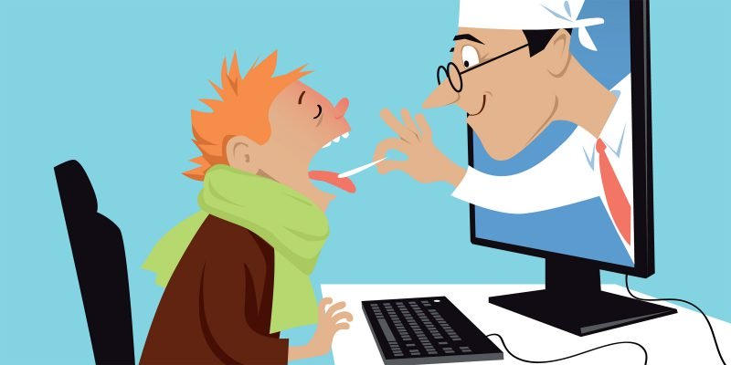
- Limited assessments – The biggest challenge for Dave and I is taking care of you without being able to do a physical exam. About 70-80% of the time the exam provides confirmatory information to the diagnoses and treatment plan that we are already considering. However, 20-30% of the time, the physical helps us identify the problem and devise a treatment plan. The three exams that can be difficult to do virtually are joint exams, lung exam, and ear exam. Occasionally the others need to be done in person as well. Also, labs and tests may not be possible to arrange remotely. It will be up to Dave and I to use our clinical judgement to decide when people absolutely need to be seen in person.
- Costs/billing issues – These do not affect you in our practice. I mention it only because some of the specialists you see may be running into tricky insurance reimbursement rules. I suspect that will fall mostly on the physicians but you may hear about it. If you receive an unexpected bill, please talk to your physician.
- We miss you – You all know that I have no trouble being the sappy one, but I am not alone. Dave missed seeing you around the office just as much. I just thought I would let you know. But ultimately, we want to keep you safe and will return to more telemedicine visits to keep you healthy if needed.
Telemedicine is a wonderful tool to have and I think it is a great supplement to traditional “in-office visits” for when unique circumstances arise:
- You have a quick question or request (phone, portal, email)
- We want to give you a quick update (phone, portal, email)
- We don’t want to put you at risk of spreading or catching an illness (phone, FaceTime, Zoom)
- You aren’t near Denver (phone, FaceTime, Zoom)
- You can’t physically get to the office (phone, FaceTime, Zoom)
- The office is closed at night or on the weekends and you need to speak with a doctor urgently (phone)
Our office staff, Nancy and Kris who spend most of their time answering phones. They are happy to help make recommendations or to chat with Dave and I to see if an “in-office” visit would be safest and most appropriate or if telemedicine would be just as effective.

Questions for Dave and I

- Where can I get the most efficient COVID-19 nasal swab testing?
COVID Nasal Swab Testing Options
Remember nasal swab testing is the preferred testing method to see if you have COVID-19 now. The test is about 70% accurate. Tests may be falsely negative, meaning you have the virus but the test says you don’t. If your symptoms are mostly diarrhea and less cough, a rectal swab may be preferred to increase accuracy.
NONE of the testing options are perfect. We have heard complaints about all of the sites, but currently, they are more efficient than our office. It has taken up to 7-12 days to gets tests results back when sent from our office.

- CO COVID Drive Up is an extension of the Women’s Health Group, a Women's Health medical practice with multiple locations throughout Denver. The COVID nasal swab and antibody tests are provided and processed by Unipath, a Colorado based diagnostics and clinical testing facility here in Denver. Testing is fully covered by most insurance plans. Test results are provided to everyone who is tested via email or text 24-48 hours after tests are taken. Results are delivered to employees and associates via email or phone number provided on the secure patient form in 48 hours.

- Rocky Mountain Urgent Care is providing a clinic in their parking lot. Patient's must email them their driver's license, insurance card, address & phone number. Once it is received, a MA will give the patient a call to schedule. They are promoting that their test results take 48-72 hours. Patients can also call (303) 529-8317 and select the urgent care to get more info. They do not need a physician referral for this. aurora@rm-uc.com

- The Pepsi Center is proving nasal swab testing through Lab Corp. Appointments are not required. You can just drive through, but there may be a wait. A referral is not required. You have to set up an online account to get results that can be cumbersome. Results should be back in 48-72 hours.

- AFC Urgent Care locations throughout Denver are providing drive through nasal swab testing. They require an appointment. A referral is not required. See https://afcurgentcaredenver.com/covid-19-testing/ for more details.

- How should I be washing my facemasks so that I am not subjecting more disease?

It is as important to dry your mask after you wash it as it is wash it! The dryer kills more bacteria and viruses than the washer. In fact, you should even wash your hands after you transfer your clothes from the washer to the dryer. A little bit of virus or bacteria on clothes can spread throughout the whole load during the wash cycle, only to be killed in the dryer.

According to the CDC:
How to Wash & Dry Your Facemask
  - Washing Machine
    - You can include your face covering with your regular laundry.
    - Use regular laundry detergent and the warmest appropriate water setting for the cloth used to make the face covering.
  - Washing by hand
    - Prepare a bleach solution by mixing:
      - 5 tablespoons (1/3rd cup) household bleach per gallon of room temperature water or
      - 4 teaspoons household bleach per quart of room temperature water
    - Check the label to see if your bleach is intended for disinfection. Some bleach products, such as those designed for safe use on colored clothing, may not be suitable for disinfection.
    - Soak the face covering in the bleach solution for 5 minutes.
    - Rinse thoroughly with cool or room temperature water.
  - Dryer (preferred)
    - Use the highest heat setting and leave in the dryer until completely dry.
  - Air
    - Lay flat and allow to completely dry. If possible, place the cloth face covering in direct sunlight.
One benefit of this pandemic over prior pandemics is the hot electric or gas dryer!

- I have returned to outdoor yoga/tai chi classes. We are adequately spaced, 6 feet apart, but some of my classmates are not wearing masks and are encouraging the teacher to take off his mask. Should he be wearing his mask?
Yes. And so should you. We wish that your fellow classmates would wear their masks for your safety however, there are certainly pockets of resistance to following the guidelines. If the class were indoors, we would say, definitely do not go. The risk outside is fairly low. Perhaps standing at the perimeter or near like-minded folks will help ease concern.
- What is your favorite website for tracking COVID?
My personal favorite is: https://coronavirus.1point3acres.com. You may have to choose the English version. There are daily updates for the United States and globally. Also you can click on Colorado and get more specific state and county level data. Some states update throughout the day. Colorado updates the data around 5:30pm each evening.
As always, we remain here for you. We send you our love and care. Keep sending your questions! Please stay cool and hydrated during these hot summer days.
Take care,
Jeannette and Dave

David L Mellman MD & Jeannette Guerrasio MD
David L Mellman MD, PLLC

