From the desks of
David L Mellman MD &
Jeannette GUerrasio MD

April 23, 2020
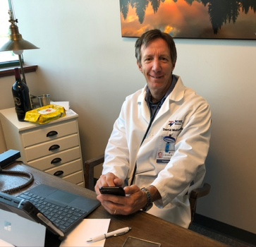
To Our Patients:

Dr. Dave Mellman has built quite an amazing team. Nancy and Kris have been sheltering-in-place safely in their homes, answer phone messages as quickly as possible. Because they are home, they are unable to pick up the office phone directly. Instead they retrieve messages between phone calls and call patients back as soon as possible. (Thank you for your understanding and patience.)

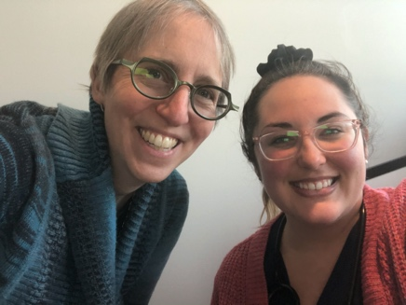
Sarah is braving the storm with us, coming in each day to make sure that the office runs smoothly and that our patients are well taken care of. The ship remains afloat and our lifejackets are securely tightened. Hopefully you will continue to recognize us as our individual hairstyles continue to chart their own new courses.

I wanted to make one important clarification from the last email. While about 30 patients in Dr. Mellman and my practice have been diagnosed with COVID-19, aka coronavirus, they have NOT been seen at the office. We continue to keep the office clean and safe for those who need to be seen for other medical reasons.

Random Pearls:
- For the next 24 hours, replace the words, “I have to…” with “I get to…”
  - I get to spend more time with my children.
  - I get to enjoy more time at home.
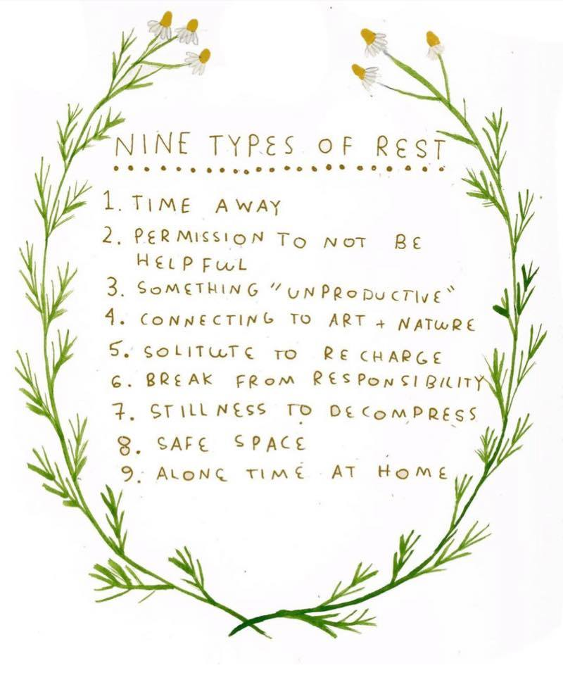
  - I get to learn new technology.
  - I get to spend more time resting.
  - I get to save the landfill by using less toilet paper and discover creative uses for the hair dryer. (Poor Dave has to tolerate my sense of humor every day!)

- Here are a few more recommendations suggested by other patients in our practice community:
  - The Overstory – Richard Powers
  - Bird by Bird – Anne Lamott
  - The Clockmaker’s Daughter – Kate Morton
  - The Water Dancer – Ta-Nehisi Coates
  - Unorthodox – Deborah Feldman
  - This Is How It Always Is – Laurie Frankel
  - The Library Book – Susan Orlean
  - American Dirt – Jeanine Cummins
  - The Spy… I think it is a series on Netflix

- Cultivate Awe:
  - Read something or watch a documentary about someone you admire.
  - Take an “Awe walk” and be more mindful of what is around you.
  - Plant something. Even if it is one seed in one small pot and watch it grow!
  - Notice the splendors of spring.

Questions for Dave and I:
- As the shelter in place restrictions loosen up, what should I do?
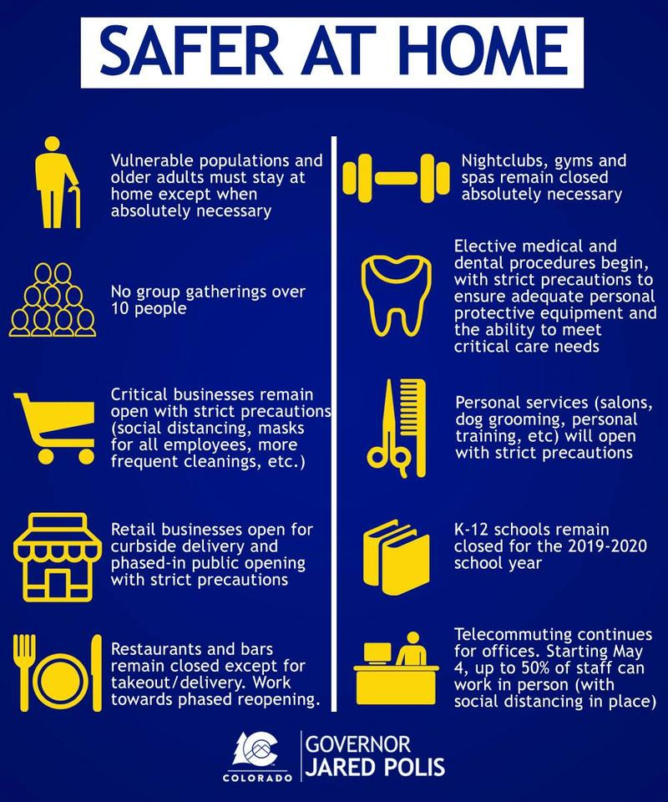
Governor Polis has recently announced the first phase of relaxing the shelter in place restrictions. He is calling then “Safer at Home.” A summary of the guidelines can be seen on the left.

Dave and I feel that it is very important for you to continue wearing a mask if you go to stores, at work and when within 24 feet of people (other than your immediate household members). Continue to keep your hands away from your face, which can be particularly difficult as everything starts to bloom. Continue to wash your hands thoroughly and regularly. Continue to limit trips to stores and avoid gatherings. Governor Polis’ recommendation of 10 is a very generous number. The smaller the better. Start with small trips to see immediate family members, i.e. check in on mom and dad, or pick one or two friends to meet up with. We want you to avoid all medium or large gatherings until the number of new cases per day in Colorado and the number of deaths per day in Colorado begin to decrease. We are still seeing about 30,000 new cases ever day in the United States and 300-400 new cases per day in Colorado (22.5% of which require hospitalization, 4-5% of the total number of cases are dying.)

- If I get sick, I know that I will have to stay at home. How do I protect the people that I live with?
As much as possible, stay in one room with the door closed. Stay away from other people and pets in your home (especially cats.) While you see photos of my dogs all of the time, I have a cat too and I love her as much as the dogs! It is just that there are now more substantially documented cases of the virus spreading to cats (domestic and one tiger at the Bronx Zoo in NY). Dogs are thought to be less likely to get infected, but remember that all pets can carry the virus throughout the house on their fur.
If possible, use a separate bathroom. When you must be around other people in the house, but you and they should be masked. Disinfect your path throughout the house frequently (at least daily). Do not share household items. Do not shake out laundry. Wrap up clothes, sheets and towels and place them directly in the washing machine. Wash them in warm or hot water with detergent. They may be washed with the clothes of other family members as the water temperature will kill the virus. And of course, wash your hands often.

- What is the difference between isolation and quarantine?
Isolation separates sick people with a contagious disease from people who are not sick. Quarantine separates and restricts the movements of people who were exposed to a contagious disease to see if they become sick. Quarantine should last 14 days. Isolation should last at least 72 hours after recovery, which is defined as resolution of fever without medication and respiratory symptoms and at least 7 days since the symptoms first appeared. (CDC guideline)

- Can you give us an update on testing?
Nasal swabs: Dave and I are now able to get patients tested for active COVID 19 disease with the nasopharyngeal swabs. The swabs however are only 62% sensitive (effective), so we only recommended testing patients with symptoms. If you have no symptoms even if you have the disease, the tests will mostly likely come back negative.

Antibody testing: We are still waiting to receive the antibody test kits that we had ordered. Nationally, there were some delays to reassure that the results were accurately measuring COVID 19 and not just prior exposure to other more common strains of coronavirus. We are also exploring other testing options on a daily basis. In the meantime, National Jewish is offering high quality antibody tests. It is unclear how many tests they have, but we can recommend testing and assist with medical prioritizing of patients. If you are interested in testing and have not been in contact with either Dave or I about this, please reply to this email. We have an ongoing list of people who are interested in being test. We can only send prescriptions to test patients in the practice.

As always, we are here whenever you need us.

Best wishes and Take care!

Jeannette and Dave

David L Mellman MD & Jeannette Guerrasio MD
David L Mellman MD, PLLC

