MEMBER RESOURCES
Manage Anxiety/Stress | CDC - Manage anxiety and Stress  https://www.cdc.gov/coronavirus/2019-ncov/prepare/managing-stress-anxiety.html
COVID -19 RELATED | How to stay connected while intentionally isolated  https://www.endsocialisolation.org/covid19
Social activities at home:
https://gerocentral.org/wp-content/uploads/2020/03/Social-Activities-At-Home.pdf

five ways to view coverage of the coronavirus
https://www.apa.org/helpcenter/pandemics

Speaking of Psychology: Coronavirus anxiety
Podcast: https://www.apa.org/research/action/speaking-of-psychology/coronavirus-anxiety

Covid-19 Managing stress in this anxious time
https://newpaltz.edu/media/idmh/covid-19/IDMH%20COVID19%20Community%20Stress%20Management%20Tip%20Sheet%202020%20Final.pdf

coping with stress during infectious disease outbreaks
https://store.samhsa.gov/product/Coping-with-Stress-During-Infectious-Disease-Outbreaks/sma14-4885

SAMHSA's taking care of your behavioral health; tips for social distancing, quarantine, and isolation during an infectious disease outbreak
https://www.samhsa.gov/sites/default/files/tips-social-distancing-quarantine-isolation-031620.pdf

taking care of your behavioral health during an infectious disease outbreak
https://store.samhsa.gov/product/Taking-Care-of-Your-Behavioral-Health-During-an-Infectious-Disease-Outbreak/sma14-4894
Video: NICAB’s How to work with anxiety during the COVID-19 pandemic - part 1
https://www.nicabm.com/working-with-anxiety-during-a-pandemic-part-1/

Part 2
https://www.nicabm.com/working-with-anxiety-during-a-pandemic-part-2/

Video: Taking the fear out of coronavirus
https://www.joanborysenko.com/2020/03/taking-the-fear-out-of-coronavirus/

For older adults | APA: Older adults and disasters: How caregivers can be prepared and assist others  https://www.apa.org/pi/aging/resources/caregivers-disasters.pdf
COVID-19 guidance and advice for older people
https://gerocentral.org/wp-content/uploads/2020/03/Covid-19-Guidance-and-advice-for-older-people.pdf

APA: Older adults and disasters: how to be prepared and assist others
https://www.apa.org/pi/aging/resources/older-adults-disasters.pdf

For kids | Helping homebound children during the COVID-19 outbreak  https://www.cstsonline.org/assets/media/documents/CSTS_FS_Helping_Homebound_Children_during_COVID19_Outbreak.pdf
coping resources for children during national Covid-19 emergency
https://www.nctsn.org/what-is-child-trauma/trauma-types/disasters/pandemic-resources

talking to children about COVID-19
https://www.nasponline.org/resources-and-publications/resources-and-podcasts/school-climate-safety-and-crisis/health-crisis-resources/talking-to-children-about-covid-19-(coronavirus)-a-parent-resource

For family | the National Child Traumatic Stress Network: Parent/caregiver guide to helping families cope with the coronavirus disease 2019  https://www.nctsn.org/print/2251
Center for the Study of Traumatic Stress: Taking care of your family during the coronavirus and other emerging infectious disease outbreaks
https://www.cstsonline.org/assets/media/documents/CSTS_FS_Corona_Taking_Care_of_Your_Family.pdf.pdf

Relaxation podcasts | Kaiser  www.kp.org/listen
UCLA mindfulness (some in Spanish)
https://www.uclahealth.org/marc/mindful-meditations

Crisis resources | National Suicide Prevention Lifeline (800-273-8255)
 | Disaster Distress Helpline (800-985-5990) or text TALKWITHUS to 66746 free

Free Entertainment
Amazon audible stories are now opening up for free
stories.audible.com/disovery
online movement resources (e.g., yoga)
https://docs.google.com/document/d/10zGZo1re8NDh-b3ewUtsV2vqMAOujKmMwf61QVKE5SU/edit?fbclid=IwAR1JylsNnnzknZ8WPVQr0TaT00hduRmEbaIvsC9TYsPuG6vigatDqZaZYaY
Wiener Staatsoper live at home is offering a free online show every night starting March 15th
www.staatsoperlive.com
Berliner Philharmoniker Digital Concert hall is offering free access to all concerts now
digitalconcerthall.com
"450 Ivy League courses you can take online right now for free"
https://www.freecodecamp.org/news/ivy-league-free-online-courses-a0d7ae675869/?fbclid=IwAR2uHtc5ZnCTkgMWTexLAA9KJKIVUn9evhW3Hx5bWPvCvPPX8TbPhLvYXFg

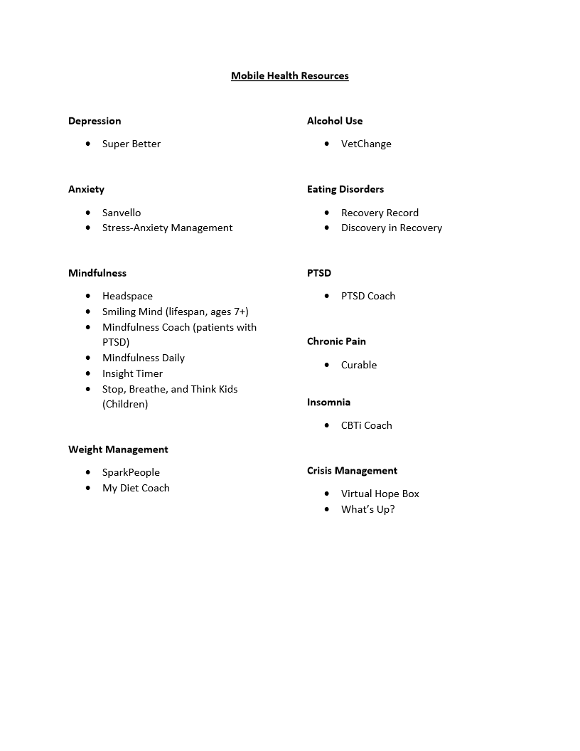
We often imagine that we know what the future will bring. Right now, it’s particularly clear that we don’t. So here are a few free resources to help you, and your clients, deal with the anxiety of these uncertain times.
Interviews with my friend Dr. Christine Padesky, an international CBT pioneer, and me on how to work with not knowing:
Click here for Working with Not Knowing Video #1
Click here for Working with Not Knowing Video #2
Simple, effective, calming meditations offered by my friend Dr. Joan Borysenko, a pioneer in psychoneuroimmunology:
Click here for Calming Meditations Video
I hope that you and your clients find these useful!

Overall supports in the community:

SAMHSA Disaster Distress Helpline (800) 985- 5990 that provides 24/7, 365-day-a- year crisis counseling and support to people experiencing emotional distress related to natural or human-caused disasters. 211 local agencies that can provide assistance with bills, rent, and food Cal Fresh can be applied online at: https://www.getcalfresh.org/
Low Cost Comcast:
Https://www.internetessentials.com/covid19

2-1-1 is a good resource line to know what your county is doing regarding coronavirus.

COVID19-specific resources:

Websites:
- CDC: https://www.cdc.gov/childrenindisasters/helping-children-cope.html
- Fact: https://www.cdc.gov/coronavirus/2019-ncov/symptoms-testing/share-facts.html
- Video of how to talk to Kids (please note we only recommend this video, not subsequent videos): https://www.youtube.com/watch?v=WhVad8ToCiU&feature=youtu.be

https://www.cdc.gov/coronavirus/2019-ncov/prepare/managing-stress-anxiety.html

https://www.mindheart.co/descargables

There are many things you can do to support your child
- Take time to talk with your child or teen about the COVID-19 outbreak. Answer questions and share facts about COVID-19 in a way that your child or teen can understand.
- Reassure your child or teen that they are safe. Let them know it is ok if they feel upset. Share with them how you deal with your own stress so that they can learn how to cope from you.
- Limit your family's exposure to news coverage of the event, including social media. Children may misinterpret what they hear and can be frightened about something they do not understand.
- Try to keep up with regular routines. If schools are closed, create a schedule for learning activities and relaxing or fun activities (yoga, mindfulness activities, arts and crafts, and child led play).
- Be a role model. Take breaks, get plenty of sleep, exercise, and eat well. Connect with your friends and family members via text, face time, writing letter etc.
Websites:
- CDC: https://www.cdc.gov/childrenindisasters/helping-children-cope.html
- Fact: https://www.cdc.gov/coronavirus/2019-ncov/symptoms-testing/share-facts.html
- Video of how to talk to Kids (please note we only recommend this video, not subsequent videos): https://www.youtube.com/watch?v=WhVad8ToCiU&feature=youtu.be
- 9 Things Every Parent with an Anxious Child Should Try: http://www.huffingtonpost.com/renee-jain/9-things-every-parent-with-an-anxious-child-should-try_b_5651006.html
Children Book:
- https://www.mindheart.co/descargables (this website has the book included below in different languages)
  - https://660919d3-b85b-43c3-a3ad3de6a9d37099.filesusr.com/ugd/64c685_319c5acf38d34604b537ac9fae37fc80.pdf
Fun Activities to do at Home
- Check out podcasts:
https://www.wired.com/story/best-podcasts-for-kids/
https://www.timeout.com/new-york-kids/things-to-do/best-podcasts-for-kids-of-all-ages
- Family yoga and exercise:
https://awakeandmindful.com/best-kids-yoga-videos-on-youtube/
https://www.therealisticmama.com/exercise-videos-for-kids/
- Play board games
- Make homemade bread
- Learn to juggle, find a video on youtube
- Arts and crafts
- Make origami from an online video
- Build paper airplanes and have a contest who can fly them farther
- Start a journal
- Play cards, or learn online

Techniques to support Anxiety
Techniques are meant to distract the mind from focusing on the anxiety, panic, stressful thoughts or the anticipation of another panic attack.. And bring them back to the present moment, re-focusing on the body, the physical feelings.

Interventions to help with panic: Placing cold towel on back of child's neck or place child in cold water- the coldness cues the mammalian diving reflect which causes out body tempt to change, heart rate to decrease, and parasympathetic nervous system is activated to create relaxation response.

Grounding techniques: Identify five objects around you, touch them, and name them out loud. Take a couple of deep breathes. In through your nose (count to 5) out through your mouth (count to 5).

The 5-4-3-2-1 (similar to 5 objects): 5 things you see, 4 things you feel, 3 things you hear, 2 things you smell, 1 thing you can taste

Crisis resources | 916-737-7483
 | TLCS 24 hour mental health crisis respite center (free, Sacramento)
Senior "friendship" line
24-hour line | toll Free - 800.971.0016
 | crisis intervention hotline and a warmline for a non-urgent calls.
Crisis TEXT Line | Free 24/7 text messaging services: text CONNECT to 741741 in United States to connect with crisis counselor
General Support Services | call 211 or 916 498 1000
COVID-19 talk with kids | https://www.mindheart.co/descargables
Services for undocumented members | https://ciyja.org/covid19/

