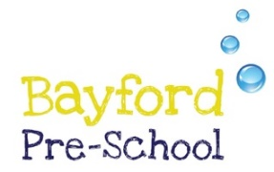

Curriculum

Here at Bayford Preschool we provide a happy, nurturing, enriched learning environment for all children.
We follow the EYFS statutory framework, and our intention is to provide a broad and ambitious curriculum for all children that gives them essential knowledge and a positive sense of self.
We provide daily activities which support each child’s educational development across the seven areas of learning.
We follow children’s interests which keep them highly motivated, curious and enthusiastic learners. Keeping play and well being at the heart of everything we do.
Our inclusive curriculum nurtures their social, emotional and cognitive development, preparing them for successful transitions to school.

