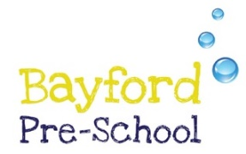
BAYFORD PRESCHOOL
CURRICULUM GOALS
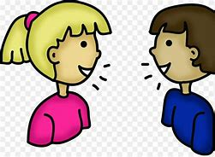
Communication and Language
Experience a language rich environment.
Responds to simple instructions.
Encouraged to share own ideas.
Sings familiar songs and rhymes
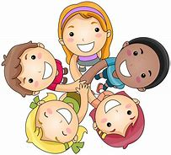
Personal, Social and Emotional
Understands boundaries and routines.
Manage emotions and develop a positive self-esteem.
Plays alongside others.
Make their own choices.
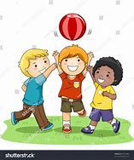
Physical
Enjoy healthy and happy active lives.
Begin to be independent in self-care, using the toilet and putting on own shoes and coat.
Begin to use one handed tools.
Has control of large body movements.
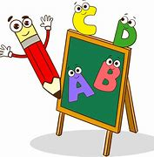
Literacy
Communicate using meaningful marks.
Develop a lifelong love of reading.
Recognises own name.
Repeats words from familiar stories.
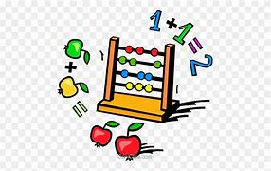
Mathematics
Develop understanding of number to 5.
Compares and talks about objects in relation to size and weight.
Names 2d shapes.
Notice patterns around them.
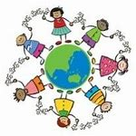
Understanding of the world
Explore the natural world around them.
Talks about their close family.
Recognises that everyone is different and unique in their own way.
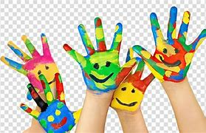
Expressive Art and Design
Make independent choices when creating.
Engages in simple pretend play.
Joins in with singing and responds to music.

