Most of the kidney diseases are silent in nature and present very late in their course by which time many patients have lost the opportunity for successful treatment and progress to End Stage needing dialysis and transplantation.

Knowledge about kidneys and their diseases can provide some insight into the problems and help common public in early referral to doctors and create awareness among kidney patients who already know about their diseases.

Most of kidney failure patients who have end stage disease not on dialysis and those on dialysis die of cardiac complications, hence cardiac evaluation should form part of kidney diseases.

Secondly infections play a major role in repeated hospitalisaton and effect survival more so in late stages.

This booklet is a collective effort of our team to impart knowledge on the patients about kidney disease and related disorders. With this we intend to guide our patients who are under treatment with us. Apart from this it can also provide information those who are willing to know about kidney diseases to keep them healthy.

Introduction
The kidney is a giant-dwarf, relentless worker and an accurate chemist who never pauses for rest working 24x7 equivalent to 168hours a week.
Kidneys don’t always get the respect they deserve. But, kidneys are truly impressive and the more you learn, the more you’ll understand why you want to help keep them healthy.
Another word for kidney is renal. You may hear your doctor talk about renal function or read materials that mention renal failure. Whenever you see or hear the word renal, you will know the subject is about kidneys.
Location and description
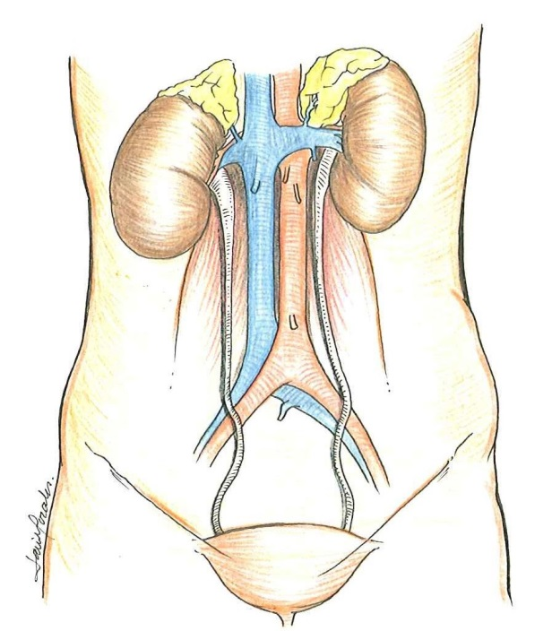
The kidneys are two bean-shaped organs about five-inches long, three-inches wide and one-inch thick located in your back on each side of your spine. Each kidney is about the size of a fist and measures more than 9cm in length. Each adult kidney weighs between 125 and 170 grams in males and between 115 and 155 grams in females. They are situated above your waist, with the left kidney a little higher and a little larger. The right kidney is a little lower and smaller to make room for the liver. The left kidney is approximately at the vertebral level T12 to L3, and the right slightly lower. The lower ribs protect your kidneys.
Inside the kidneys are nephrons. These are tiny units where the filtering of excess fluids and dissolved particles occurs. There are between 1 and 1.3 million nephrons in each kidney.
Any shrink in size of kidneys is also considered as kidney disease.
What does a kidney do?
Most people think their kidneys are just responsible for producing urine, but there’s a lot more to it. In addition to removing extra fluid and water from your body, kidneys:
- Filter the blood
- Balance fluid content in the body
- Produce the enzyme renin that helps control blood pressure
- Produce the hormone erythropoietin to help make red blood cells
- Activate vitamin D to maintain healthy bones
- Adjust levels of minerals and other chemicals to keep the body working properly
How kidneys do their jobs?
The basic function of kidneys begins when you eat and drink. After the body takes the nutrients it needs, the extras become wastes. Some of the waste winds up in the blood and needs to be filtered out. The blood gets circulated through the body with every beat of the heart. It’s the job of the kidneys — with their millions of nephrons — to filter and clean out the blood and remove the extra fluids. The extra fluid and waste becomes urine and travels from the kidneys down the ureters to the bladder until eliminated through the urethra.
Removing waste is only one job of the kidneys. In addition to filtering, the kidneys monitor the levels of chemicals, salts and acids in the blood. Inside the nephrons are sensors that keep track of sodium, phosphorus, calcium and potassium. When levels are high, the kidneys signal to remove the excess from your blood for elimination.
Another important job of the kidneys is to monitor and regulate certain body functions. An enzyme called renin is secreted by the kidneys to control blood pressure. A hormone called erythropoietin tells the bone marrow to make red blood cells, and one called calcitriol helps to keep bones strong.
Inside the kidneys
Inside each kidney is approximately 1 million tiny filtering units called nephrons. Each nephron has a glomerulus and tubules. The glomerulus is a series of specialized capillary loops where water and small particles are filtered from the blood. The waste and extra fluids then travel through the tube-like structure of the tubules where several processes take place to turn those fluids into urine. The tubules lead to the collecting duct where the urine is drained into a funnel-shaped sac called the renal pelvis. Each kidney has a ureter that connects the renal pelvis to the bladder. The urine from the kidneys flows down the ureters into the bladder and is then passed out of the body through the urethra.

Kidney failure

What Are the Causes of Kidney Disease?
About 20 million adults in the U.S. have kidney disease (also called renal disease) and many don’t know it. Do you know the causes of kidney disease and if you’re at risk?

What exactly are the main causes of kidney disease?
There are several causes of kidney disease, a condition that affects one in 10 adults age 20 or older in the United States. Learning about the root causes of kidney disease can help you get the right treatment and potentially preserve remaining kidney function.
Diabetes is the number one cause of kidney disease, responsible for approximately 44 percent of all kidney failure cases¹. High blood pressure (also called hypertension) is the second leading cause, accountable for about 28 percent1. Glomerulonephritis, a general term for many types of kidney inflammation, as well as genetic diseases such as polycystic kidney disease (PKD), autoimmune diseases, birth defects and other problems can also cause kidney disease.

Will my kidneys fail if I have diabetes?
Diabetes is a risk factor for renal disease, but it does not mean your kidneys will fail if you have diabetes. You can care for your kidneys by controlling your blood sugar and getting regular microalbumin urine tests to track the passage of protein. If you develop diabetic kidney disease, you can work with your doctor to keep your kidneys working for as long as possible.

Can I catch kidney disease from someone who has it?
No. Kidney disease is not contagious. Most kidney disease is caused by diabetes or high blood pressure, conditions that can run in families. If you are a family member of someone who has diabetes, high blood pressure or kidney disease, it is a good idea to ask your doctor to check your blood pressure, blood sugar and kidney function at your next checkup.

I have a family member with polycystic kidney disease (PKD). Should I be tested?
According to the PKD Foundation®, polycystic kidney disease (PKD) does not skip generations like other genetic diseases. If you have a family member with PKD, ask your doctor about getting tested. The first test used for PKD is an ultrasound to look at the kidneys and see if there are cysts. Learning more about PKD may help you to take better care of your kidney health.

Symptoms

Kidney failure symptoms from buildup of wastes in the body
- A metallic taste in the mouth or ammonia breath
- Protein aversion (no longer wanting to eat meat)
- Nausea and vomiting
- Difficulty concentrating
- Loss of appetite
- Itchiness (pruritis)

Kidney failure symptoms from buildup of fluid in the body
- Swelling in the face, feet or hands
- Shortness of breath (from fluid in the lungs)

Kidney failure symptoms from damage to the kidneys
- Making more or less urine than usual
- Blood in the urine (typically only seen through a microscope)
- Urine that is foamy or bubbly (may be seen when protein is in the urine)

Kidney failure symptoms from anemia
- Fatigue
- Shortness of breath
- Weakness
- Mental confusion
- Feeling cold all the time
- Desire to chew ice, clay or laundry starch (called pica)
To determine if the symptoms you have are because of kidney failure, your doctor will perform specific tests:
- Urinalysis – An examination of a sample of your urine to check for protein, blood and white blood cells in the urine
- Blood tests – Particularly a test for creatinine and BUN, waste products that healthy kidneys remove from the bloodstream.

Take action when you have kidney failure symptoms
Often, early kidney problems don't have many symptoms—but if you are experiencing any of the ones mentioned above, you will want to your doctor to determine if your signs are caused by kidney failure. Write down any of the renal failure symptoms you may have and bring that information with you to your next doctor’s appointment. Whether you discover that your kidneys are okay or if you learn you have kidney problems, knowing about it sooner may ease your mind and allow you to take steps to slow the progress of kidney disease, including delay or prevent dialysis or a kidney transplant.

What is chronic kidney disease (CKD)?
Healthy kidneys function to remove extra water and wastes, help control blood pressure, keep body chemicals in balance, keep bones strong, tell your body to make red blood cells and help children grow normally. Chronic kidney disease (CKD) occurs when kidneys are no longer able to clean toxins and waste product from the blood and perform their functions to full capacity. This can happen all of a sudden or over time.

What are the symptoms of chronic kidney disease?
Knowing the symptoms of kidney disease can help people detect it early enough to get treatment. Symptoms can include:
- Changes in urination — making more or less urine than usual, feeling pressure when urinating, changes in the color of urine, foamy or bubbly urine, or having to get up at night to urinate.
- Swelling of the feet, ankles, hands, or face — fluid the kidneys can't remove may stay in the tissues.
- Fatigue or weakness — a build-up of wastes or a shortage of red blood cells (anemia) can cause these problems when the kidneys begin to fail.
- Shortness of breath — kidney failure is sometimes confused with asthma or heart failure, because fluid can build up in the lungs.
- Ammonia breath or an ammonia or metal taste in the mouth — waste build-up in the body can cause bad breath, changes in taste, or an aversion to protein foods like meat.
- Back or flank pain — the kidneys are located on either side of the spine in the back.
- Itching — waste build-up in the body can cause severe itching, especially of the legs.
- Loss of appetite
- Nausea and vomiting
- More hypoglycemic episodes, if diabetic
If you believe you have any of these symptoms, talk to your doctor about your concerns. This is especially important if you have a close family member who has kidney disease, or if you have diabetes or high blood pressure, which are the main causes of kidney failure.

How can I find out if I have kidney disease?
Kidney disease can be found through lab tests or by symptoms. High blood levels ofcreatinine and urea nitrogen (BUN) or high levels of protein in your urine suggest kidney disease. Diabetics should have a yearly urine test for microalbumin, small amounts of protein that don't show up on standard urine protein test.

If I have signs of kidney disease, what should I do?
After you have basic screening tests done, if you have signs of kidney disease, you should ask for a referral to a nephrologist, a specialist in treating kidney disease. A nephrologist will perform an evaluation then suggest medications or lifestyle changes to help slow the progression of kidney disease.

Stages of Chronic Kidney Disease

About chronic kidney disease (CKD)
With chronic kidney disease, the kidneys don’t usually fail all at once. Instead, kidney diseaseoften progresses slowly over a period of years. This is good news because if CKD is caught early, medicines and lifestyle changes may help slow its progress and keep you feeling your best for as long as possible.

Five stages of chronic kidney disease
To help improve the quality of care for people with kidney disease, the National Kidney Foundation (NKF) created a guideline to help doctors identify each level of kidney disease. The NKF divided kidney disease into five stages. When the doctor knows what stage of kidney disease a person has they can provide the best care, as each stage calls for different tests and treatments.

Glomerular Filtration Rate (GFR)
Glomerular filtration rate (GFR) is the best measure of kidney function. The GFR is the number used to figure out a person’s stage of kidney disease. A math formula using the person’s age, race, gender and their serum creatinine is used to calculate a GFR. A doctor will order a blood test to measure the serum creatinine level. Creatinine is a waste product that comes from muscle activity. When kidneys are working well they remove creatinine from the blood. As kidney function slows, blood levels of creatinine rise.
Below shows the five stages of CKD and GFR for each stage:
- Stage 1 with normal or high GFR (GFR > 90 mL/min)
- Stage 2 Mild CKD (GFR = 60-89 mL/min)
- Stage 3A Moderate CKD (GFR = 45-59 mL/min)
- Stage 3B Moderate CKD (GFR = 30-44 mL/min)
- Stage 4 Severe CKD (GFR = 15-29 mL/min)
- Stage 5 End Stage CKD (GFR <15 mL/min)
Dialysis or a kidney transplant needed in order to maintain health.

End stage renal disease
Also called: ESRD, end stage renal failure
End stage renal disease (ESRD) is the last stage (stage five) of chronic kidney disease (CKD). This means kidneys are only functioning at 10%–15% of their normal capacity. Kidneys are important organs that contribute to your overall well-being. When kidney function is this low, they cannot effectively remove waste or excess fluid from your blood.
Kidneys are also responsible for other functions that support the body, such as balancing electrolytes and producing certain hormones. When chronic kidney disease develops into ESRD, dialysis or a kidney transplant is necessary to stay alive.

Creatinine
Creatinine is a chemical waste product that is released into the blood when muscles contract. When kidney function is normal, creatinine is filtered from the blood through the kidneys. When creatinine levels are high, it can be an indicator of kidney disease. For adults, dialysis is recommended when creatinine levels reach 10.0 mg/dL; for children, dialysis is recommended when levels reach 2.0 mg/dL. To find out what a person’s creatinine levels are, a doctor will order a blood test called serum creatinine to determine kidney function and use the number to calculate the glomerular filtration rate (GFR), which can determine the stage of chronic kidney disease.
Doctors perform two other tests to determine creatinine levels: creatinine clearance (Ccr or CrCl) and BUN/creatinine. Creatinine clearance is a combination of a blood and a urine test, which measures how much creatinine is cleared out of the body, or how well kidneys filter waste. The test may be ordered by the doctor if a person shows signs of kidney problems or is going to start dialysis. BUN/creatinine is the ratio between blood urea nitrogen (BUN), a waste product in the blood from protein metabolism, and creatinine. This ratio is used to help determine if kidney function is impaired due to damaged or diseased kidneys or another factor outside of the kidneys. The serum creatinine and BUN/creatinine tests are usually performed during regular blood work. When a person has kidney disease, his or her doctor will continue performing creatinine tests to monitor the disease’s progression and to determine the person’s kidney disease treatment.

Definition of Dialysis
Also called: kidney dialysis
The main purpose of dialysis is to help impaired renal function. When your kidneys are damaged, they are no longer able to remove wastes and excess fluid from your bloodstream efficiently. Wastes such as nitrogen and creatinine build up in the bloodstream. If you have been diagnosed with chronic kidney disease (CKD), your doctor will have these levels carefully monitored. Before dialysis, patients often felt weak and ill. Dialysis brings relief from these symptoms. This is the primary benefit of dialysis.
Dialysis is done by using a special fluid called dialysate. Dialysate, a mixture of pure water and chemicals, is carefully controlled to pull wastes out of your blood without removing substances your body needs. A semipermeable membrane (one with microscopic holes that allow only certain types of particles to pass through) keeps the blood apart from the dialysate. This membrane lets the wastes and fluid in your blood flow through into the dialysate. Your blood cells and larger molecules, like protein that you need, cannot fit through the holes. There are two main types of kidney dialysis: hemodialysis (HD) and peritoneal dialysis (PD).

Hemodialysis

Hemodialysis is a therapy that filters waste, removes extra fluid and balances electrolytes (sodium, potassium, bicarbonate, chloride, calcium, magnesium and phosphate). In hemodialysis, blood is removed from the body and filtered through a man-made membrane called a dialyzer, or artificial kidney, and then the filtered blood is returned to the body. The average person has about 10 to 12 pints of blood; during dialysis only one pint (about two cups) is outside of the body at a time. To perform hemodialysis there needs to be an access created to get the blood from the body to the dialyzer and back to the body.
The dialyzer is the key to hemodialysis. The dialyzer is called the artificial kidney because it filters the blood — a job the kidneys used to do. The dialyzer is a hollow plastic tube about a foot long and three inches in diameter that contains many tiny filters. There are two sections in the dialyzer; the section for dialysate and the section for the blood. The two sections are divided by a semipermeable membrane so that they don’t mix together. A semipermeable membrane has microscopic holes that allow only some substances to cross the membrane. Because it is semipermeable, the membrane allows water and waste to pass through, but does not allow blood cells to pass through.

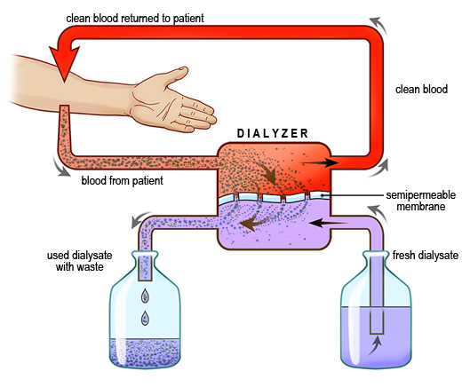

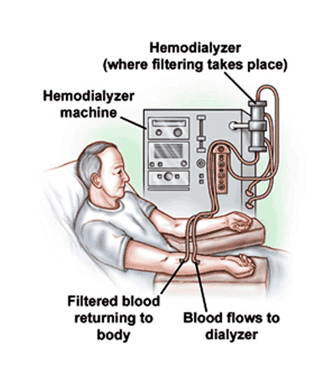

Peritoneal dialysis

Peritoneal dialysis (PD) is a treatment for patients with severe chronic kidney disease. The process uses the patient'speritoneum in the abdomen as a membrane across which fluids and dissolved substances (electrolytes, urea, glucose,albumin and other small molecules) are exchanged from the blood. Fluid is introduced through a permanent tube in the abdomen and flushed out either every night while the patient sleeps (automatic peritoneal dialysis) or via regular exchanges throughout the day (continuous ambulatory peritoneal dialysis). PD is used as an alternative to hemodialysis though it is far less commonly used in many countries, such as the United States. It has comparable risks but is significantly less costly in most parts of the world, with the primary advantage being the ability to undertake treatment without visiting a medical facility. The primary complication of PD is infection due to the presence of a permanent tube in the abdomen.

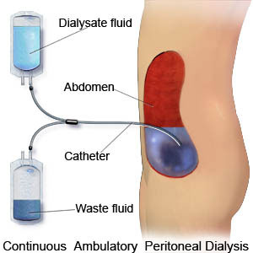

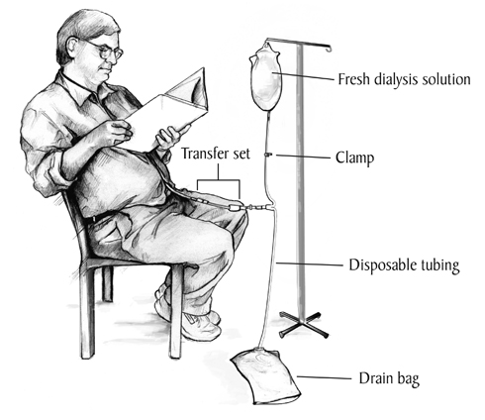

Finding What Fits: Your Treatment Choices
When it comes to treating end stage renal disease (ESRD), one size does not fit all. With your physician’s guidance, you can choose from several types of treatment options to find the one that best suits your health and lifestyle needs.

How to choose the right treatment
As you begin the conversation with your care team about which treatment option is right for you, remember that you're not stuck with this option for life. The treatment that's right for you right now may not be tomorrow, and you can always speak with your doctor about changing. Here are a few considerations to help inform your decision.
- Do you like to lead an active lifestyle?
- Do you want more control of your schedule and time?
- Do you currently have daytime obligations such as work or school?
- Do you want to consider performing your own dialysis treatments?
- Do you want to do your treatments at home or in a center?
- Do you have someone available to help you with treatments at home?

Which treatment suits your needs?
Take a brief look at the different treatment options:
Kidney transplant
- The preferred treatment for kidney disease.
- Freedom to enjoy life with no dialysis-relatedschedule restrictions.
- Virtually no diet or fluid limitations.
The wait for a kidney transplant varies greatly. Learn more about kidney transplants.
Peritoneal dialysis (PD)
- Usually preserves remaining kidney function for a longer period of time thanhemodialysis.
- Can be performed at home or work.
- Needle-free and blood never leaves your body.
- Fits your schedule, with fewer diet restrictions and more travel flexibility.
Peritoneal dialysis is often done at night in your home for 8-10 hours, using an automated cycler machine while you sleep. Or you may use a manual PD method, which usually means doing four to five 30-minute fluid exchanges a day to clean your blood fully.
Home hemodialysis (HHD)
- Performed in the comfort and privacy of your own home.
- Flexible treatment times can be arranged around your schedule.
- A care partner is needed to assist you with treatments.
People on home hemodialysis have the option to dialyze more frequently to achieve improved health benefits. Short, daily treatments are generally performed five or six times a week for two to three hours per session.
In-Center Hemodialysis
- Performed in a dialysis center.
- Trained medical professionals are withyou at all times.
- Social interaction with staff andother patients.
The usual schedule for in-center hemodialysis is three times a week, for about three to four hours each treatment, plus travel time to and from the center. Or you may consider in-center nocturnal dialysis (available at some centers).

Vascular Access: Your Lifeline to Hemodialysis
Before beginning hemodialysis treatment, a person needs an access to their bloodstream, called a vascular access. The access allows the patient’s blood to travel to and from the dialysis machine at a large volume and high speed so that toxins, waste and extra fluid can be removed from the body.
There are two types of vascular access:
- Arteriovenous (AV) fistula
- Arteriovenous (AV) graft
The fistula and graft are permanent accesses placed under the skin. When patients find out they are in the advanced stages of chronic kidney disease and will need dialysis, theirnephrologist will advise them to get a fistula or graft. Having the access in place well before beginning dialysis will give this lifeline time to "mature," so it can be ready to use.
When patients suddenly discover they have kidney failure, a catheter may be placed to allow for immediate dialysis treatment. The catheter will be used until a fistula or graft has time to mature.

Arteriovenous fistula
Also called: AV fistula
An AV fistula is created by directly connecting a person’s artery and vein—usually in the arm. This procedure may be performed as an outpatient operation using a local anesthetic. As blood flows to the vein from the newly connected artery, the vein grows bigger and stronger. The patient is taught to do exercises—such as squeezing a rubber ball—to help the fistula strengthen and mature to get it ready for use. This takes anywhere from six weeks to four months or more. Once the fistula has matured, it can provide good blood flow for many years of hemodialysis.
Kidney and hemodialysis experts, including the National Kidney Foundation (NKF), Centers for Medicare and Medicaid Services (CMS), the American Association of Kidney Patients (AAKD) and others consider the fistula the "gold standard" access choice. Research studies have proven patients with a fistula have the fewest complications, such as infection or clotting, compared to all other access choices.
The benefits of a fistula compared to other access types include:
- lower risk of infections
- lower risk of forming clots
- performs better
- allows for greater blood flow
- lasts longer, sometimes even for decades if well-cared for
Some of the drawbacks include:
- the appearance of bulging veins at the access site
- taking several months for a new one to mature
- not maturing (in some cases)
Not everyone may be able to have a fistula due to various conditions; discuss your access options with your doctor, but ask for a fistula first.

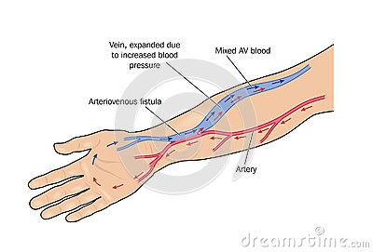

AV Graft
The AV graft is similar to a fistula, in that it connects the artery and vein under the skin, except that a manmade tubing connects the artery and vein. It’s about one-half inch in diameter and is made from a type of Teflon or Gore-Tex material. Transplanted animal or human vessels may also be used as grafts. They’re usually placed in the arm, but can also be placed in the thigh.
Grafts don’t require as much time to mature as fistulas, because they don’t need time to enlarge before using. Usually a graft can be used about two to six weeks after placement. Because grafts are created from materials outside of the body, they tend to have more problems than fistulas due to clotting and infections and may need to be repaired or replaced each year.

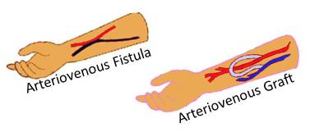

Caring for a fistula or graft
Here are things you can do to take care of your access.
1) Keep your access area clean and free of any trauma. Your dialysis care team will teach you how to carefully wash it before each treatment. Look for signs of infection,including pain, tenderness, swelling or redness around your access area. Also, be aware of any fever and flu-like symptoms. If you do get an infection and catch it early, it can usually be treated with antibiotics.
2) Protect your access from any restriction or trauma by:
- avoiding tight clothes, jewelry or anything that puts pressure on your access
- not sleeping on top of or resting on your access area
- refraining from carrying bags or heavy items across your access area
- requesting that blood be drawn from your non-access arm
- requesting that blood pressure be taken from your non-access arm
Learn to feel the vibration of blood going through your access and check it several times a day. Call your dialysis care team immediately if the flow stops or changes, as this could be a blood clot has formed and needs to be treated.
Learn to listen with a stethoscope to the sound of blood flowing through your access. If the sound changes to a higher pitch, like a whistle, it could be an indication that blood vessels are narrowing. Call your dialysis care team if you notice any change in your access.
3) Prevent tearing or damage to your access by paying attention to the needle stick locations when you’re being put on dialysis. The arterial and venous needle tips should be at least two inches apart from each other, as well as away from access surgical scars. The new needle stick sites should be at least one-fourth inch from the sites used the time before. Allow about two weeks for healing of previous sites to help maintain the health of the access.
Ask your nephrologist and dialysis care team about numbing creams to reduce the pain and fear of needle sticks.
Many patients find they prefer having control of the needle stick process (self-cannulation). When you self-cannulate, you can control and participate in this part of your vascular access care and treatment. Ask your care team about training.
After treatment, your needles will be removed and you will need to apply pressure with sterile gauze over your needle sites to stop the bleeding. Your team will provide you with clean gloves and teach you the proper procedures to stop bleeding as well as prevent infection.

HCV and dialysis

Hcv is short form of Hepatitis C virus which affects liver and will adversely affect the life of a dialysis patient. It is most commonly transmitted through blood transfusion and dialysis equipment. Of late it has become a major burden to dialysis population. Apart from reducing the life span of dialysis population it is associated with reccurent hospitaliations and poor performance of dialysis patients. It also adversely affects graft function post transplantation. This shows the stressing need for complete seperation of HCV positive patients from HCV negative dialysis patients.

Another virus of such type is the HBV which also needs attention.

Fortunately HCV and HBV can be treated in atleast a few patients who are otherwise fit for treatment and unfortunately some donot respond to treatment.

We at Ramesh Hospitals ensure complete seperation of HCV and positive and Negative patients.

Erythropoietin

Erythropoietin (also called epo) is a hormone produced by the kidneys in response to decreased oxygen levels in the circulating blood that stimulates the bone marrow to produce red blood cells (RBCs). Anemia in chronic kidney failure mainly develops because diseased kidneys no longer produce adequate amounts of erythropoietin. Replacement of the deficient hormone through erythropoiesis-stimulating agent (ESA) therapy, such as Epoetinalfa, Epogen® and Procrit® allows practitioners to keep patients’ hemoglobins (a protein in RBCs that carries oxygen) in a recommended range.

What is acute renal failure?
"Renal" means related to the kidneys. "Acute" means sudden. So acute renal failure means the kidneys have failed suddenly, often due to a toxin (a drug allergy or poison) or severe blood loss or trauma. Dialysis is used to clean the blood and give the kidneys a rest. If the cause is treated, the kidneys may be able to recover some or all of their function.

Acute Renal Failure—When Kidneys Stop Working Suddenly
If you are confused about the difference between acute renal (also called kidney) failure and chronic kidney failure, you came to the right place. Chronic kidney failure is a condition where the kidneys’ ability to filter waste from the bloodstream becomes worse over time, generally over a period of years.
Acute kidney failure is the sudden loss of this important ability. If your kidneys have experienced a direct injury or an obstruction, you are at risk. Although the condition can be life-threatening, it can also be reversible.

What is else should I know about acute kidney failure?
Acute kidney failure is the sudden and dramatic loss of kidney function. This condition develops rapidly, often in just a few days.
Healthy kidneys filter and remove wastes and excess fluid from blood and turn it into urine. When you encounter acute kidney failure, the kidneys are operating at less than 10 percent of normal function. This means wastes such as creatinine and urea nitrogen build up in the bloodstream. If this waste is not removed, you can feel extremely ill.

What causes acute renal failure?
Renal failure symptoms can be difficult to detect. Acute renal failure may occur for a variety of reasons:
- A crush-type injury may damage internal organs, including the kidneys
- Over-exposure to metals, solvents and certain antibiotics and medication
- A kidney infection may cause them to shut down
Obstructions in the urinary tract or renal artery can initiate acute kidney failure. Tumors, kidney stones or an enlarged prostate can block the flow of urine in the urinary tract. A blockage in the renal artery cuts off the supply of oxygen to the kidneys, and kidneys need oxygen to function.
Shock or trauma to the body can lead to low blood pressure. Sometimes the stress of surgery on the body can lower blood pressure to dangerous levels. Extremely low blood pressure means there is a decrease in blood flow, and kidneys will not receive oxygen or filter blood as efficiently as before.

What are the symptoms of acute kidney failure?
One of the most obvious renal failure symptoms is a decrease of urine. This symptom occurs in 70 percent of cases. Many people with acute kidney failure only create 16 ounces of urine a day (the average adult urinates between 34 to 50 ounces per day).
When urine output is low, fluid retention occurs, causing swelling in the legs, feet and ankles. Because wastes are not being removed from your body, you will feel ill. In addition, many people report:
- Nausea
- Vomiting
- Feeling drowsy
- Difficulty paying attention
- Numbness or decreased sensation in the hands and feet
Doctors can diagnose acute kidney failure with blood and urine tests.

How is acute renal failure treated?
Doctors will first treat any reversible illnesses that caused the renal failure. Infections can be treated with medication. Blockages, such as tumors or kidney stones, may need to be removed. Because treating the causes of acute renal failure takes time, your body will be unable to remove the waste from the bloodstream. In order to remove the toxins from the bloodstream and help you feel better, you would need dialysis.
Sometimes people develop high levels of potassium in their blood as a result of acute renal failure. This is condition is called hyperkalemia. Doctors can prescribe medication to control potassium levels.
In order to help keep the wastes and electrolytes at acceptable levels, you may be placed on a kidney diet that is low in protein, salt and potassium. Your fluid intake may also be restricted.

Can I prevent acute kidney failure?
Taking the necessary steps to stay healthy is the best way to prevent acute kidney failure. If you are going to be hospitalized for surgery or an illness, be aware of the risks and complications of any procedure you may undergo. Immediately report any changes in your urine output. And, as always, follow any instructions your doctors and nurses give you.
Keeping an open channel of communication with your healthcare team can help you get the treatment you need if acute kidney failure occurs.

Proteinuria

What is proteinuria?
When healthy kidneys filter fluid, minerals and wastes from the blood, they usually do not allow large amounts of serum protein to escape into the urine. But when kidneys aren’t filtering properly, proteinuria can occur, meaning that an abnormal amount of protein is present in the urine.
The two major groups of serum proteins in the blood arealbumin and globulins. Albumin is abundant in the blood, accounting for more than 50 percent of all serum proteins. Its important functions include pulling water into capillaries and maintaining the right amount of water in the circulatory system, as well as binding and carrying substances that are poorly soluble in water. Three examples of these substances are fat soluble vitamins, calcium and some medications.
Globulins are divided into alpha, beta and gamma globulins. Alpha and beta globulins also transport substances, while gamma globulins are known as immunoglobulins or antibodies. Testing for protein in the urine can include all the different proteins or albumin only.

Types of proteinuria
Transient proteinuria is the temporary excretion of protein and can be caused by strenuous exercise, a high fever, exposure to cold, stress and other conditions. Pregnant women may also excrete more protein in their urine. Transient proteinuria does not involve underlyingkidney disease and requires no treatment.
Orthostatic proteinuria means an increased amount of protein is excreted when a person is in the upright position. It’s most often found in tall, thin adolescents and young adults less than 30 years of age. The kidneys are usually healthy.
Proteinuria can be caused by diseases not involving the kidneys, such as multiple myeloma, a cancer of the plasma cells in the bone marrow. In this case, the blood is flooded with too many proteins that are then filtered into the urine. The condition is known as overflow proteinuria.
The other type of proteinuria is due to kidney disease, such as glomerulonephritis, primaryfocal segmental glomerulosclerosis (FSGS) or kidney damage due to a systemic disease. Microalbuminuria means low levels of albumin are detected in the urine. Microalbuminuria can indicate that people with diabetes or hypertension are developing early stages of kidney disease.

Symptoms of proteinuria
In most cases, proteinuria has no symptoms and is detected during a routine screening in people with high blood pressure or diabetes. If protein loss is severe, swelling or edema can occur. Edema can be present in the:
- Face and around the eyes
- Arms, hands, legs, ankles and feet
- Abdomen
Other symptoms can include:
- Foamy urine
- Weight gain caused by fluid retention
- Diminished appetite
- Hypertension

How is proteinuria diagnosed?
Urinalysis covers a number of tests performed on urine. Abnormal presence of cells and urinary casts, tiny tube-shaped particles, may reveal underlying kidney disease.
The Urine Albumin to Creatinine Ratio (UACR) is a test that estimates how much albumin is excreted in a 24-hour period without requiring patients to collect urine for a whole day.
Common proteinuria blood tests check serum creatinine, albumin, cholesterol and blood glucose levels to help determine whether the condition is caused by kidney damage.
If kidney disease is suspected, any of three tests may be conducted:
- Glomerular filtration rate (GFR): Estimates how much blood passes through these tiny filters. Normal results range from 90 to 120 mL/min,while levels below 60 mL/min for three or more months are a sign of chronic kidney disease.
- Renal ultrasound scan: Produces an image of the kidneys. It can show obstructions, stones and tumors or cysts.
- Kidney biopsy: Involves removal of a tiny piece of kidney tissue for examination under a microscope.

Treating proteinuria
Because proteinuria is a symptom and not a disease itself, medical care focuses on treating the underlying condition, such as normalizing blood pressure in people with hypertension or controlling blood sugar levels in those with diabetes.
People with nephrotic syndrome and fluid overload should restrict salt in their diet. The nephrologist may also recommend a mild restriction in protein intake.
ACE inhibitors are medications used primarily for the treatment of hypertension, but they’re also very effective in reducing proteinuria regardless of whether the patient has hypertension or not.

RENAL BIOPSY
Renal biopsy (also kidney biopsy) is a medical procedure in which a small piece of kidney is removed from the body for examination, usually under a microscope. Microscopic examination of the tissue can provide information needed to diagnose, monitor or treat problems of the kidney.
A renal biopsy can be targeted to a particular lesion, for example a tumour arising from the kidney (targeted renal biopsy). More commonly, however, the biopsy is non-targeted as medical conditions affecting the kidney typically involve all kidney tissue indiscriminately. In the latter situation, any sufficiently-sized piece of kidney tissue can be used.
After the site is prepared, the doctor injects local anaesthetic into the skin, through the subcutaneous tissue and down to and around the kidney. There may be a sharp sting as the local anaesthetic is injected. After a few seconds, the site will be numb and only a sensation of pressure should be felt. A small 1-2mm incision is made to allow insertion of the biopsy needle. In most cases, real-time imaging will be used to guide positioning of the local anaesthetic and biopsy needles. In the case of blind biopsy, this will not be used. A loud click may be heard as the spring loaded biopsy needle is fired into the kidney to obtain a tissue sample. The resulting core of kidney tissue is usually less than 1mm in diameter and up to 1 cm long. This may be done more than once to obtain sufficient kidney tissue.
A pathologist or pathology scientist may be present at the biopsy to examine the core(s) of kidney tissue for adequacy under a low power microscope. They will inform the person performing the procedure about how much kidney tissue was obtained, specifically how of biopsy sample is kidney cortex and how much is kidney medulla. In some centres, this role will be performed by the proceduralist with the naked eye.When enough kidney tissue has been obtained, pressure will be applied to the biopsy site. After a period of time, it will be cleaned and dressed. Sutures are usually not required.
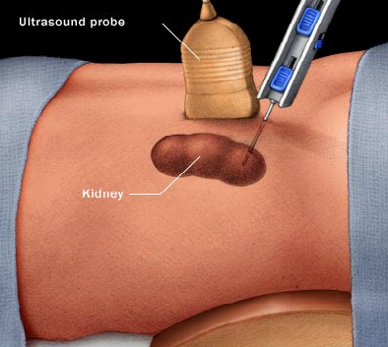

Polycystic Kidney Disease

What is polycystic kidney disease?
Polycystic kidney disease (PKD) is the number four cause of kidney failure in Americans, and an estimated 600,000 people in the United States currently have it. About half of the people diagnosed with PKD will experience end stage renal disease (ESRD) and will need dialysis or a kidney transplant. So what is PKD all about?
Typically, a kidney is about the size of a closed fist. But for those who inherit PKD, cysts that are filled with fluid form in the kidneys and can change their size, interfering with normal kidney function.
PKD is commonly believed to equally affect men and women of all races. However, some studies have shown that the disease may occur more often in Caucasians than in African-Americans and in females more often than males.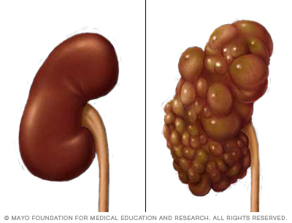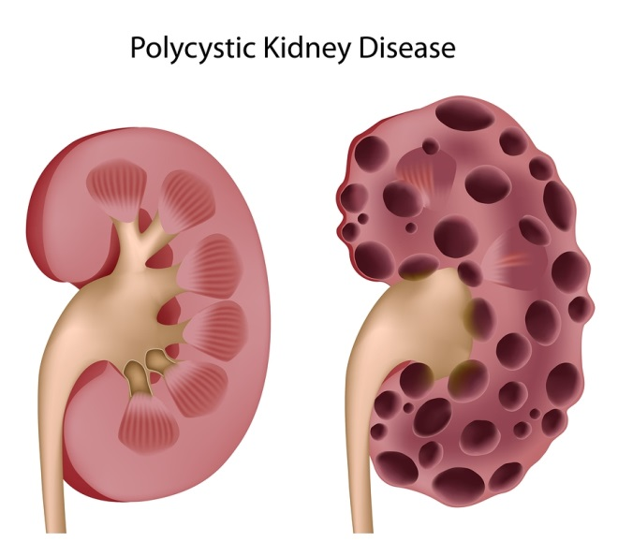How does someone get polycystic kidney disease?
Polycystic kidney disease is hereditary and there are two forms of the disease that are passed down from a parent:
- Autosomal dominant polycystic kidney disease (ADPKD) is by far the most common form of PKD (90 percent of all cases) and runs in families. It is passed from parent to child, and the odds are 50/50 of a child inheriting it from an affected mother or father. About 10 percent of people with ADPKD have not inherited the disease from a parent, but have a gene that mutated, causing the disease.
- Autosomal recessive polycystic kidney disease (ARPKD) is rare and strikes infants, sometimes even before birth. It is also known as “infantile PKD” and affects about one out of every 10,000 people in the U.S. Both parents must be “carriers” of the ARPKD gene to pass it to a child, and each of their children has a one in four chance of getting the disease.

How can a doctor detect polycystic kidney disease?
Because many people with PKD have no signs or symptoms, some people can live their entire life not knowing they have the disease. In these cases, routine blood and urine tests may not even show any signs of PKD.
Ultrasound is most commonly used to detect initial-stage ADPKD, and it can reveal cysts in a fetus’s kidneys, while it is still in the womb when detecting ARPKD (ultrasound imaging has no side effects and is safe for all patients). Sound waves pass harmlessly through the kidneys and create a picture for the doctor to examine. The doctor will be able to see the cysts if they are large enough.

What is being done to treat polycystic kidney disease?
By identifying the processes that trigger the formation of kidney cysts, and experimenting with drugs that can inhibit or block them, there is hope that research will lead to improvements in treating PKD and a cure.

Do You Have Symptoms of Kidney Failure?
Many people may be in the early stages of kidney disease and not have any indication something is wrong with their kidneys. There are certain symptoms, however, that could be a sign you have kidney failure, whether it is acute renal failure or hereditary such as polycystic kidney disease (PKD). When kidney failure (also called renal failure) is detected in the early stages, there are steps you can take to help slow the progression of kidney disease and improve your quality of life.
Below are lists of kidney failure symptoms that are grouped in categories based on a typical cause. If you have any of these renal failure symptoms, you should make an appointment with your doctor as soon as possible and ask that your kidneys be checked.
Hydronephrosis
Hydronephrosis — literally means "water inside the kidney" — refers to distension and dilation of the renal pelvis and calyces, usually caused by obstruction of the free flow of urine from the kidney. Untreated, it leads to progressive atrophy of the kidney. In cases of hydroureteronephrosis, there is distention of both the ureter and the renal pelvis and calices.
Sources of obstruction that can arise from other various causes include kidney stones, blood clots, or sloughed off tissue.
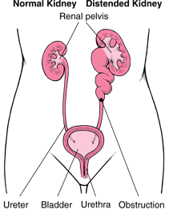
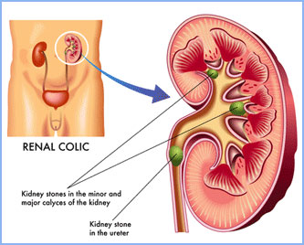
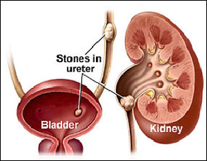
DJ stenting
What is it?
A thin, hollow tube placed inside the ureter during surgery to ensure drainage of urine from the kidney into the bladder. J shaped curls are present at both ends to hold the tube in place and prevent migration, hence the description "Double J stent".
Purpose?
It allows the kidney(s) to drain urine by temporarily relieving any blockage, or to assist the kidney(s) in draining stone fragments freely into the bladder if definitive kidney stone surgery is carried out.

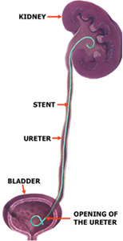
Vesicoureteral reflux
(VUR) is an abnormal backward movement of urine from the bladder into ureters or kidneys.
Urine normally travels from the kidneys via the ureters to the bladder.
Vesicoureteral reflux may present before birth as prenatal hydronephrosis, an abnormal widening of the ureter or with a urinary tract infection or acute pyelonephritis.

Newborns may be lethargic with faltering growth, while infants and young children typically present with pyrexia, dysuria, frequent urination, malodorous urine and GIT symptoms, but only when urinary tract infection is present as the initial presentation of VUR.
In healthy individuals the ureters enter the urinary bladder obliquely and run submucosally for some distance. This, in addition to the ureter's muscular attachments, helps secure and support them posteriorly. Together these features produce a valvelike effect that occludes the ureteric opening during storage and voiding of urine. In people with VUR, failure of this mechanism occurs, with resultant retrograde flow of urine.

Primary VUR
Insufficient submucosal length of the ureter relative to its diameter causes inadequacy of the valvular mechanism. This is precipitated by a congenital defect/lack of longitudinal muscle of the intravesical ureter resulting in an ureterovesicular junction (UVJ) anomaly.

Secondary VUR
In this category the valvular mechanism is intact and healthy to start with but becomes overwhelmed by raised vesicular pressures associated with obstruction, which distorts the ureterovesical junction. The obstructions may be anatomical or functional. Secondary VUR can be further divided into anatomical and functional groups as follows:
Anatomical: Posterior urethral valves; urethral or meatal stenosis.
These causes are treated surgically when possible.
Functional: Bladder instability, neurogenic bladder and non-neurogenic neurogenic bladder Urinary tract infections may cause reflux due to the elevated pressures associated with inflammation.^{[2]}
Resolution of functional VUR will usually occur if the precipitating cause is treated and resolved. Medical and/or surgical treatment may be indicated.
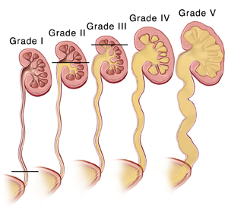
PUJ Obstruction
The ureteropelvic junction (UPJ, also uretero-pelvic junction or pelvi-ureteric junction) is the junction between the ureter and the renal pelvis of the kidney.
During the embryologic development of the kidney, this is the last part of the ureter to become patent.
Failure of this segment of ureter to become patent during development is the most frequent cause of bilateral hydronephrosis, particularly in male neonates.Pyeloplasty, which involves excision of the stenotic section and creation of a new junction, is the most common and effective treatment for this problem.
Pyeloplasty is the surgical reconstruction or revision of the renal pelvis to drain and decompress the kidney. Most commonly it is performed to treat an uretero-pelvic junction obstruction
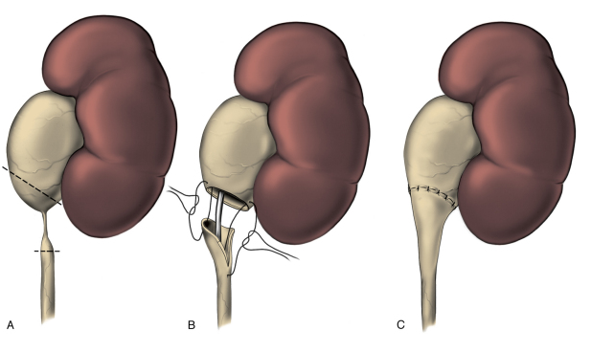
BPH
Benign prostatic hyperplasia (BPH), also called benign enlargement of the prostate (BEP),adenofibromyomatous hyperplasia and benign prostatic hypertrophy (technically incorrect usage), is a benign increase in size of the prostate.
When sufficiently large, the nodules impinge on the urethra and increase resistance to flow of urine from the bladder. This is commonly referred to as "obstruction," but urethra is only compressed. Resistance to urine flow requires the bladder to work harder during voiding, possibly leading to progressive hypertrophy, instability, or weakness (atony) of the bladder muscle. Although prostate specific antigen levels may be elevated in these patients because of increased organ volume and inflammation due to urinary tract infections, BPH does not lead to cancer or increase the risk of cancer.
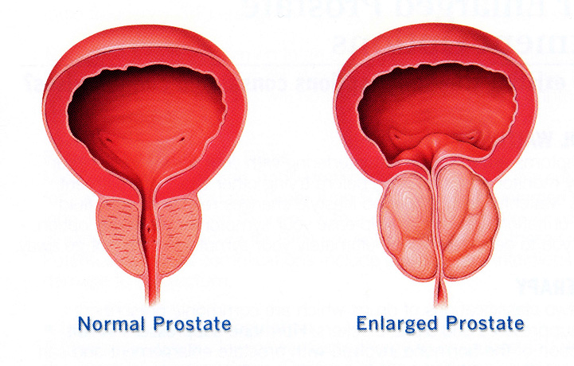

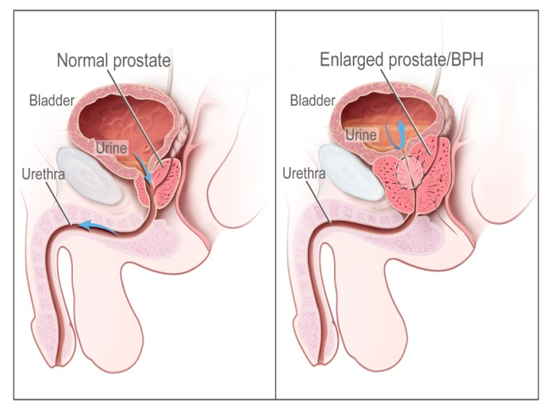
Ectopic kidney
Renal ectopia or ectopic kidney describes a kidney that is not located in its usual position. It results from the kidney failing to ascend from its origin in the true pelvis or from a superiorly ascended kidney located in the thorax.
It has an incidence of approximately 1/1000.
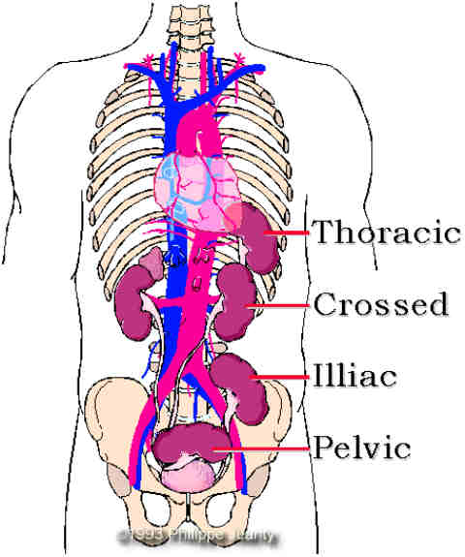
Horse shoe kidney
In this disorder, the patient's kidneys fuse together to form a horseshoe-shape during development in the womb. The fused part is the isthmus of the horseshoe kidney.
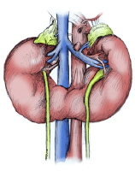
Treatments for these rare and varied conditions depend on presence of renal dysfunction and/or proteinuria.
In this booklet we did not include treatment aspects of diseases because treatments have to be individualised and are consensus based rather than one size fits all protocols.
In general treatments are mainly conservative attempts at halting progression or delaying time to dialysis.
Frequently used specific drugs aimed at treating certain curable diseases are complicated by infections. Among such drugs the most used are steroids followed cyclophosphamide, cyclosporine, tacrolimus and MMF.
Treatments benefits should outweigh the risks associated with such treatments, your treating doctor will judge the suitability and appropriateness of treatments.
At Ramesh we provide you with knowledge about your disease and treatments and side effects and you are free to discuss with our team and only after your satisfaction we proceed with treaments.
We at kamineni are dedicated to the health of our patients and we provide true facts about disease ,its nature and progression.
Most kidney disease patients need support from other specialists and at kamineni have every speciality needed for adequate management of these patients.

Our facilities at Ramesh Hospitals
State of art dialysis machines

Complete separation for HCV +ve and -ve patients

Experienced technical staff with qualified degrees in dialysis

Unique technology to ensure modern practices and adequacy of dialysis

SLED(Sustained low efficiency dialysis techniques)

CRRT(continuous renal replacement therapies)

Acute PD and CAPD facilities

Complete and comprehensive care for patients needing dialysis and transplantation

