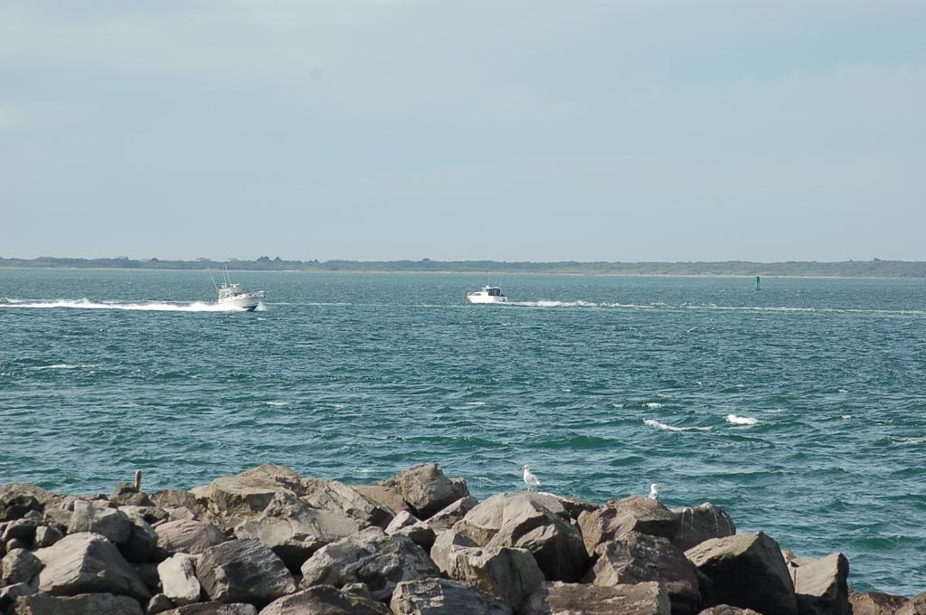
Prices Per person per night................................................………………...............$12.50
Dry camping per trailer/RV or tent per night ..…………………….….…...............…....$9.00
Group Name: __________________________________________________________
Phone Number: ________________________________________________________
Address: ______________________________________________________________
City: _______________________________________ State: ______ Zip: _________
Group Leader/Contact: __________________________________________________
Group Leader/Contact Phone: ____________________________________________
Group Leader/Contact email: _____________________________________________
Number of persons in group: __________________________
Preferred Date(s) (begin-end) _____________ to________________
Alternative Date(s) (begin-end) ____________to_______________
Approximate time of Arrival ___________________________
Reservations: A Deposit of $100.00 is required to hold your reservation. It will be refunded to you approximately ten business days after your stay if the church is left clean and no damage is found. A full refund will be sent if we are informed of your cancellation at least three weeks in advance. __________________________________________________________________________________________________
OFFICE USE ONLY
Deposit Received: (C)__________ Number of Trailers/RV’s Tents __________ Number of persons______________ Date Received: _____________ Number of Nights __________ Number of Nights ______________ Number of trailer/Tent/RV units __________ Number of person units__________ Trailer/RV/Tents (A) __________ Total (units X $9.00) (A) _________ Total (units x $12.50) (B)__________
Persons +(B) __________
Total Due _____________ Deposit Amount Returned (C) ___________ Date Deposit Returned ____________
Reason(s) the deposit was not returned:
Mail to: South Beach Presbyterian Church Please leave the Church as you found it when you arrived,
ATTN: Retreat Ministry put chairs back etc. Thank you.
PO Box 2677
Westport, WA 98595 You can email to reserve your days to: sbpc2677@yahoo.com

