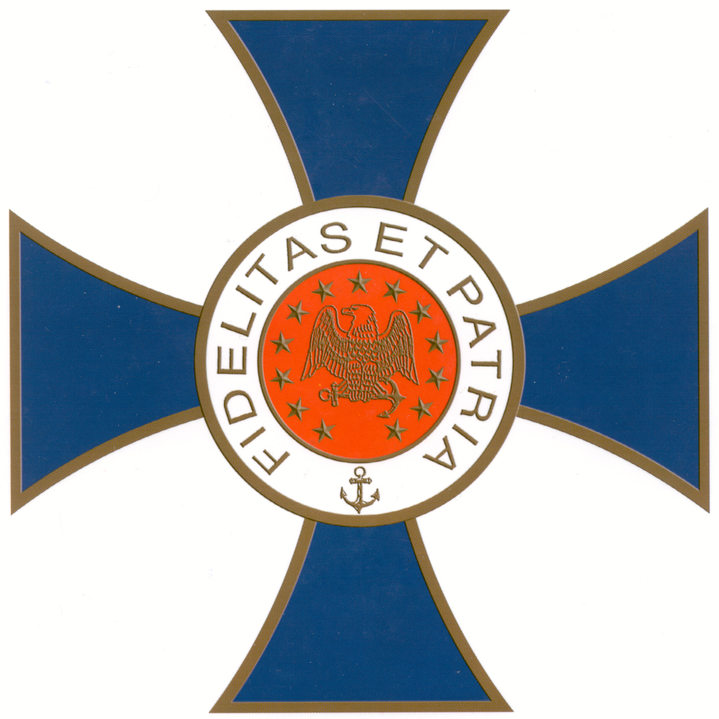

NAVAL ORDER OF THE UNITED STATES
NEW YORK COMMANDERY

Monday, 01 October 2018
Reception at 11:30am - Luncheon at Noon

Racquet & Tennis Club
370 Park Avenue (at 52nd Street)
New York City

James M. Scott

“Rampage”: MacArthur, Yamashita and the Battle of Manila

The definitive history of one of the most brutal campaigns of the war in the Pacific.

To pay on line using your credit card. Log on to Naval Order of the United States New York Commandery web page, www.navalordernyc.org. Scroll down the page to, “You may purchase this event securely via PayPal” Click on the “Buy Now ” box and follow the directions.

____ Monday, 01 October 2018 for _____ People

_____ Enclosed is a check for ____________

$70.00 per person paid in advance by Wednesday, 26 September 2018.

Please make your check payable to: NOUS - NY Commandery

_____ Number of Guests. Name_____________________________________

_____ I will attend and will pay at the door. ($75.00 per person)

Reservation or cancellation should be made by Wednesday, 26 September 2018.

_____________________________________ ________________
Please Print Your Name Here Date

Telephone ___________________ Email______________________________

Payment (check enclosed) Questions:
Send to: Contact:
James S. Trager Norm Keller
13 Casta Lane Commander,
Edgewater, NJ 07020 New York Commandery

201.394.7755 212.255.6037
jstrager@verizon.net normkeller@aol.com

If unable to reserve by mail, please call Jim Trager at 201.394.7755 or send an email to jstrager@verizon.net to reserve and pay at door.

