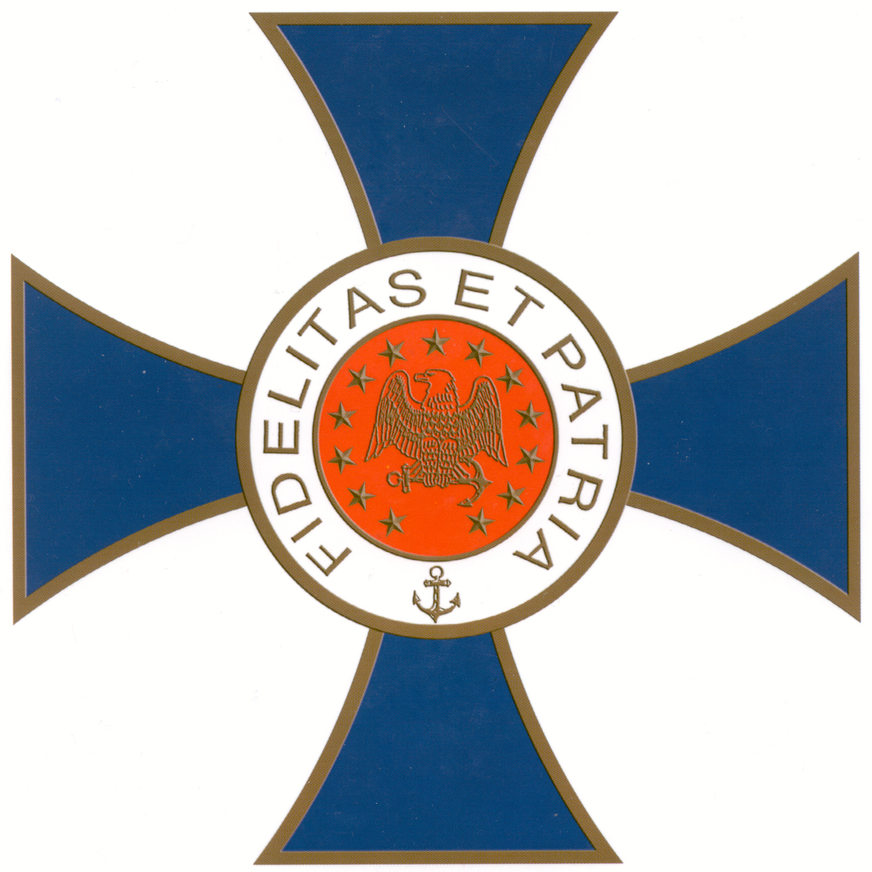

NAVAL ORDER OF THE UNITED STATES
NEW YORK COMMANDERY

Monday, 01 October 2018
Reception at 11:30am - Luncheon at Noon

Racquet & Tennis Club
370 Park Avenue (at 52nd Street)
New York City

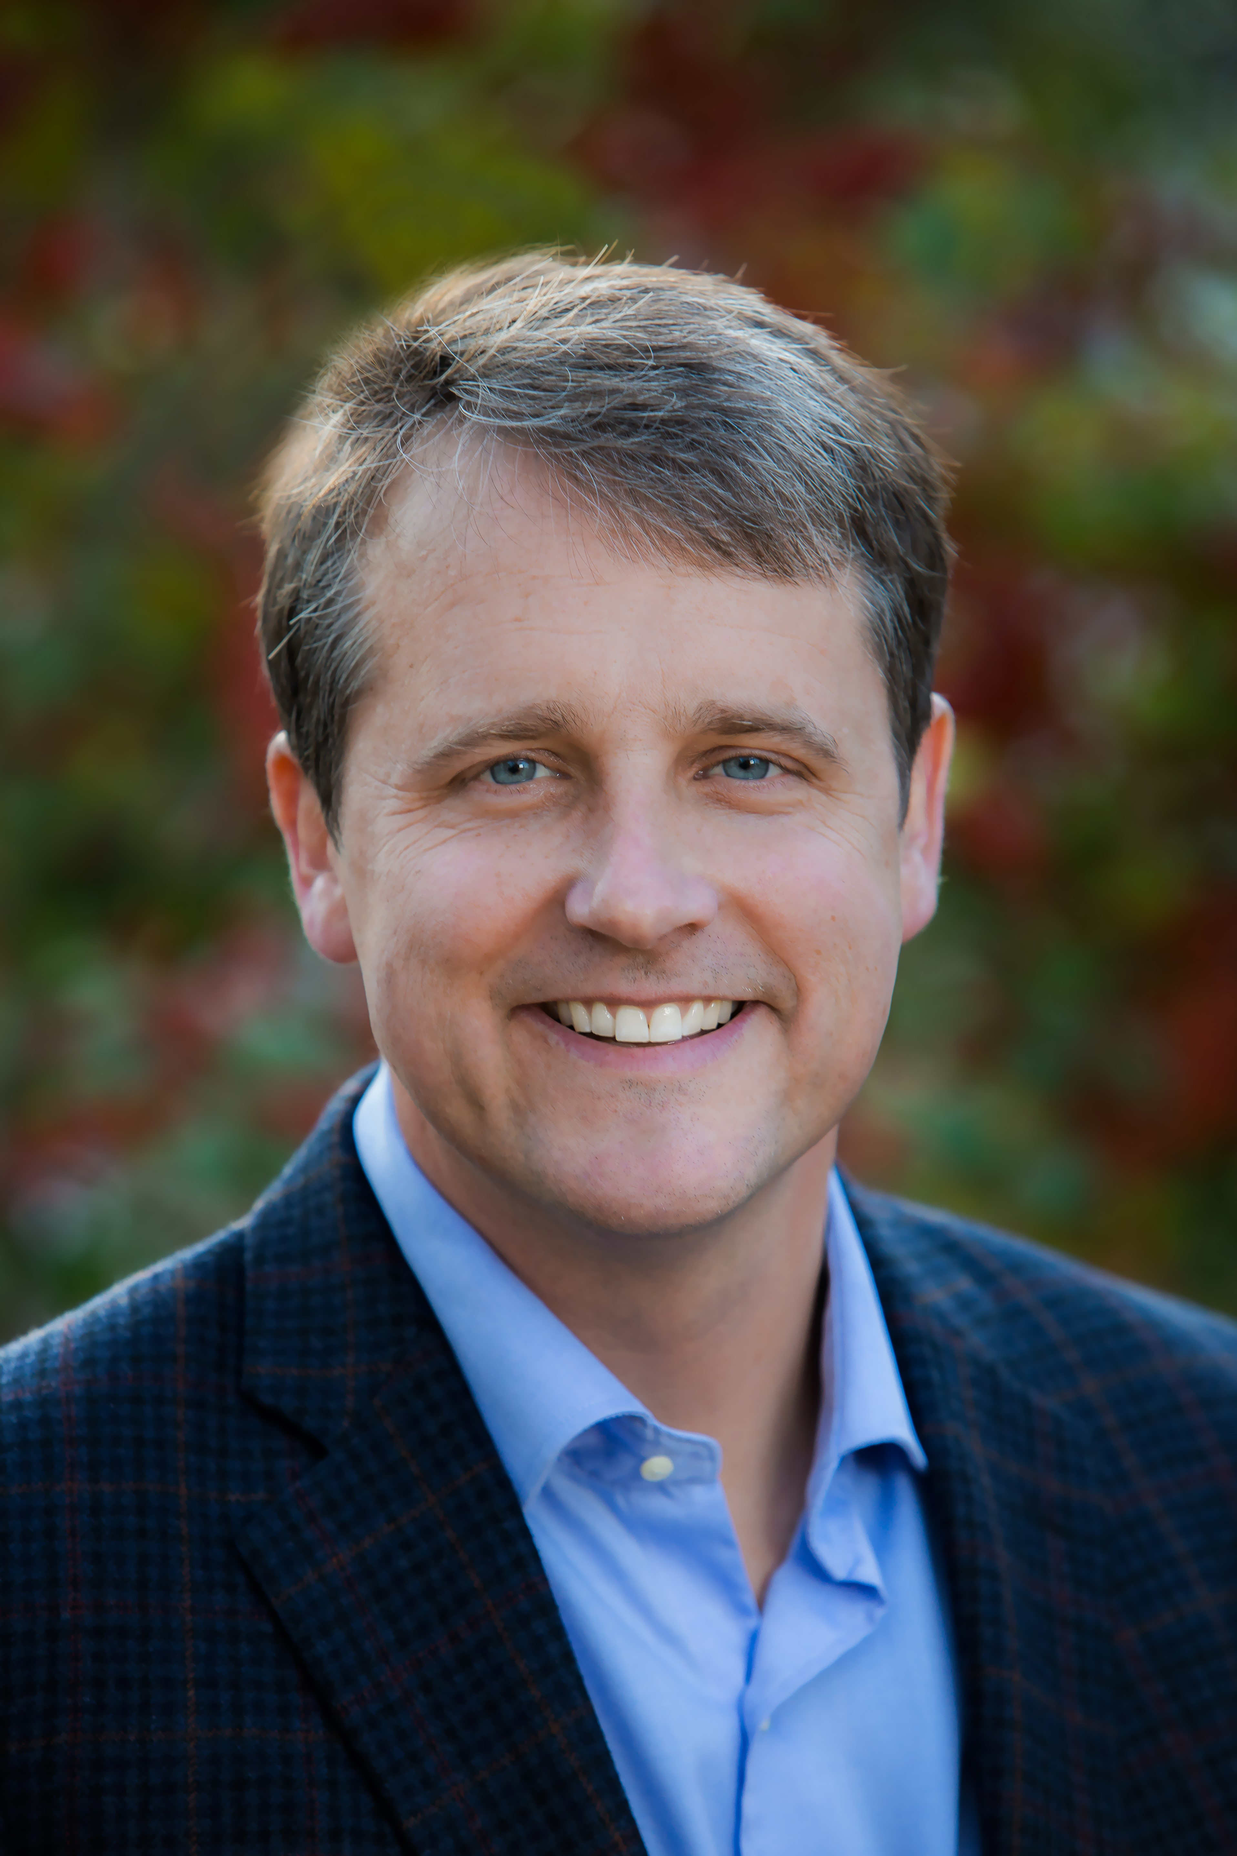

James M. Scott

“Rampage”: MacArthur, Yamashita and the Battle of Manila

The definitive history of one of the most brutal campaigns of the war in the Pacific.

American General Douglas MacArthur, driven from the Philippines under the cover of darkness at the beginning of World War II, famously vowed to return. This is the untold story of his homecoming.
The twenty-nine day battle to retake Manila resulted in the catastrophic destruction of the city and a rampage by Japanese soldiers and marines that terrorized the civilian population. Landmarks were demolished, houses torched, suspected resistance fighters were tortured and killed, countless women raped, and their husbands and children murdered in a massacre as heinous as "The Rape of Nanking."
Based on extensive research, war crimes testimony, after action reports, and survivor interviews, Rampage recounts one of the most heartbreaking chapters of the Pacific war.

Advance Praise for Rampage
“This is General Douglas MacArthur as you have not heard him, this is World War II as you have not seen it before, this is history written with a wide sweep and deep focus, the prose and reporting falling in aching rhythms on scenes of beauty, despair, defiance, the terrible trespasses people make, and their striving to endure. James Scott’s skill as a
reporter and his precision as a stylist make this story unstoppable from the very first scene. Across these pages falls the shadow of a history we thought we knew well, but in Scott’s telling, so much is revealed and illuminated. A bold surprise of a history book. A treasure for lovers of stories beautifully told. Transcendent.” —Doug Stanton, New York Times best-selling author of The Odyssey of Echo Company and 12 Strong

“James M. Scott knows how to search long and hard for the personal details that make up a gripping narrative. Admirers of his Target Tokyo will find the same skills at work in Rampage. And parts of the story he tells, particularly about the Battle of Manila, are little known, even to those of us who can never stop reading about World War II.”
—Adam Hochschild, New York Times best-selling author of Spain in Our Hearts: Americans in the Spanish Civil War, 1936–1939

“The Battle of Manila has gone down in history, like the Siege of Leningrad and the Warsaw Uprising, as an example of the sheer destructiveness and civilian cost of modern combat—costs that continue to this day out of all proportion to the numbers of soldiers involved. In re-telling the tragic story of Manila’s fate in February, 1945, James Scott does not spare us the suffering, carnage, heroism, and Japanese atrocities committed—or the ethical problems in fixing the blame for a 29-day crime against humanity. Rampage confirms Scott’s place in the first rank of American World War II historians.” —Nigel Hamilton, author of the FDR at War trilogy

“Rampage is a deeply researched and superbly written account of one of the darkest chapters of the Pacific War. I found it hard to read, but also hard to put down.”
—Ian W. Toll, New York Times best-selling author of The Conquering Tide
and Pacific Crucible

“A masterful re-telling of the events and the people caught in a city that died. There are no embellishments in James Scott's account of the Battle of the Manila: soldiers and civilians are allowed to speak about the horrors largely forgotten or unknown. The stories make for gruesome reading, but these stories have to be told, so that the suffering—and the tragedy—of the Philippines’ capital city and its people may never be repeated. James Scott is to be congratulated for giving the victims a chance to speak. It is high time that the tragedy that befell Manila in 1945 be made known to a larger audience. Rampage does this.” —Jose M. Cabarrus, president of Memorare Manila 1945 Foundation

A former Nieman Fellow at Harvard, James M. Scott is the author of Target Tokyo, which was a 2016 Pulitzer Prize finalist and was named one of the best books of the year by Kirkus, The Christian Science Monitor and The Fort Worth Star-Telegram. His other works include The War Below and The Attack on the Liberty, which won the Rear Admiral Samuel Eliot Morison Award. His latest book, Rampage: MacArthur, Yamashita, and the Battle of Manila, will be released Oct. 2, 2018.

